ELEC 374 | Digital Systems Engineering

Final Report

April 5, 2020

Department of Electrical and Computer Engineering

Daniyal Maniar | 20064993

Hermann Krohn | 20057435

Group: 7

Professor: Ahmad Afsahi, P.Eng

# Abstract

The project task was to design, simulate, implement, and verify a Simple RISC computer. The computer consisted of RISC processor, an external memory unit, and input/output functionality. The computer had to be designed in a hardware description language of choice. The group decided to implement the computer in the Verilog description language. The system was designed to be implemented on the DEO board, but due to COVID-19 measures, the design was not able to be implemented on the board.

The implemented design is similar to the project specifications that were provided. Some improvements included:

* A completely modular design that could facilitate:
  + Any 2N bit size design (16, 32, 64, 128, etc)
  + Any amount of registers (as long as the number of registers isn’t above the bit threshold)
  + Any size of RAM
* A dual bus lines system for HI/LO registers to test higher bit count operations
  + Interchange system to switch values between bus lines
* A unique register multiplexer design
* Faster addition algorithm
* Faster multiplication algorithm
* Faster division algorithm

The processor contains an ALU unit, a register file, a select and encode unit, a CON_FF unit, 7 utility registers, and a data path to connect all the modules. The RAM of choice is a synchronous RAM specification.

Table of Contents

Abstract i

Project Specification 1

Phase 1 1

Phase 2 1

Project Design and Implementation 2

Phase 1 2

Phase 2 3

Evaluation Result 4

Maximum frequency of operation 4

Percentage of chip area 4

Discussion, Conclusion, and Future Work 4

Potential Bonuses 5

Appendix I – Code, Wave forms, & Memory Dumps 6

Register 6

Register Test Bench 6

Register Waveform 7

Register File 7

Register File Testbench 7

Register File Waveform 8

Register Multiplexer 8

ALU 9

ALU Result Selector 10

CLA Adder 10

CLA Full Adder 11

CLA Adder Testbench 11

CLA Adder Waveform 11

Subtract 12

Not 12

Multiply 13

Division 14

Shift Right 15

Shift left 15

Rotate Right 15

Rotate Left 15

Datapath 16

MDR 17

MDR Testbench 17

MDR Waveform 18

CON_FF 18

RAM 19

RAM Waveform 20

Select and Encode 20

Select and Encode Testbench 21

Select and Encode Waveform 21

LD Testbench 22

LD Waveform 23

LD Case 1 23

LD Case 2 25

LDI Testbench 27

LDI Waveform 28

LDI Case 1 28

LDI Case 2 30

ST Testbench 32

ST Waveform 33

ST Case 1 33

ST Case 2 35

ADDI Testbench 37

ADDI Waveform 38

ANDI Testbench 39

ANDI Waveform 40

ORI Testbench 41

ORI Waveform 42

Branch Testbench 43

Branch Waveform 44

Branch Case 1 44

Branch Case 2 45

Branch Case 3 46

Branch Case 4 47

JR Testbench 48

JR Waveform 49

JAL Testbench 50

JAL Waveform 51

MFHI Testbench 52

MFHI Waveform 53

MFLO Testbench 54

MFLO Waveform 55

Input Testbench 56

Input Waveform 57

Output Testbench 58

Output Waveform 59

# Project Specification

The project consisted in designing and implementing a mini SRC. The specifications and requirements of the mini SRC are shown below.

## Phase 1

* PC, IR, MAR, MDR, and HI/LO registers
* General purpose registers (Change header to set specific number of register)
* Two internal registers (Z and Y)
* Two busses
  + Bus Low
  + Bus High
* Register select logic
* ALU supporting the following operations
  + Add
  + Subtract
  + Multiply
  + Logical AND
  + Logical OR
  + Divide
  + Shift left
  + Shift right
  + Rotate left
  + Rotate right
  + Increment PC
  + Not
  + Negate

## Phase 2

* Select and Encode logic unit
* CON FF logic unit
* Input/output registers
* RAM (Size can be set in header: Memory Size*BITS) – Implementation of memory subsystem
* Revision to register R0 – R0 should gate zeros when it is selected as Rb in ld, ldi, and st instructions

# Project Design and Implementation

The mini SRC is composed of many hardware components/circuits. Implementation of the components can be found below.

*Note* ***N*** *refers to the 2n bit size chosen such as 16, 32, 64, 128 etc.*

## Phase 1

* **General purpose registers** – The general-purpose registers (N bits) consist of a clock, reset, enable, and the bus as inputs. The register’s output is connected to the register select logic.
* **PC, IR, and HI/LO registers (N bits)** – Just like the general-purpose registers, the PC, IR, and HI/LO registers consist of a clock, reset, enable, and the bus as inputs. Their outputs are connected to the register select logic.
* **MAR register -** The MAR (N bits) register consist of the clock, reset, enable, and bus as inputs. Its output is the address input to the RAM unit (phase 2).
* **MDR register** – The MDR register (N bits) consists of a clock, enable, and a reset as inputs. Additionally, the MDR register has the output of a multiplexer feed in as an input. The multiplexer is used to select between data coming from the bus or RAM (phase 2). The output of MDR is connected to the register select logic.
* **Internal registers (Y and Z)** - Register Y (N bits) is used as one of the two input to the ALU unit, the other being the bus. The result of the ALU unit is placed in register Z (2*N bits).
* **Bus** – The bus is used to transfer data between hardware components. This includes sending data to registers or the ALU unit. In phase 2, a second bus was incorporated to transfer the upper N bits from register Z to the HI register.
* **Register select logic** – The register select logic is used to allow a register to place its contents on the bus. The register select logic accepts a stream of all the register values as an input, and a one-hot encoded input to select which range from the register value stream to place on the bus. In phase 2, the register select logic incorporated the BAout input to gate zeros if R0 is selected as Rb for load, load immediate, and store instructions.
* **ALU** - The ALU supports the following operations and is implemented as follows:
* **Addition:** Implemented with carry lookahead circuit/logic
* **Subtraction:** Implemented using the addition carry lookahead logic. However, the second input is negated with negation circuitry
* **Multiplication:** Implemented using radix 8 booth’s algorithm (3-bit groupings)
* **Division:** Implemented using a non-restoring division algorithm
* **Shift right/Shift left:** Module implemented using >> operator
* **Rotate left:** Module implemented by shifting the input left by the rotate amount % the number of bits and then ORing with the input shifted right by rotate amount % the number of bits subtracted from the number of bits. The modulo operator essentially optimizes the rotate operation because once the input has been rotated by the number of bits, every possible solution has been explored
* **Rotate right:** Module implemented by shifting the input right by the rotate amount % the number of bits and then ORing with the input shifted left by rotate amount % the number of bits subtracted from the number of bits. The modulo operator essentially optimizes the rotate operation because once the input has been rotated by the number of bits, every possible solution has been explored
* **Logical AND:** The logical AND operation is implemented using the && operator
* **Logical OR:** The logical OR operation is implemented using the || operator
* **Not:** The Not operation is implemented by XORing the input with 1’s
* **Negate:** The negate operation is implemented by first Noting the input with the Not logic and then adding 1 to the result
* **Increment PC:** The increment PC logic uses the carry lookahead adder to add 4 to the value of PC

## Phase 2

* **Select and Encode logic:** The select and encode logic is responsible for generating the Rin or Rout signal based on the Ra, Rb, or Rc bits of the instruction.
* **CON FF logic:** The CON FF logic uses bits 19 and 20 from a 32-bit instruction to determine the comparison type (Works with N bit sizes). Comparison types include equal to zero, not equal to zero, and checking the if the input is positive or negative. If the input passes the selected comparison test, CON FF outputs a 1, otherwise a 0.
* **Input register:** The input register is implemented like a regular register. However, the enable is always high. The input register has the clock, enable, reset, and the input unit as inputs and the output is connected to the register select logic.
* **Output register:** The output register is implemented like a regular register. The output register has a clock, reset, enable, and the bus as inputs. The output is connected to the output unit.
* **RAM:** The implementation of RAM is a MxN (M can be set in the header) matrix. The inputs to RAM are the value of MDR (data in), the read signal, the write signal, and the address of where to read or write. The output from RAM is connected to the multiplexer that feeds into the MDR register.
* **Revision to R0:** When R0 is selected as Rb in a load, load immediate, or store instruction, R0 is meant to gate zeros. This was implemented in the register select logic by incorporating the BAout signal. If the one hot bit that feeds into the register select logic represents R0 and BAout is high, then zeros are outputted.

# Evaluation Result

## Maximum frequency of operation

Based upon our individually set design constraints, the maximum frequency achieved by our design is 20 ns which amounts to a 50 MHz clock speed.

## Percentage of chip area

We can see based on the compilation report that the processor used only 7,177 out of the 15,408 logic elements available.

|  |  |  |
| --- | --- | --- |
| Total amount of logic elements used | Total amount of logic elements available | Percentage of chip area used |
| 7,177 | 15,408 | 46.58% |

# Discussion, Conclusion, and Future Work

The mini SRC was developed up to phase 2. The design and implementation of the CPU incorporated hardware components such as 16 general purpose registers, utility registers such as the PC register, two buses, and an ALU supporting ten different operations such as shifting bits. The design also had a register select circuit that used one-hot encoding to determine which register can place its contents on the bus. Additionally, in phase 2, the select and encode logic was implemented to generate the Rin and Rout signals based on the instruction. In this phase, the CON FF logic was also designed to support branching conditions such as equal to zero, not equal to zero, and checking whether an input is positive or negative. This phase also implemented the input/output registers as well as RAM, the memory subsystem. Lastly, a modification was made to the register select logic to incorporate the BAout signal. The modification allowed R0 to output zeros when R0 was selected in the Rb field of the load, load immediate, and store instructions.

In conclusion, the CPU was able to perform well and accomplished all requirements up to phase 2. Although the CPU designed for this project was relatively simple, it portrays the large number of signals that occur in today’s most powerful CPUs. Additionally, the project exemplifies the importance of timing diagrams as, for example, a small mis timing could cause a value to not get latched into a register. As mentioned before, the CPU was able to meet all expectations. However, in the future, changes and new features could be implemented to increase the performance of the CPU. One change is redesigning RAM to be asynchronous. An advantage of asynchronous RAM is that it is not bound by the clock speed and does not have to be synchronized with the clock. Additionally, asynchronous RAM is not triggered by rising or falling edges which could add latency in the synchronous case. Another change to RAM would be to support read and write operations simultaneously. To do this, both a read and write address would be required and the expected behavior must be defined when attempting to read and write to the same location. A potential solution is to read first and then write or vice versa. Another change would be to add support for interrupts. Adding support for interrupts allows asynchronous methods and events to be triggered at any point as opposed to relying on the clock. An advantage of asynchronous circuitry is that it eliminates skew problems related to the clock signal. Another future implementation would be to incorporate more buses to save execution cycles. For example, the addition of more buses could lead to the support of writing to multiple registers simultaneously which would help reduce the number of cycles needed when executing instructions. In phase 2, a second bus was incorporated which reduced the number of cycles required to transfer data to the HI and LO registers after a multiplication instruction. Lastly, future work for the CPU would require implementing the control unit. Incorporating the control unit would complete the CPU project and make it run on its own as opposed to generating the signals in the test bench.

# Potential Bonuses

* Carry lookahead adder
* Completely modular design ( $2^{N}$ bit design, any number of registers, and any size of RAM)
* Radix 8 Booth’s Algorithm (3-bit groupings)
* Dual bus lines
* Non-restoring division algorithm
* Unique register select logic (One hot-encoding)

# Appendix I – Code, Wave forms, & Memory Dumps

Register

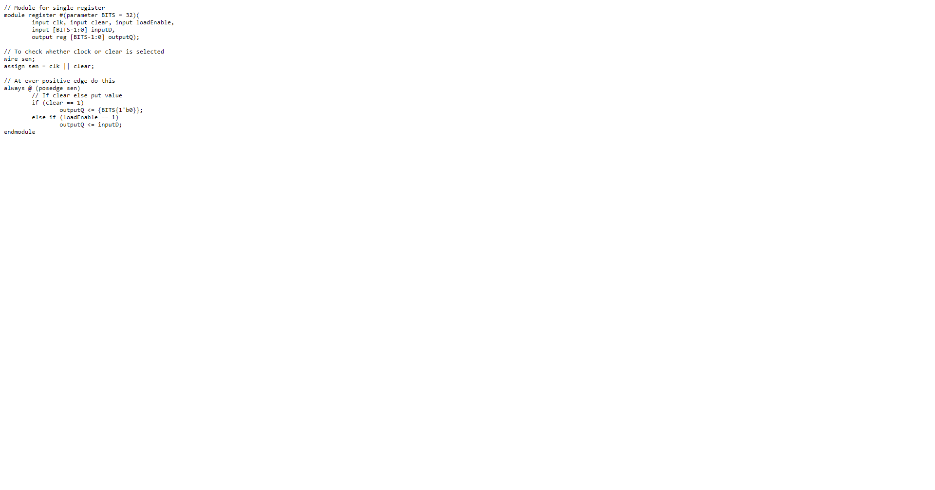

## Register Test Bench

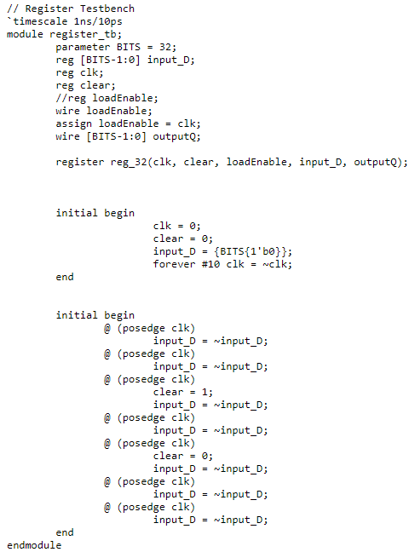

## Register Waveform

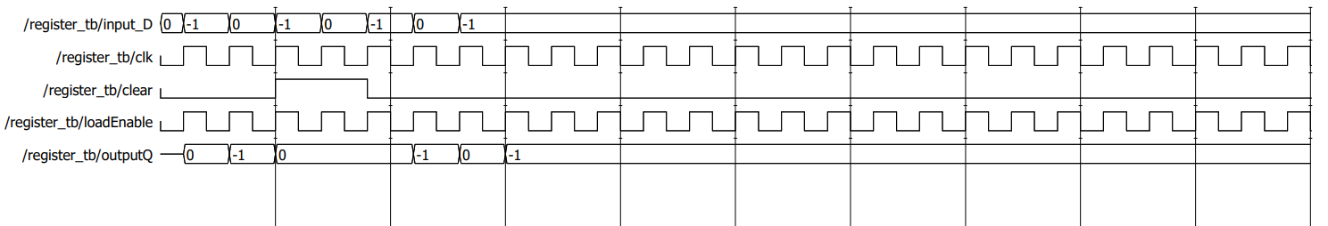

Register File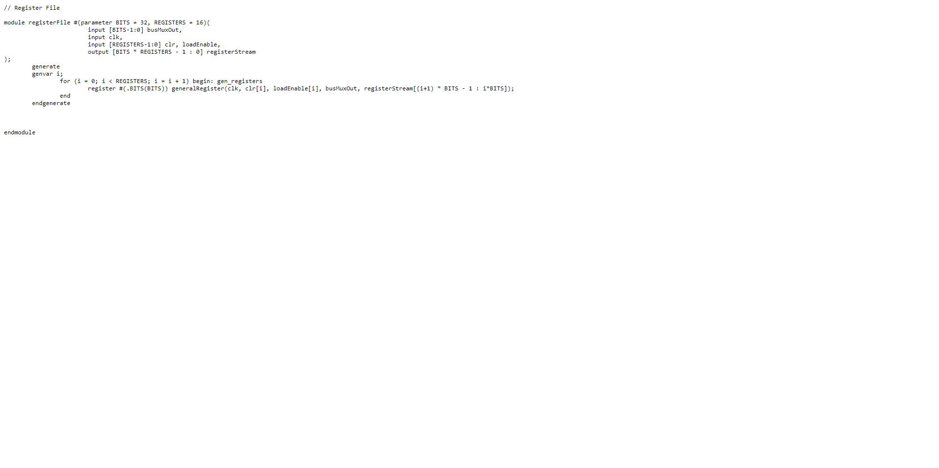

## Register File Testbench

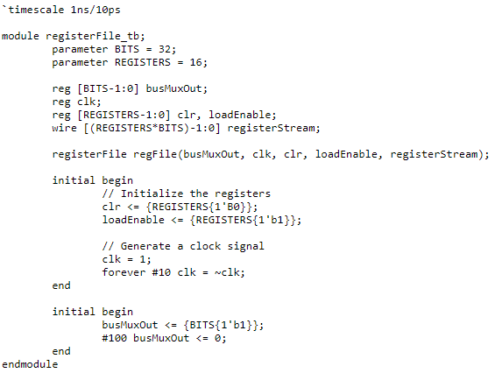

## Register File Waveform

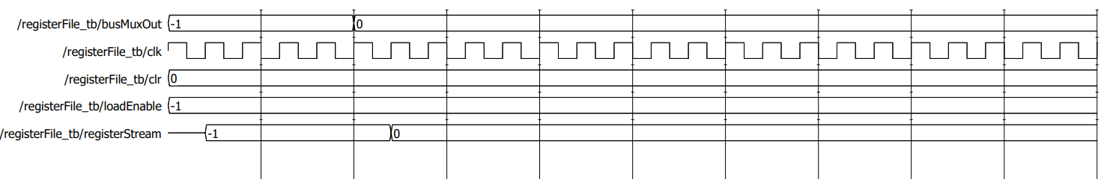

Register Multiplexer

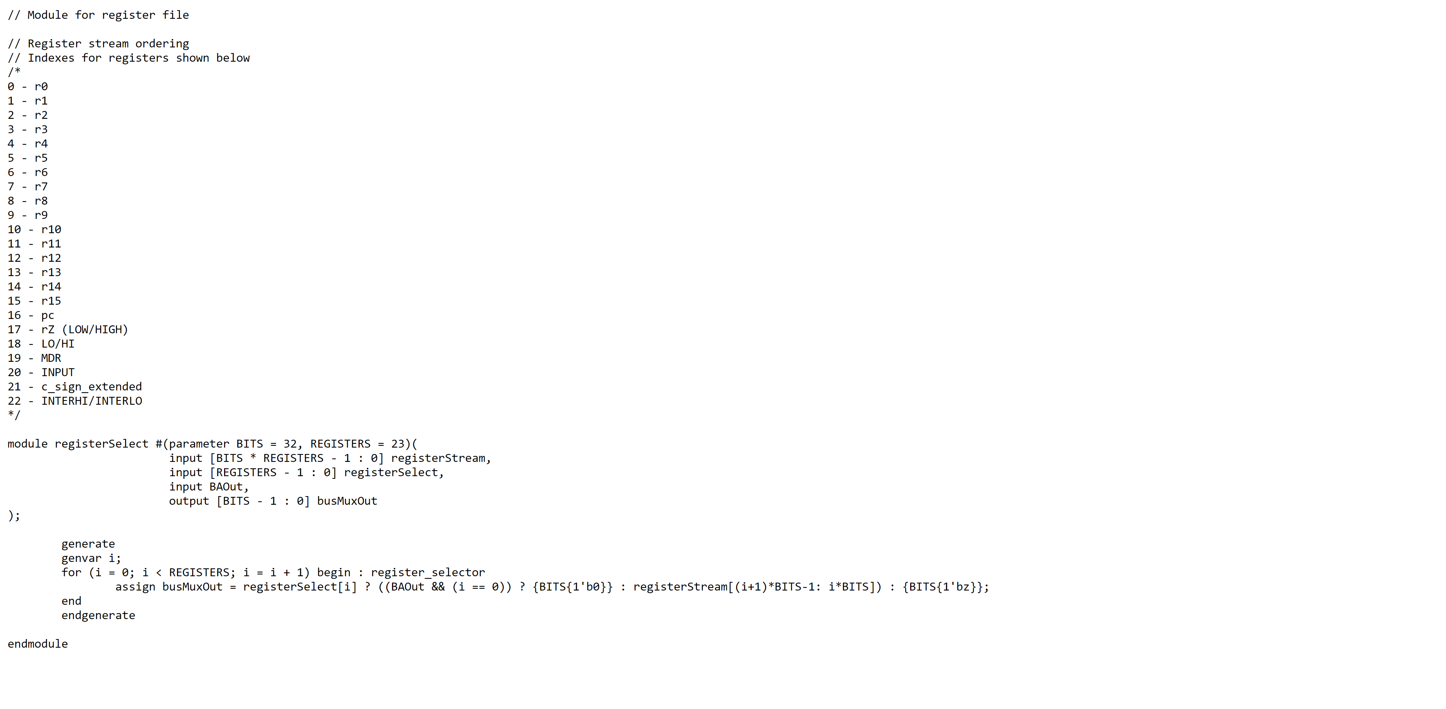

ALU

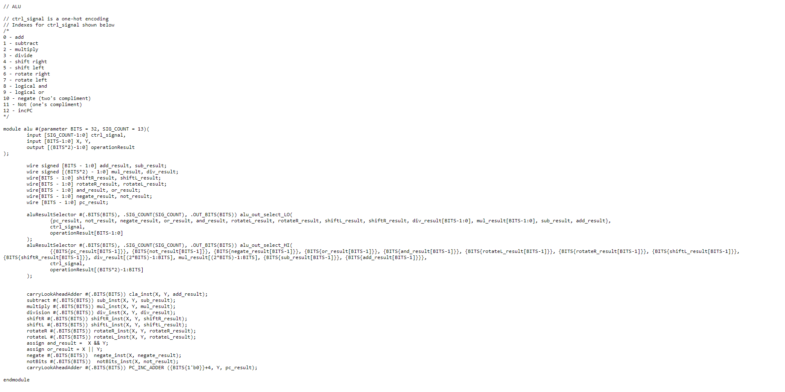

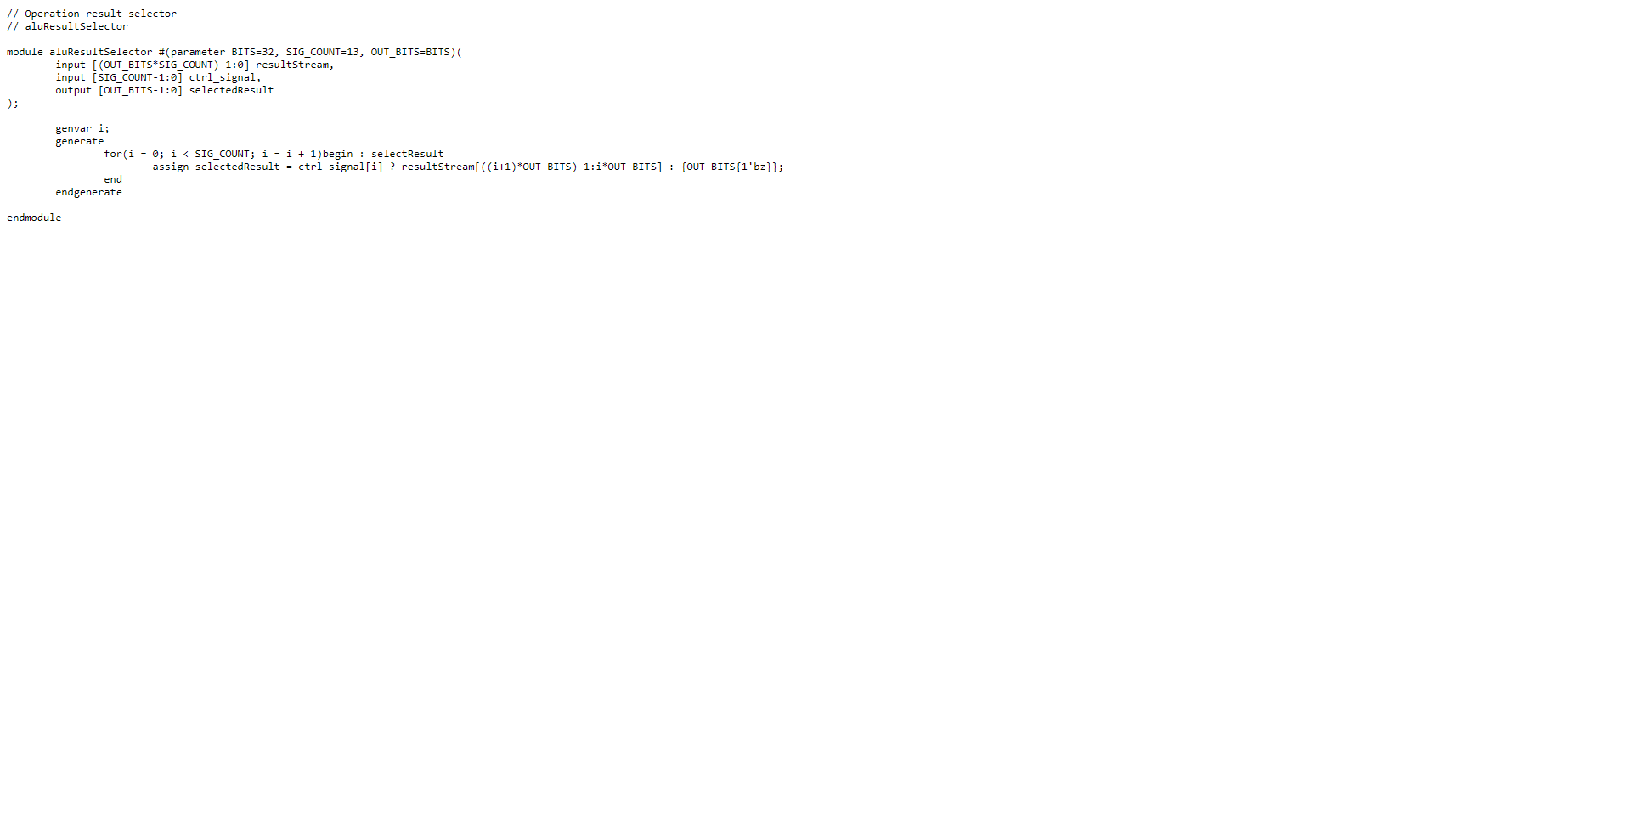ALU Result Selector

CLA Adder

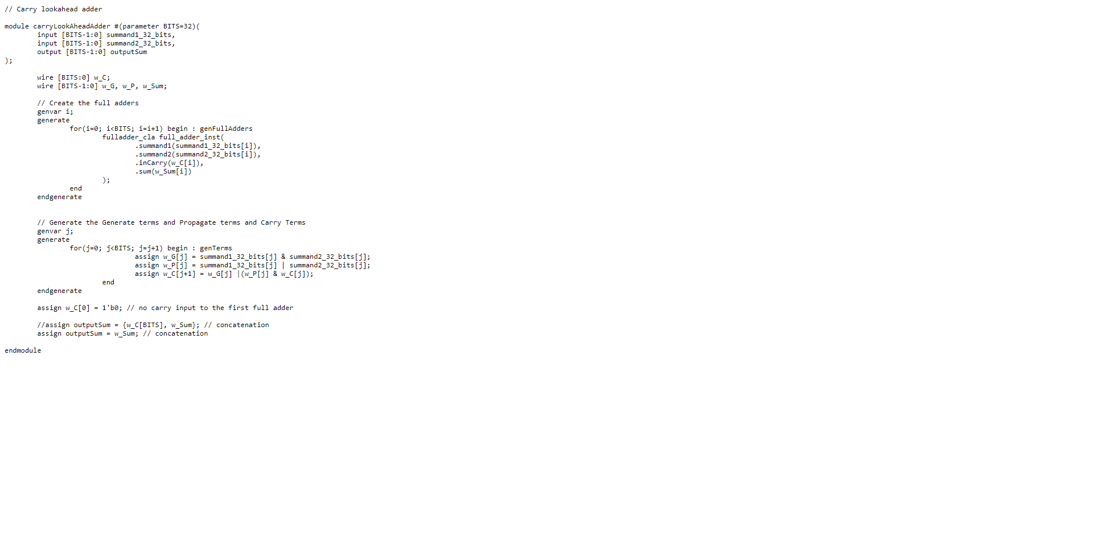

CLA Full Adder

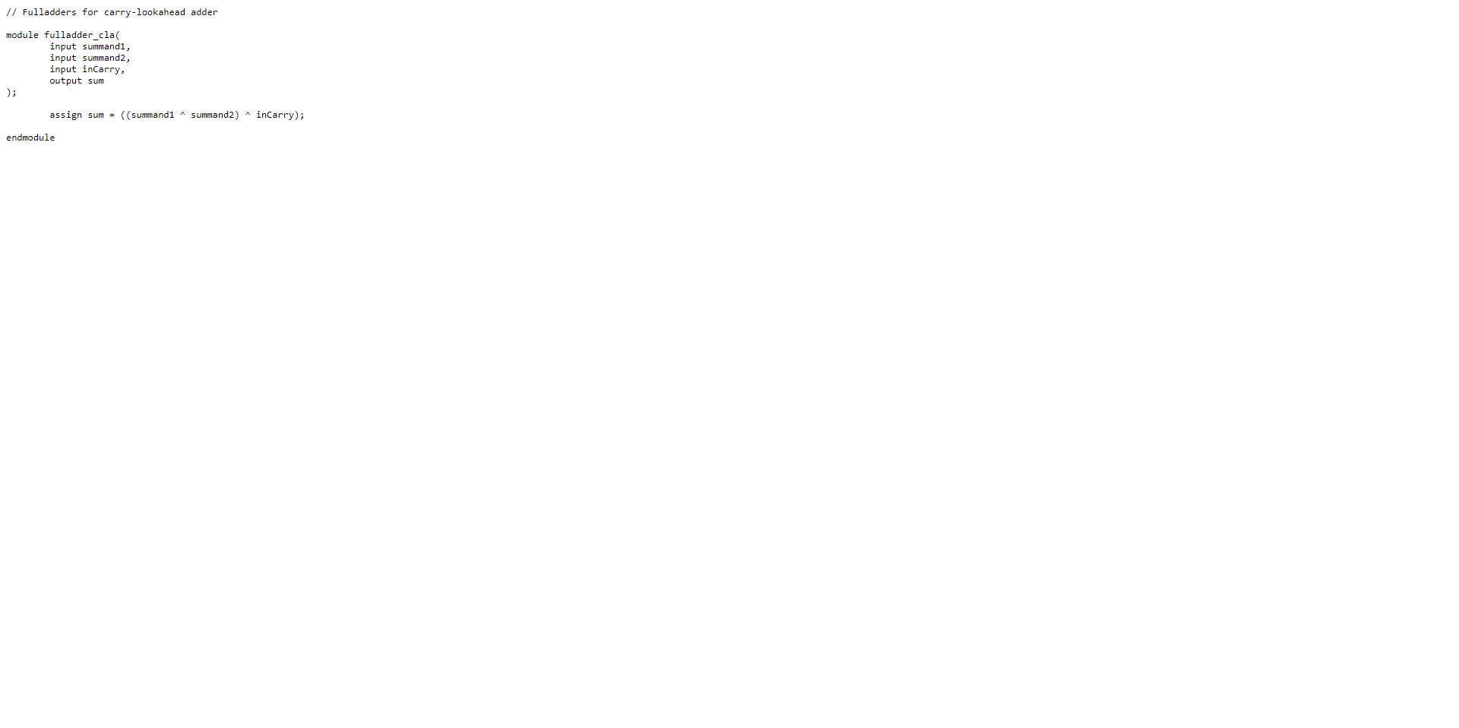

CLA Adder Testbench

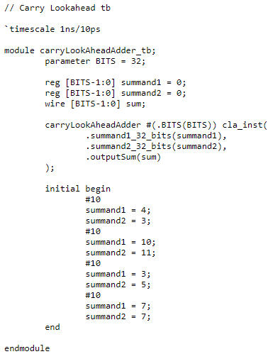

CLA Adder Waveform

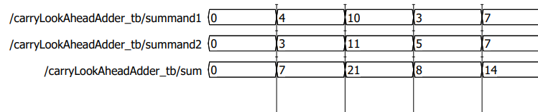

Subtract

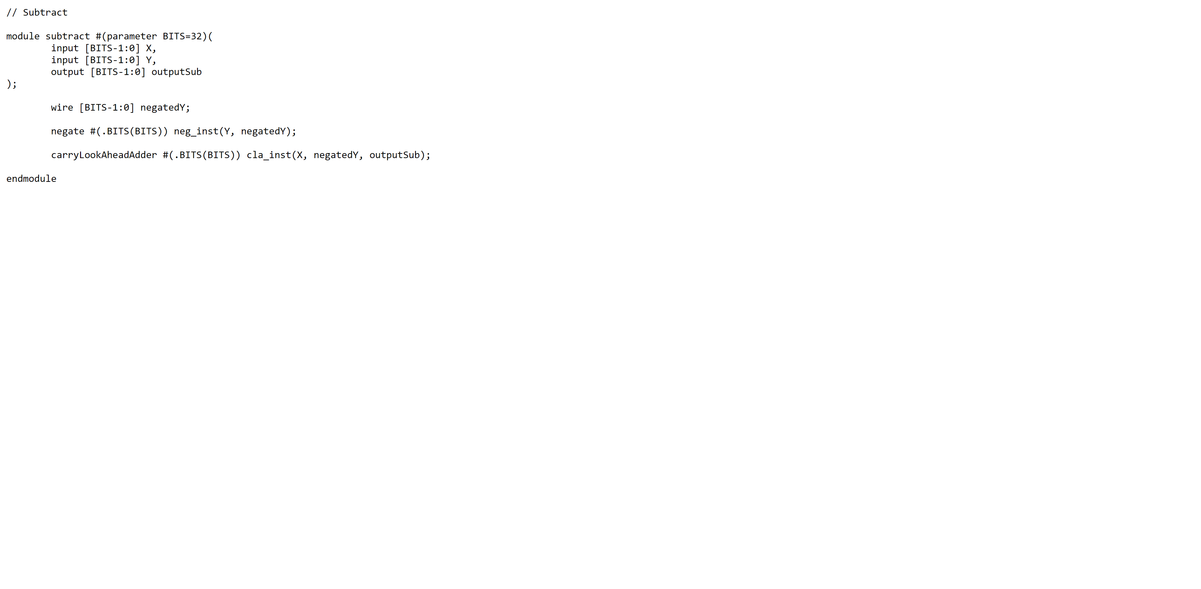

Negate

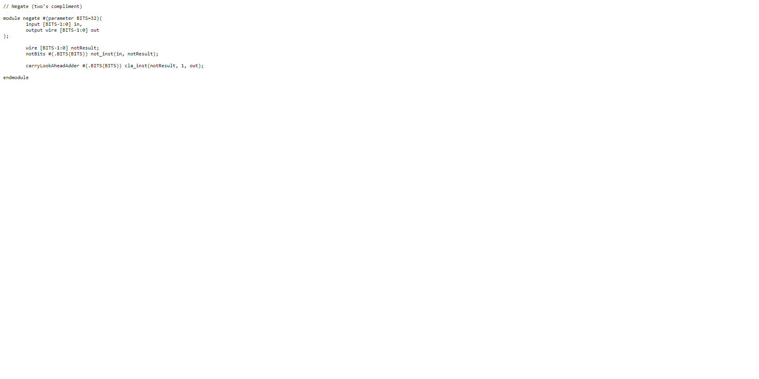

Not

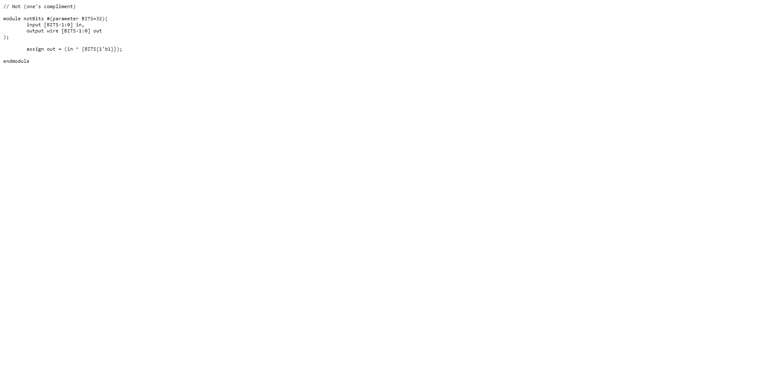

Multiply

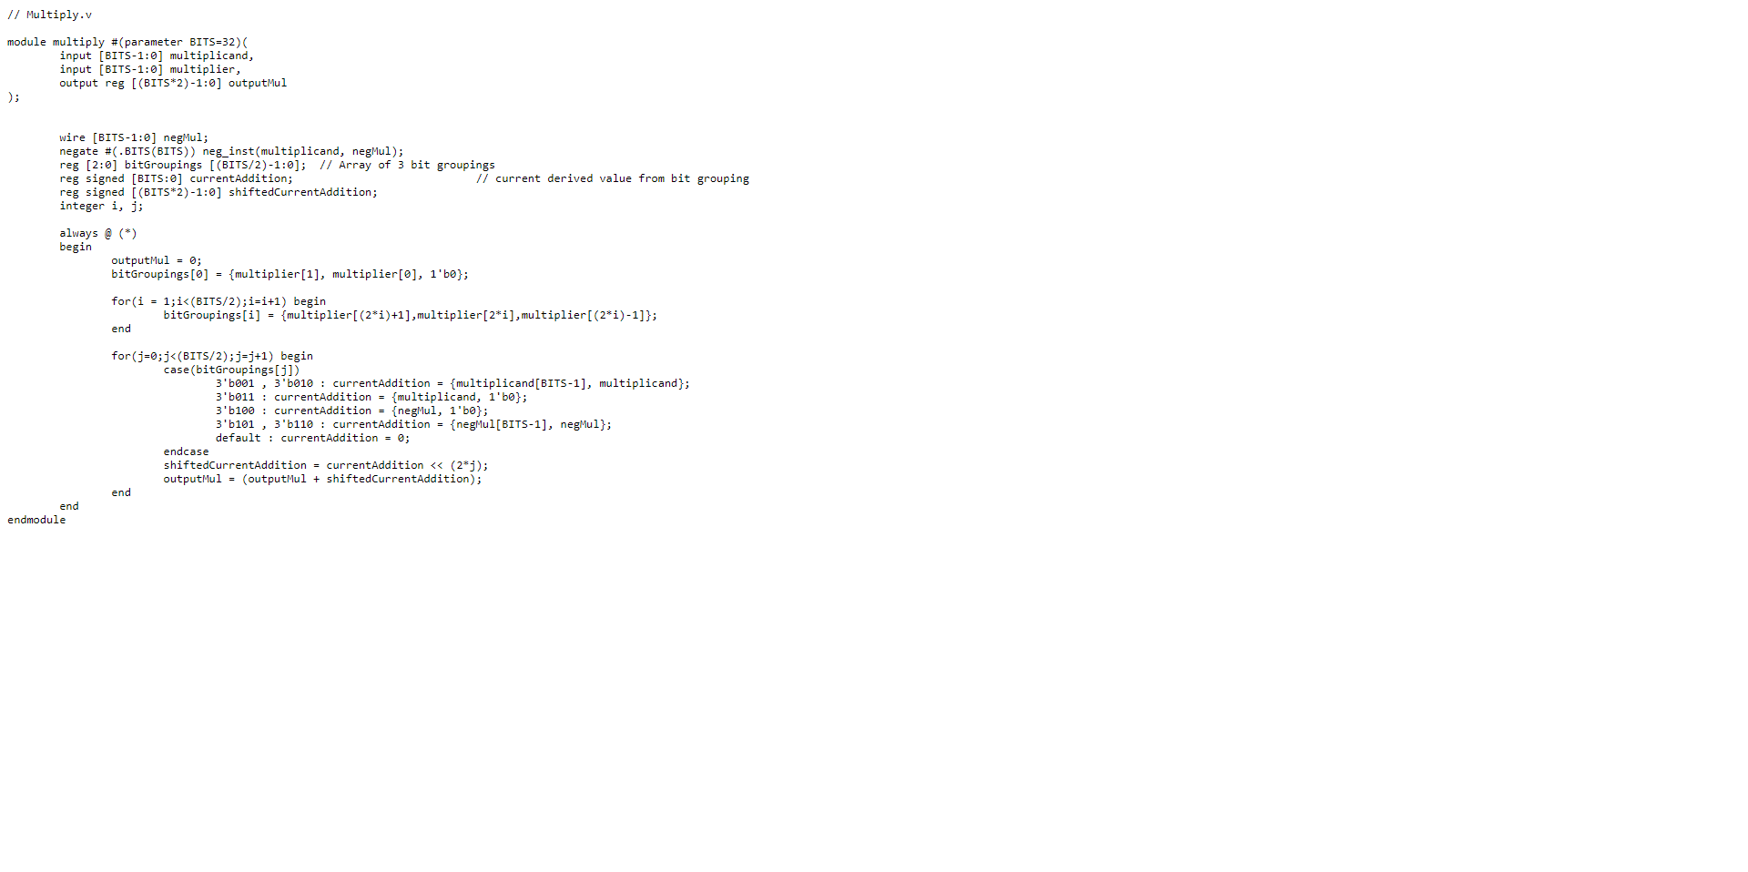

Division

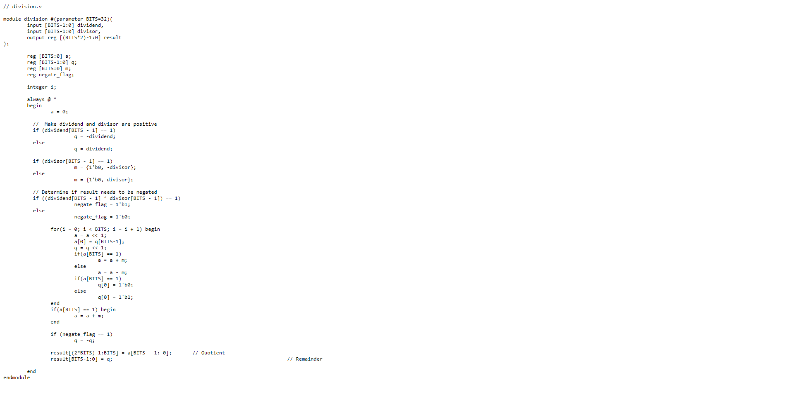

Shift Right

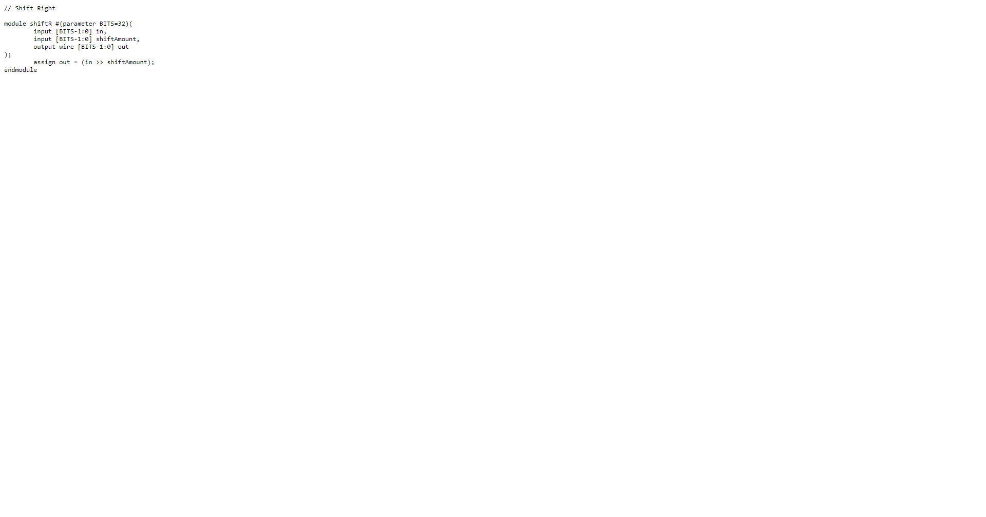

Shift left

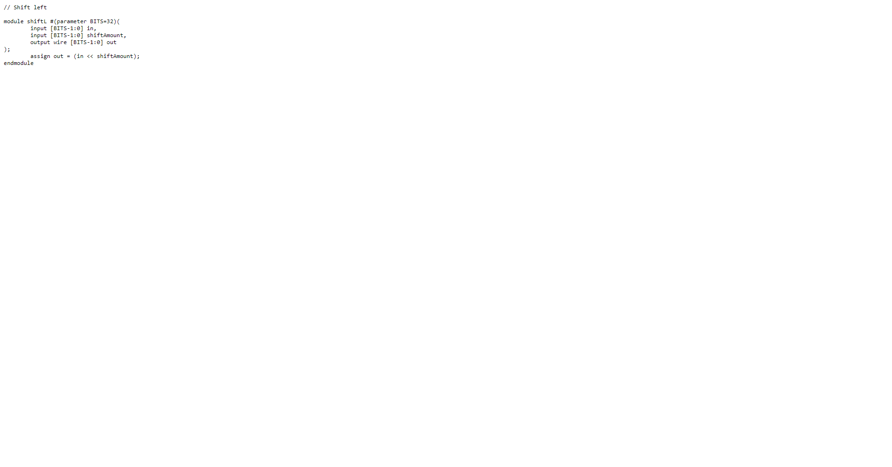

Rotate Right

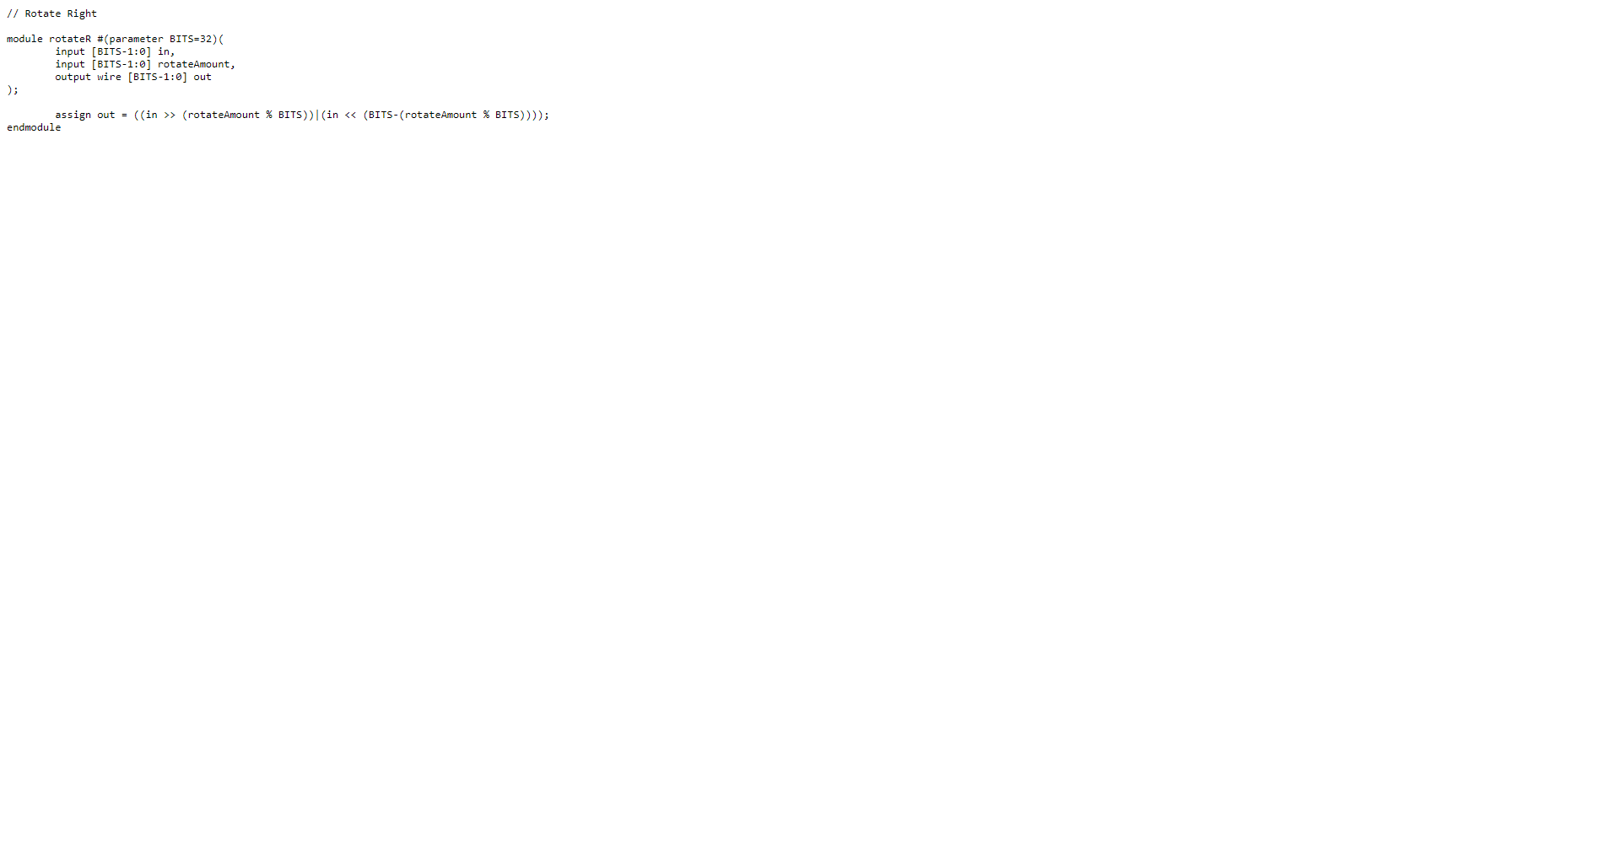

Rotate Left

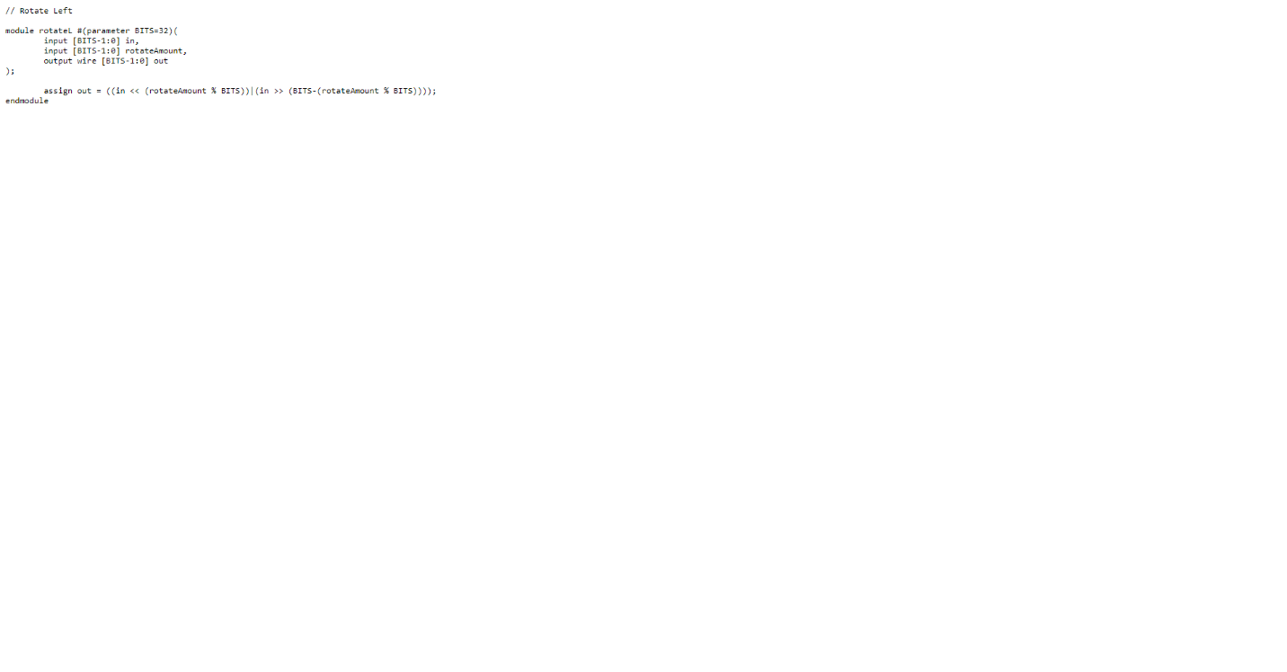

Datapath

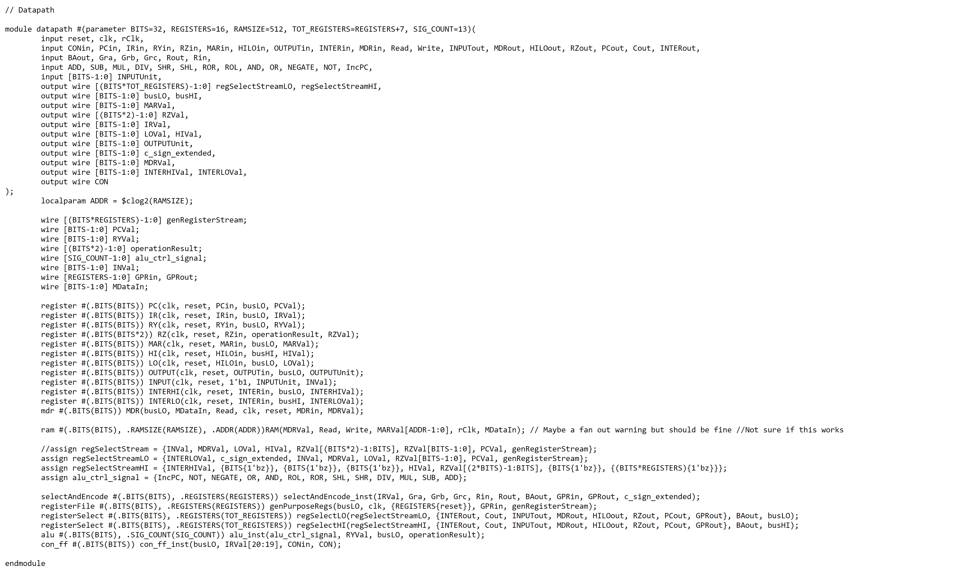

MDR

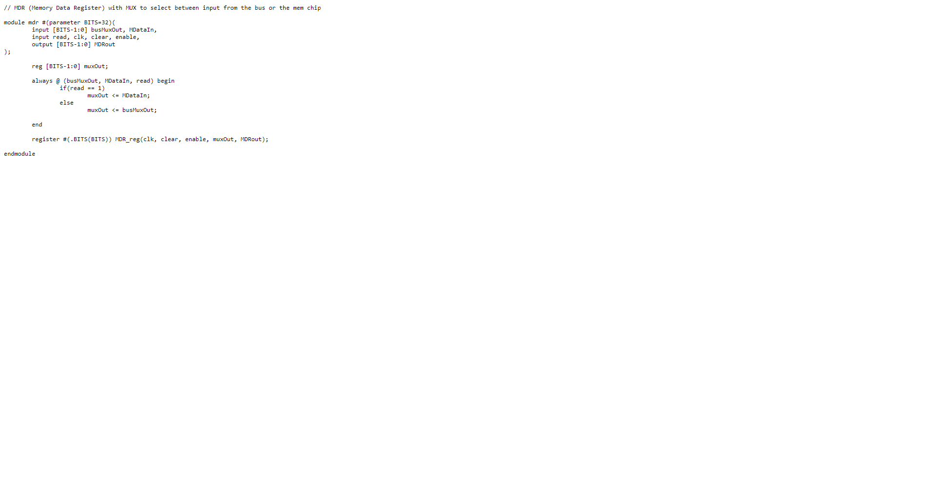

MDR Testbench

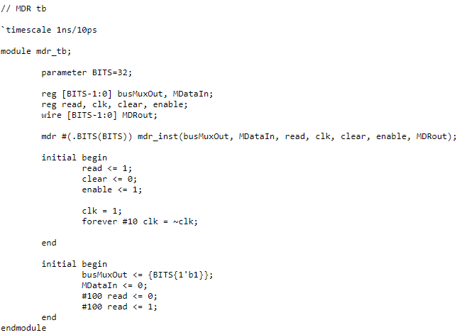

MDR Waveform

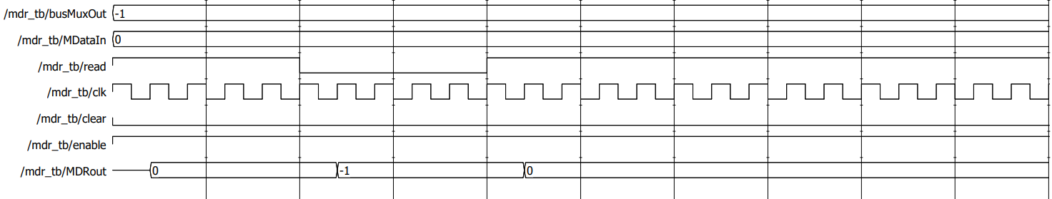

CON_FF

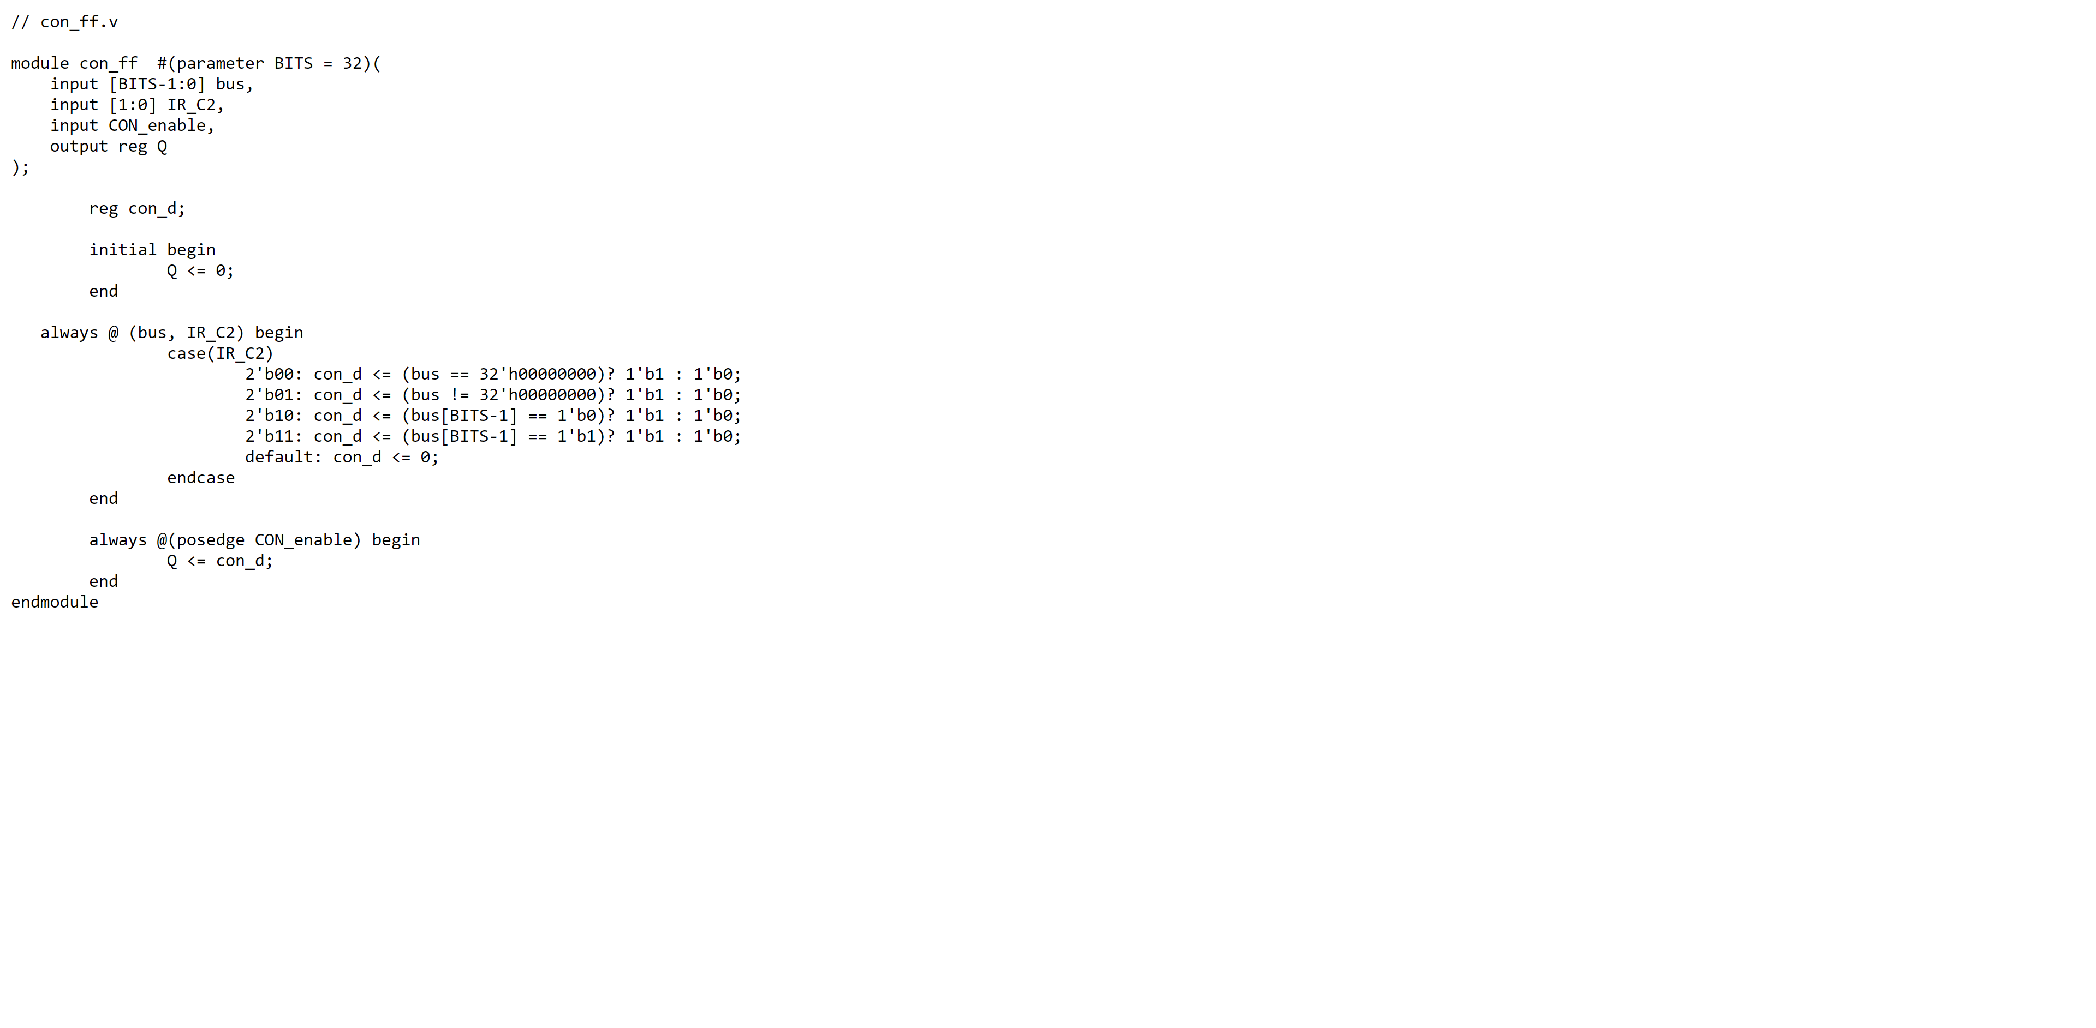

RAM

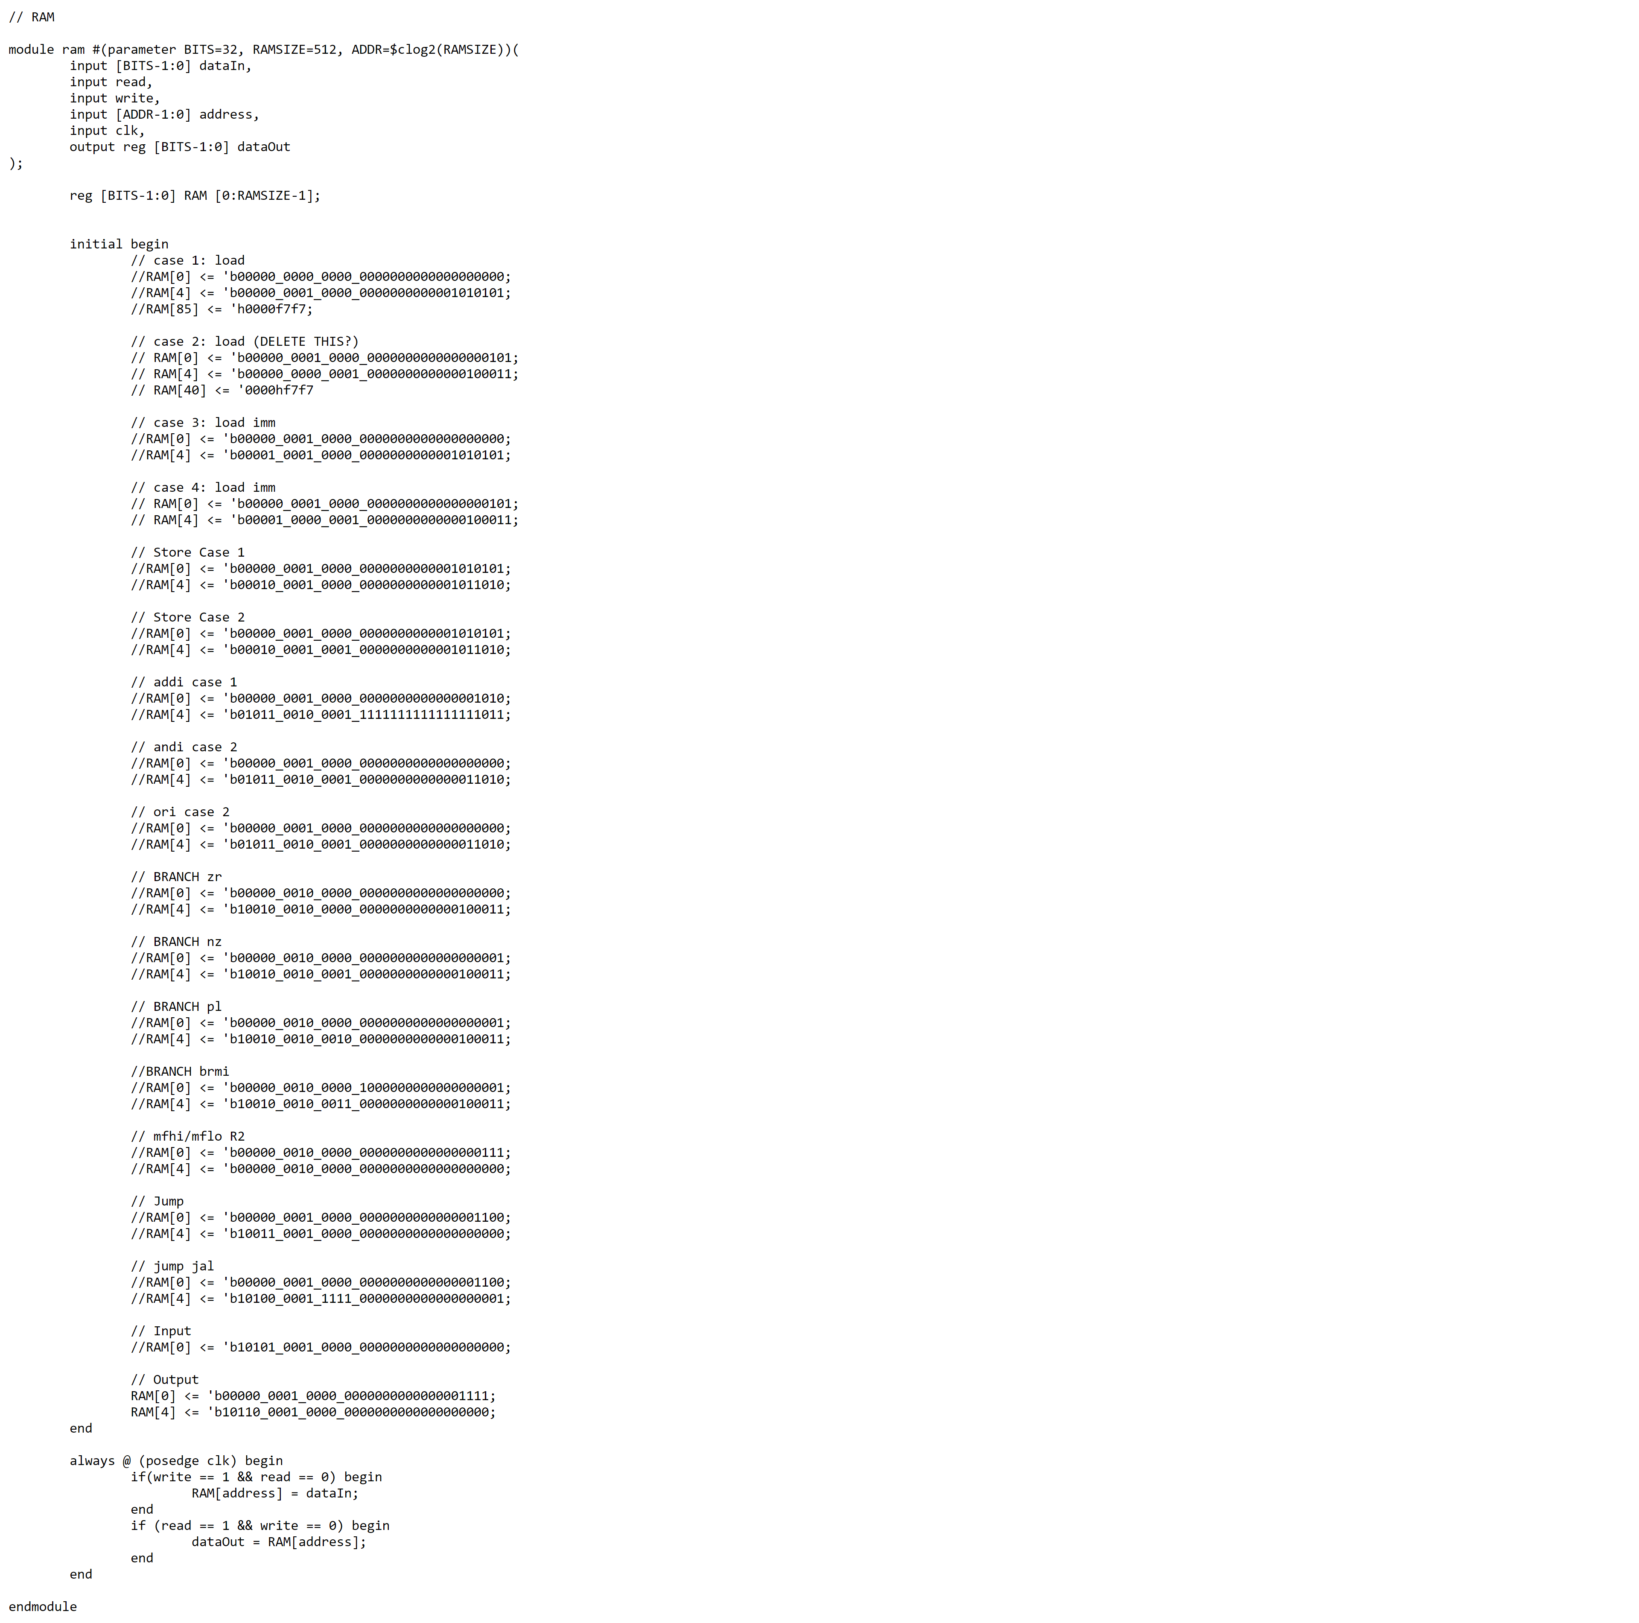

RAM Testbench

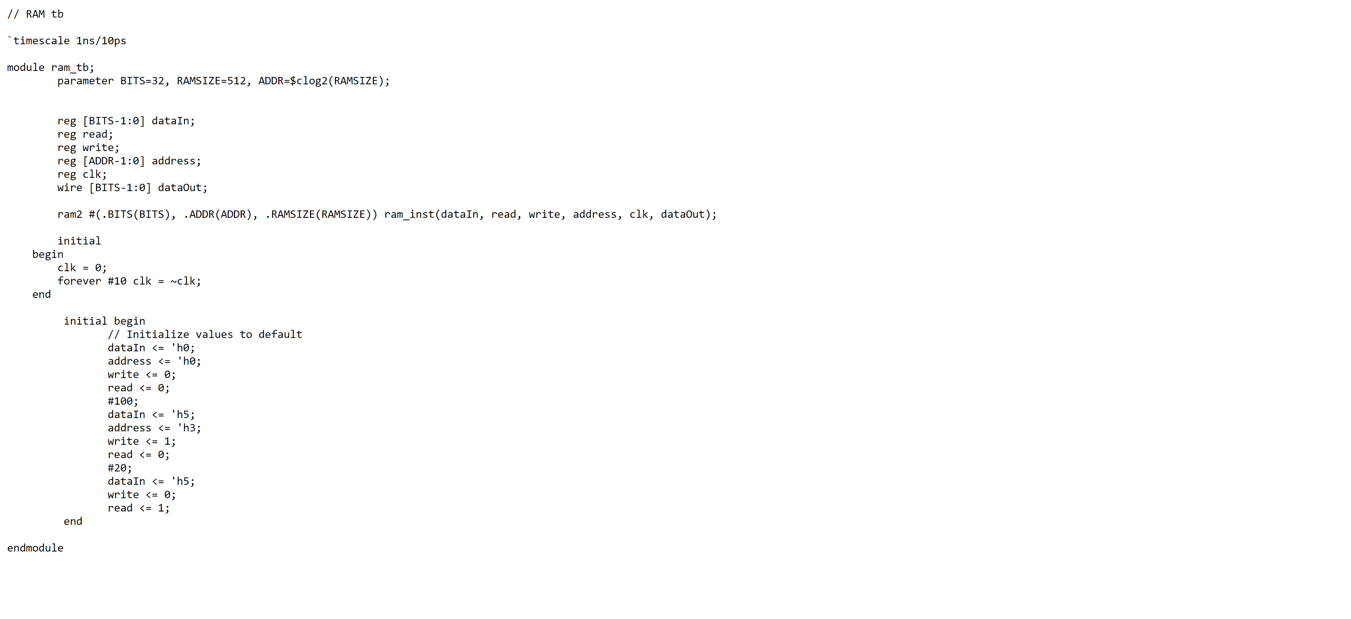

RAM Waveform

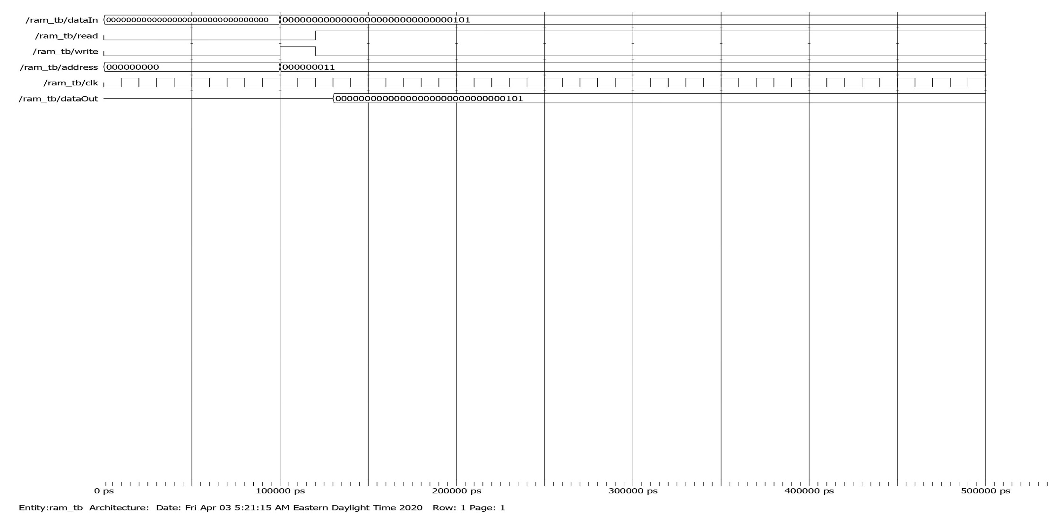

Select and Encode

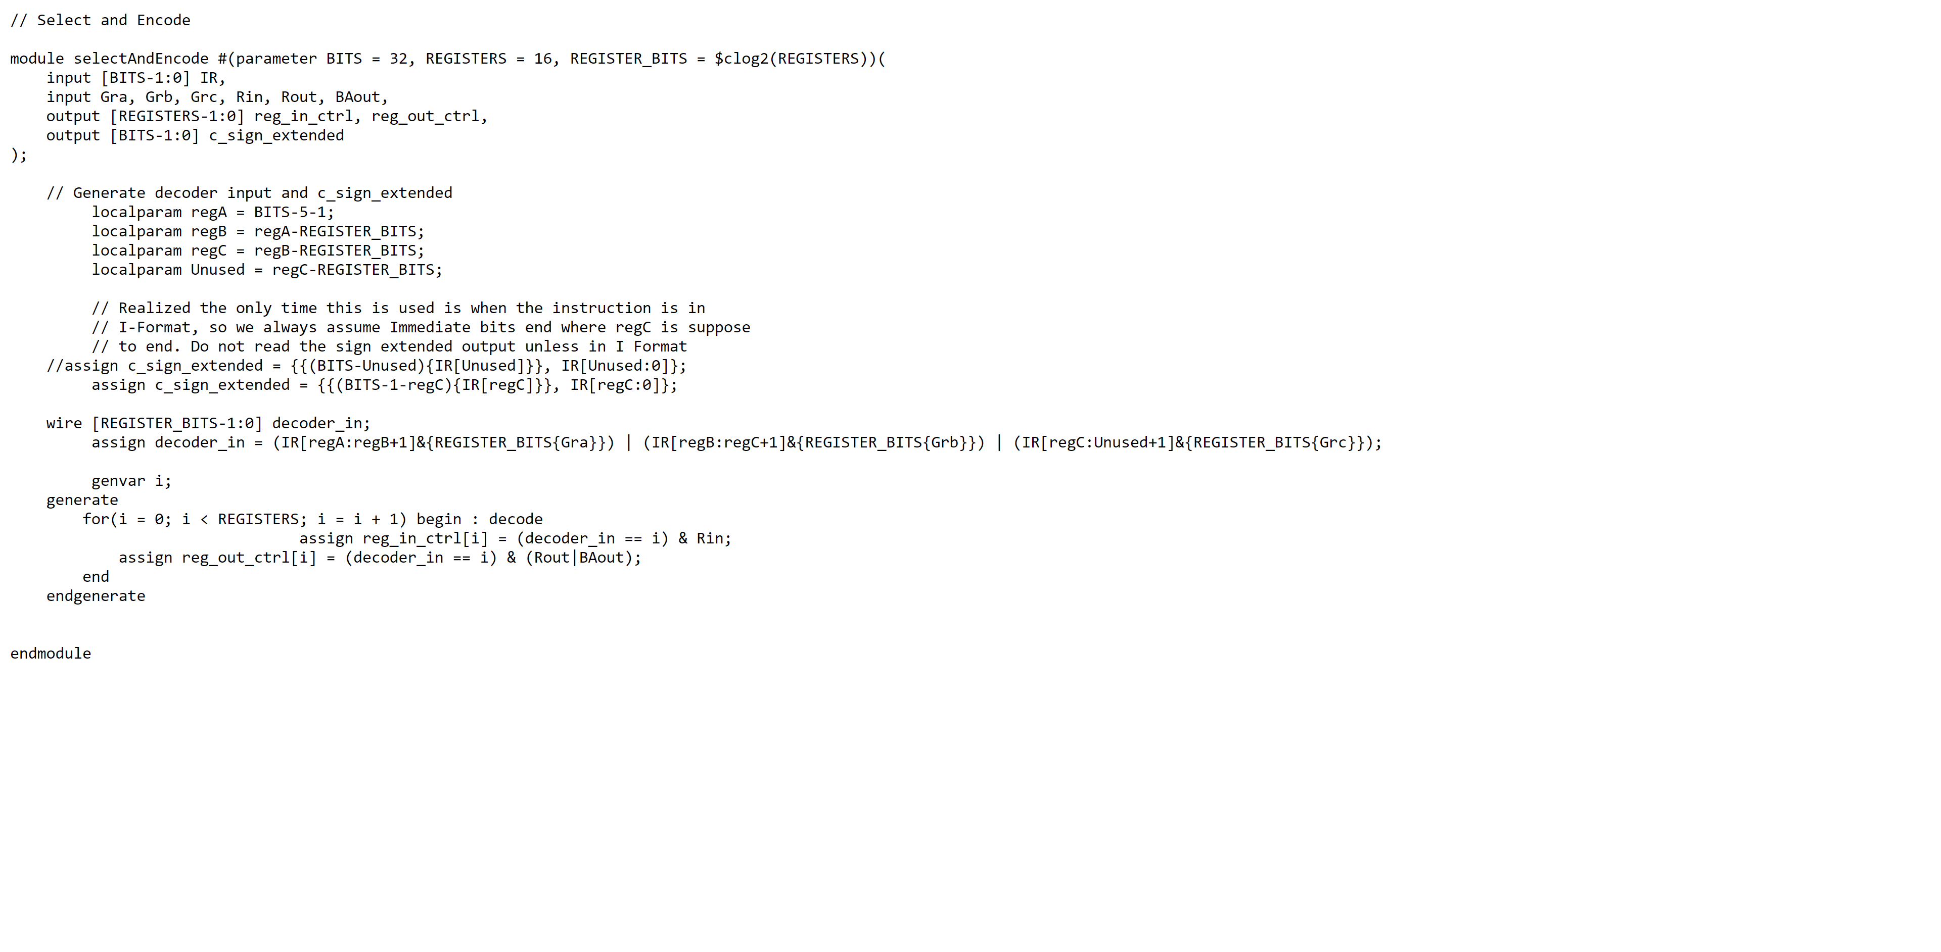

Select and Encode Testbench

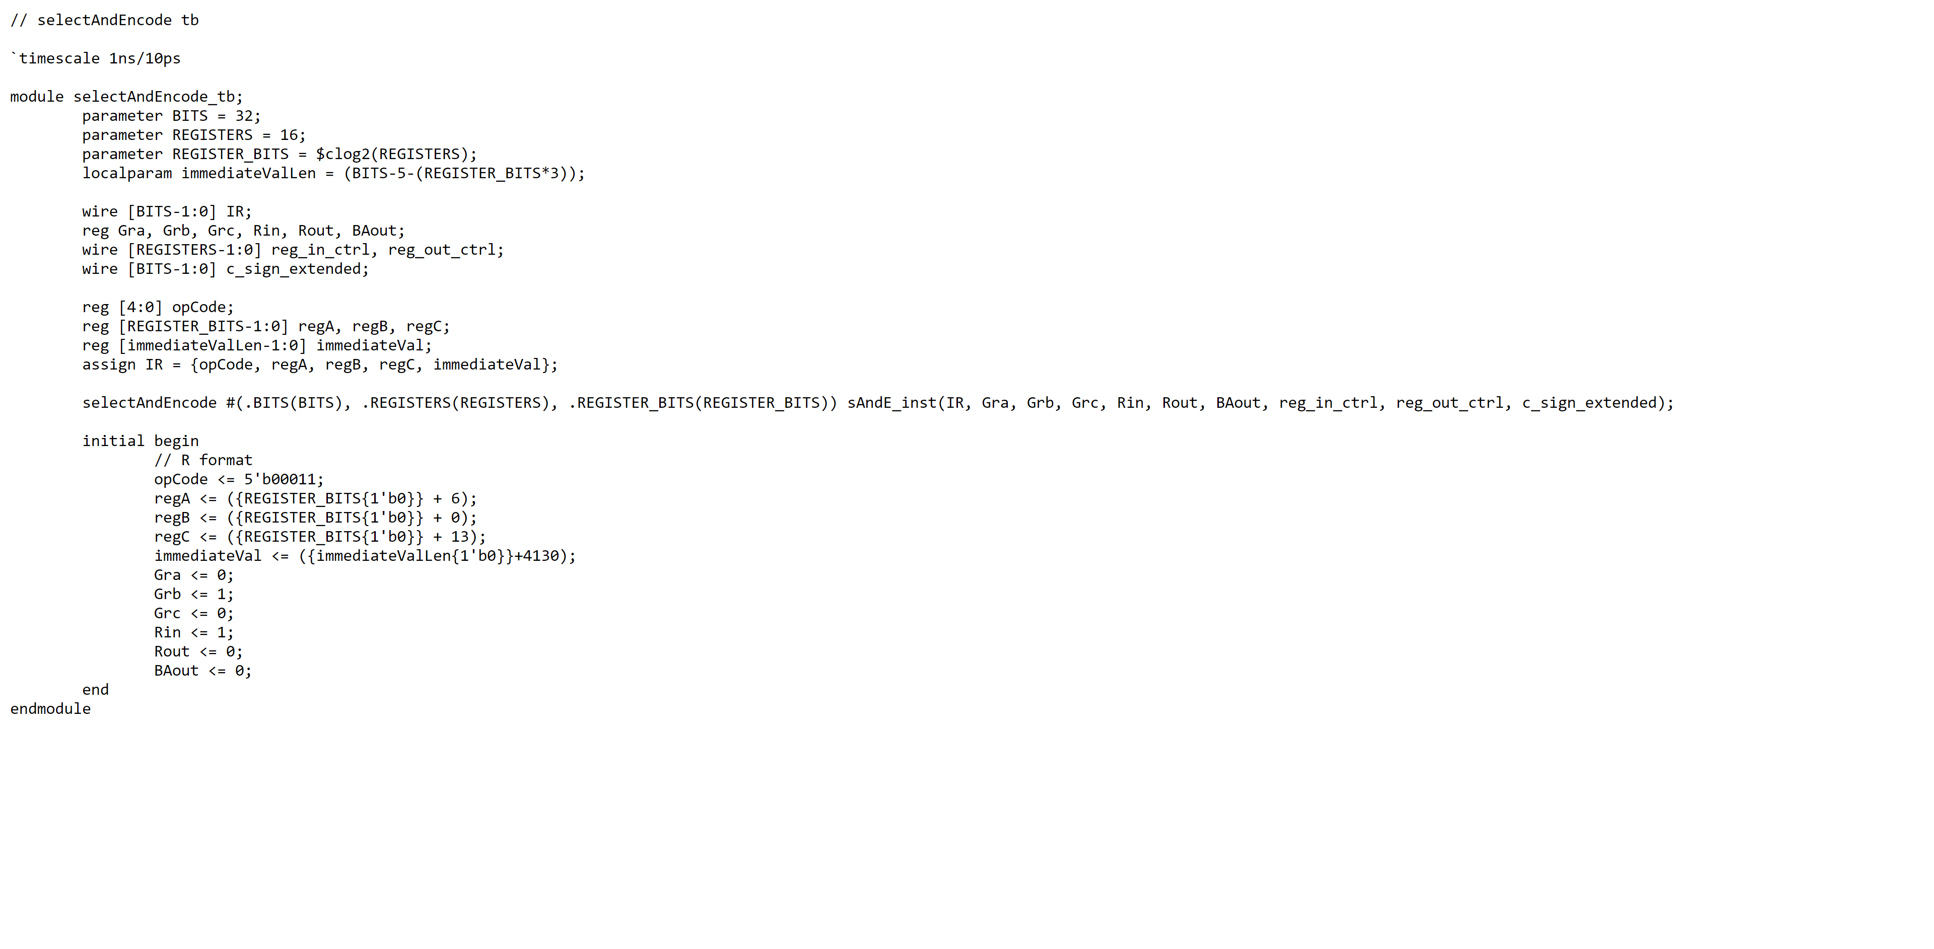

Select and Encode Waveform

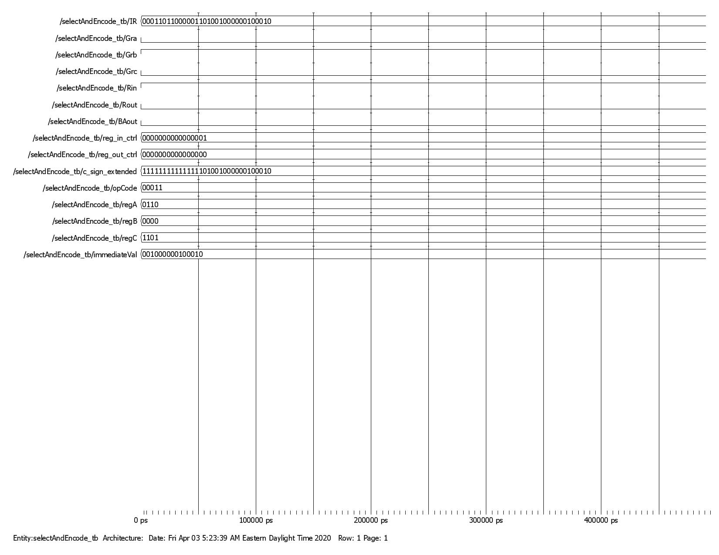

LD Testbench

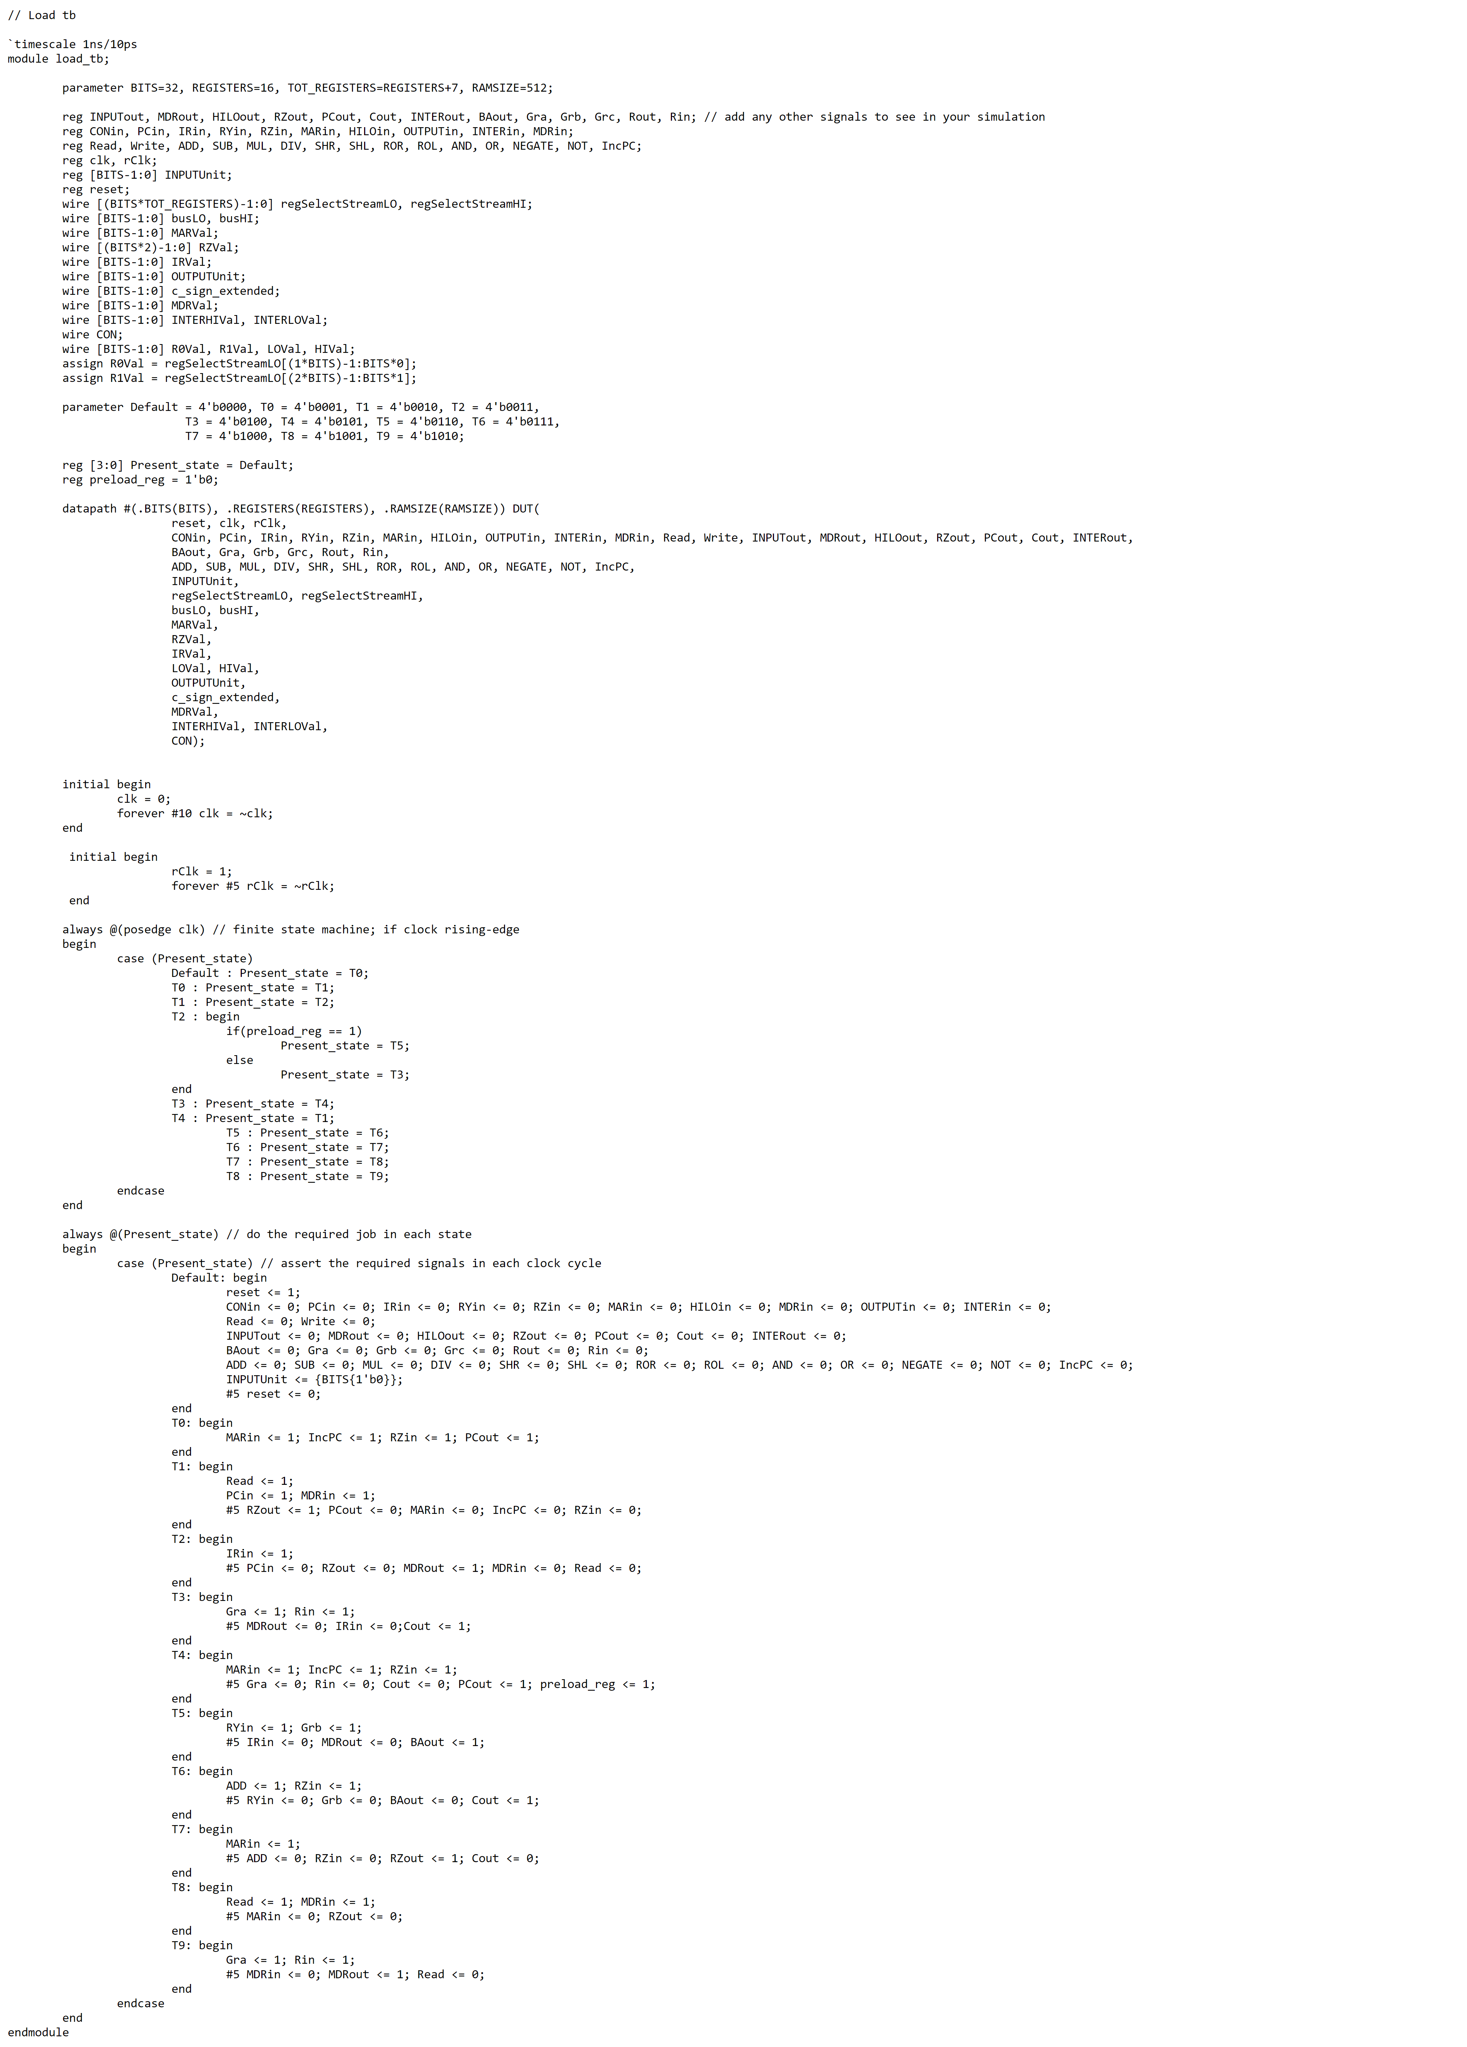

LD Waveform

LD Case 1

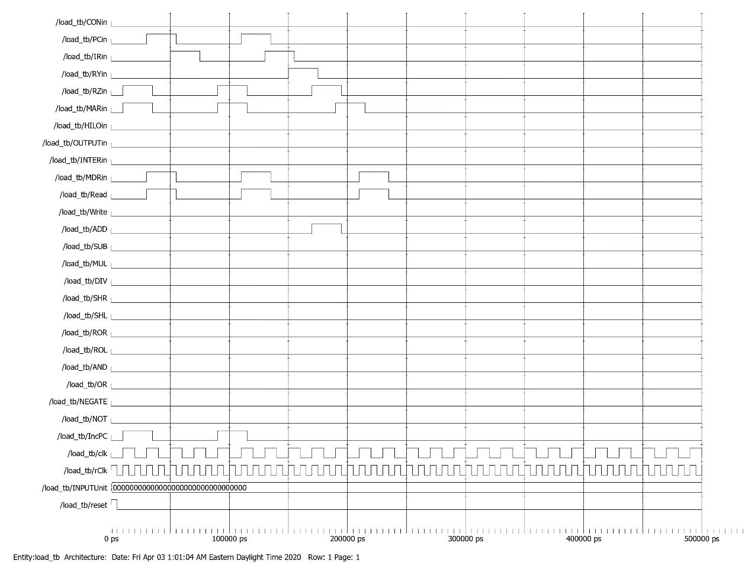

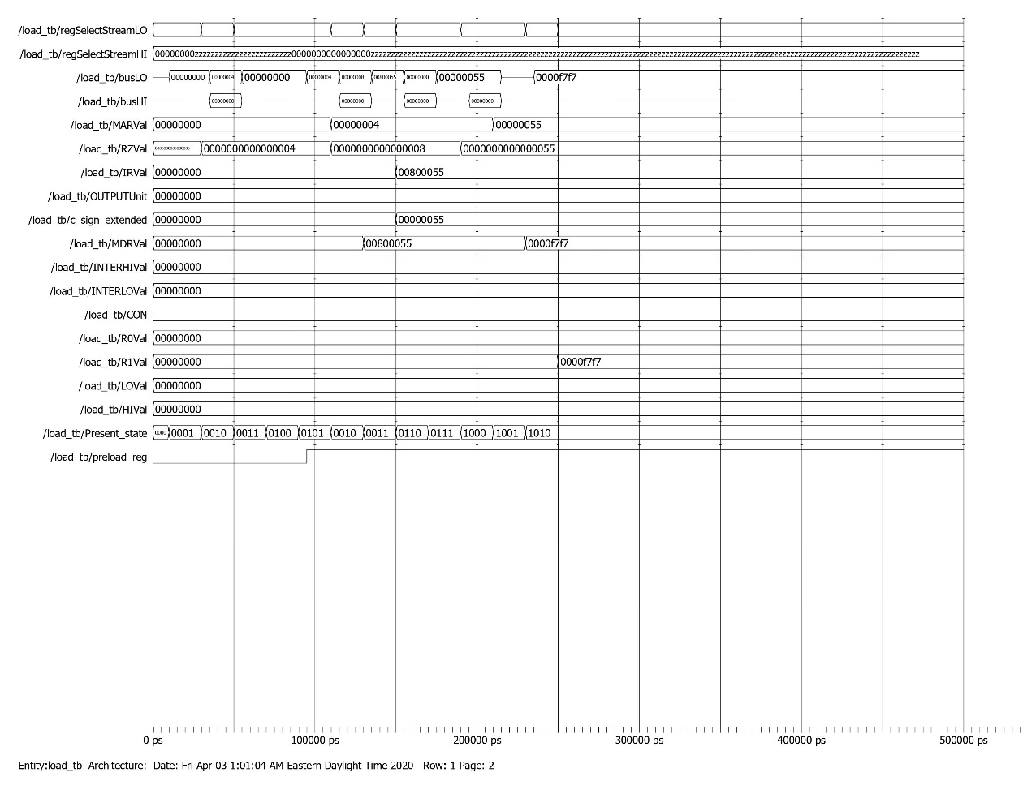

*Memory dump before LD Case 1*

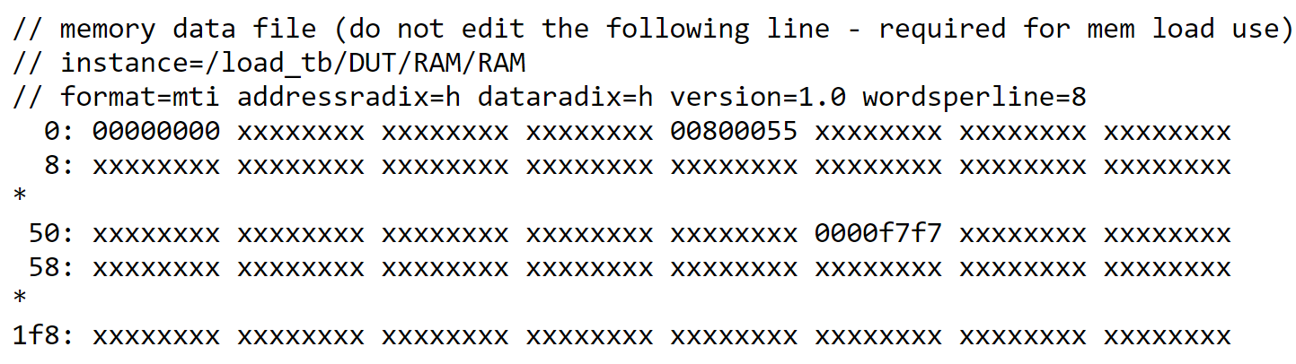

LD Case 2

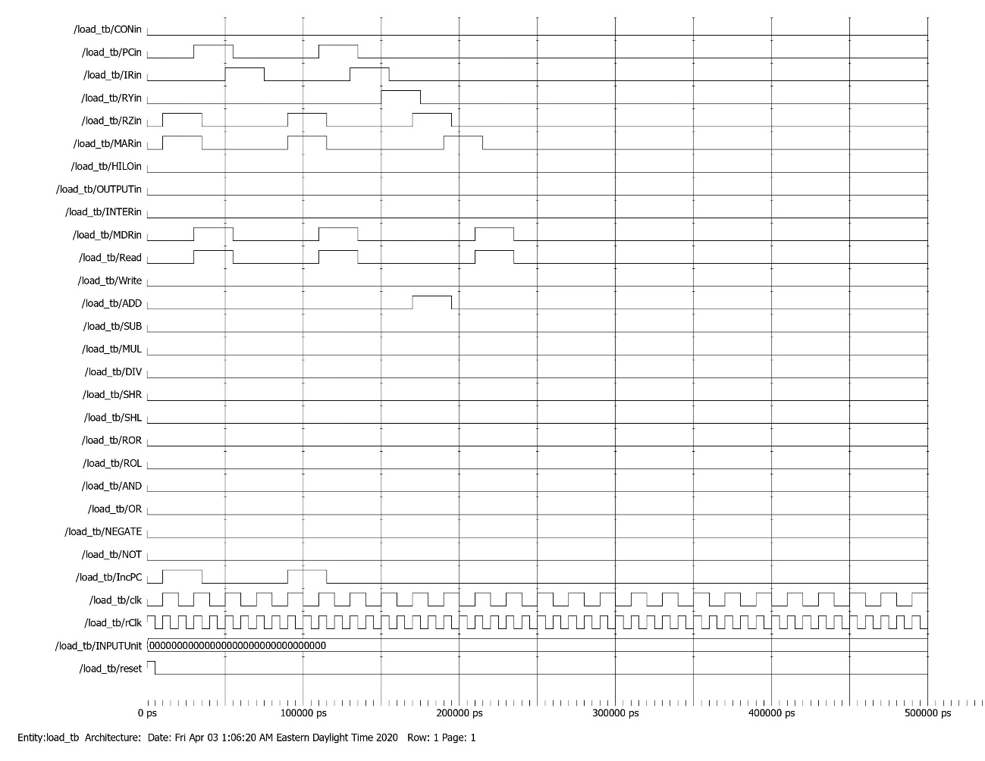

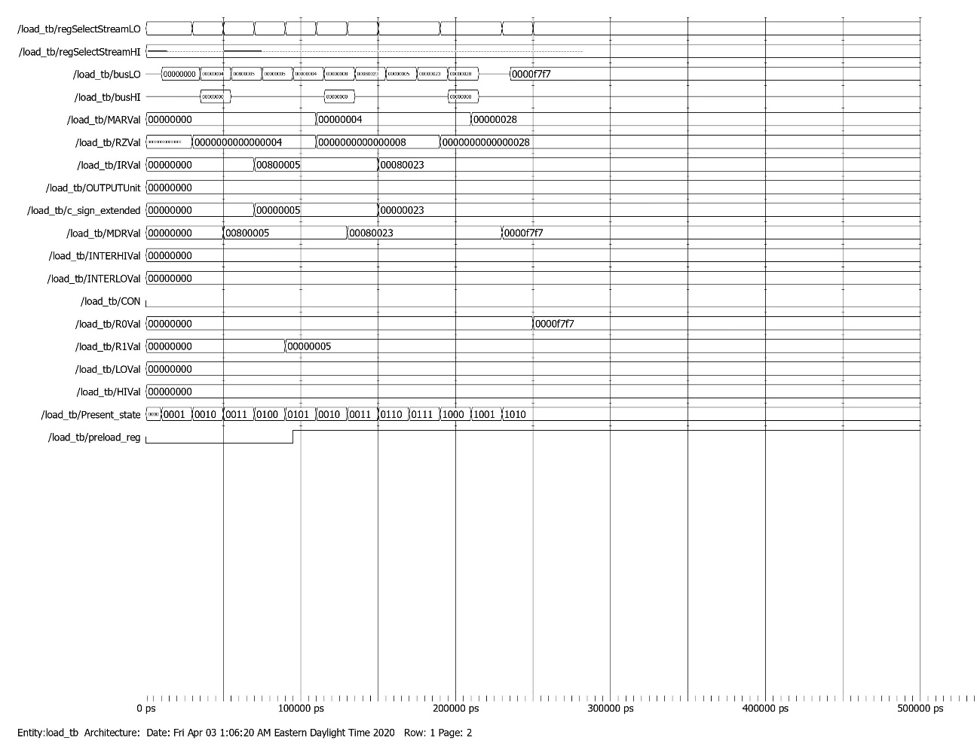

*Memory dump before LD Case 2*

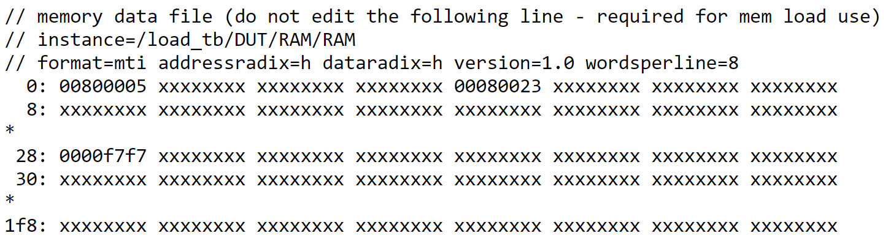

LDI Testbench

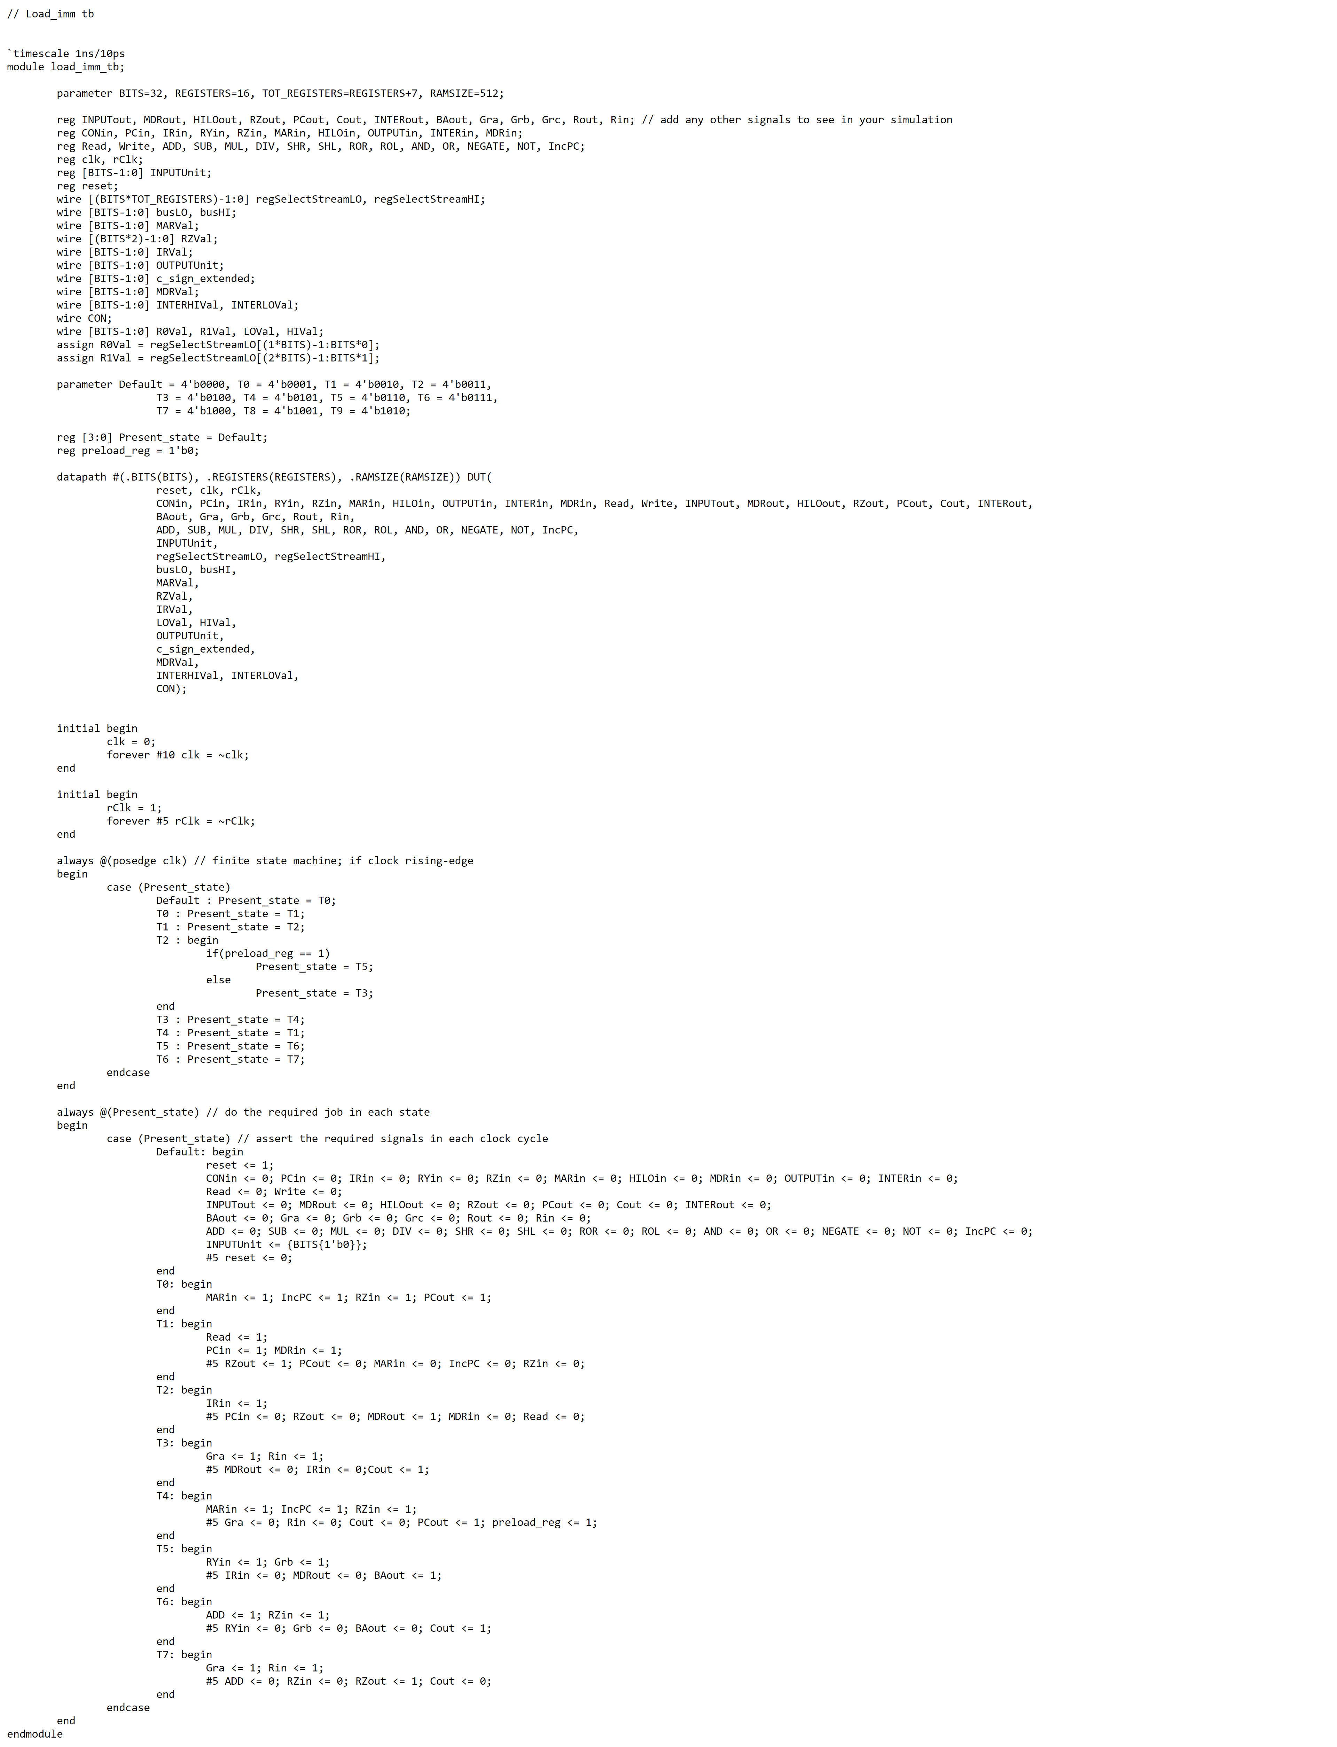

LDI Waveform

LDI Case 1

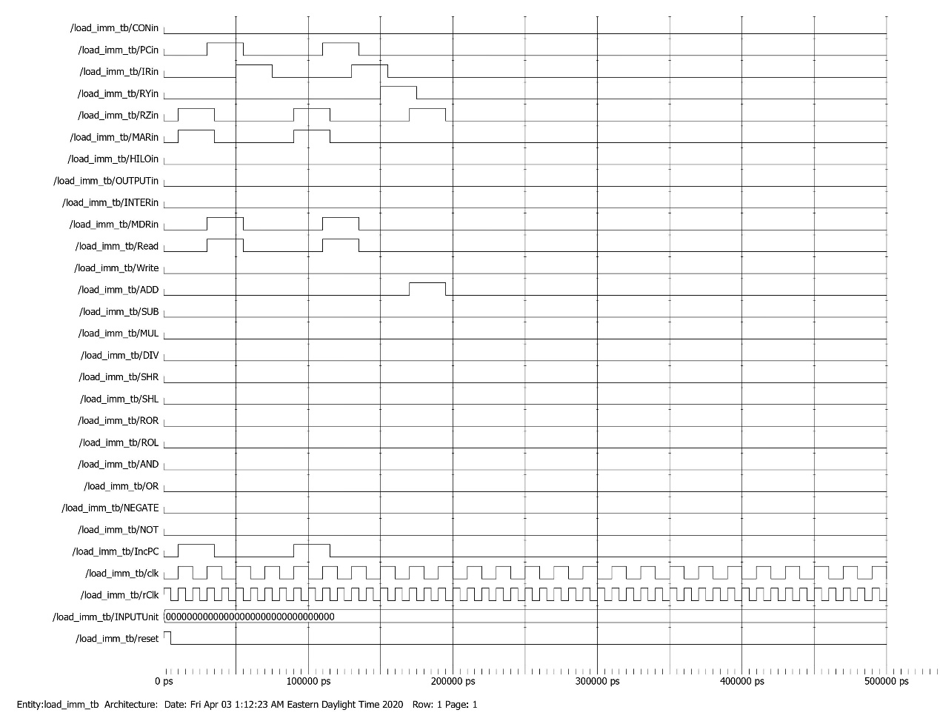

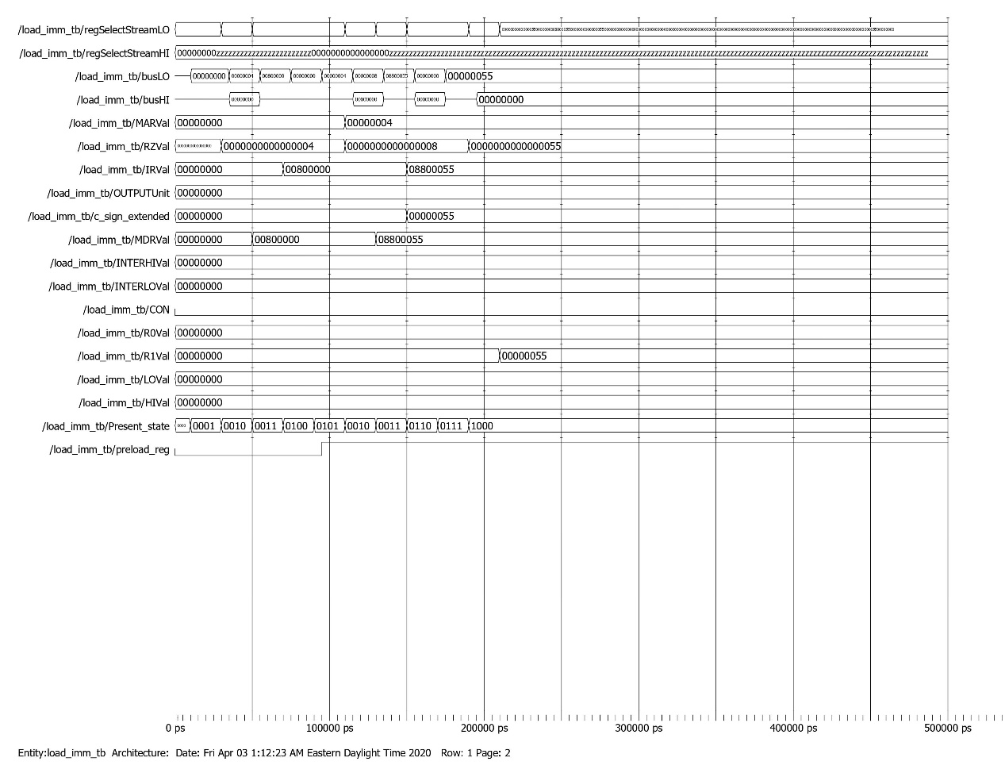

*Memory dump before LDI Case 1*

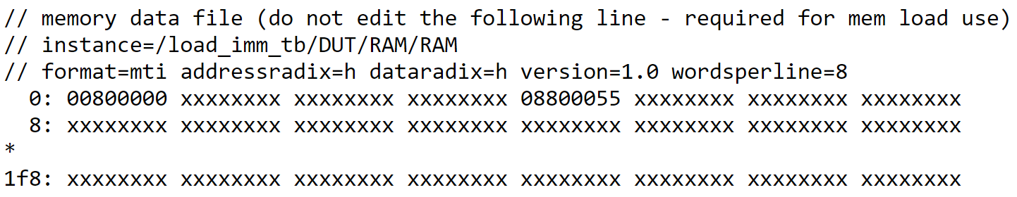

LDI Case 2

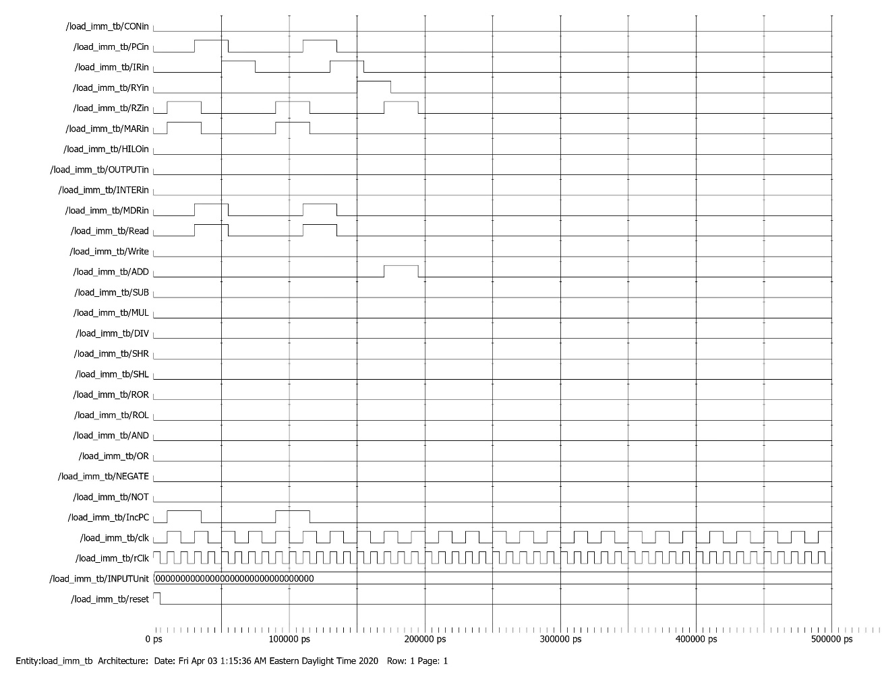

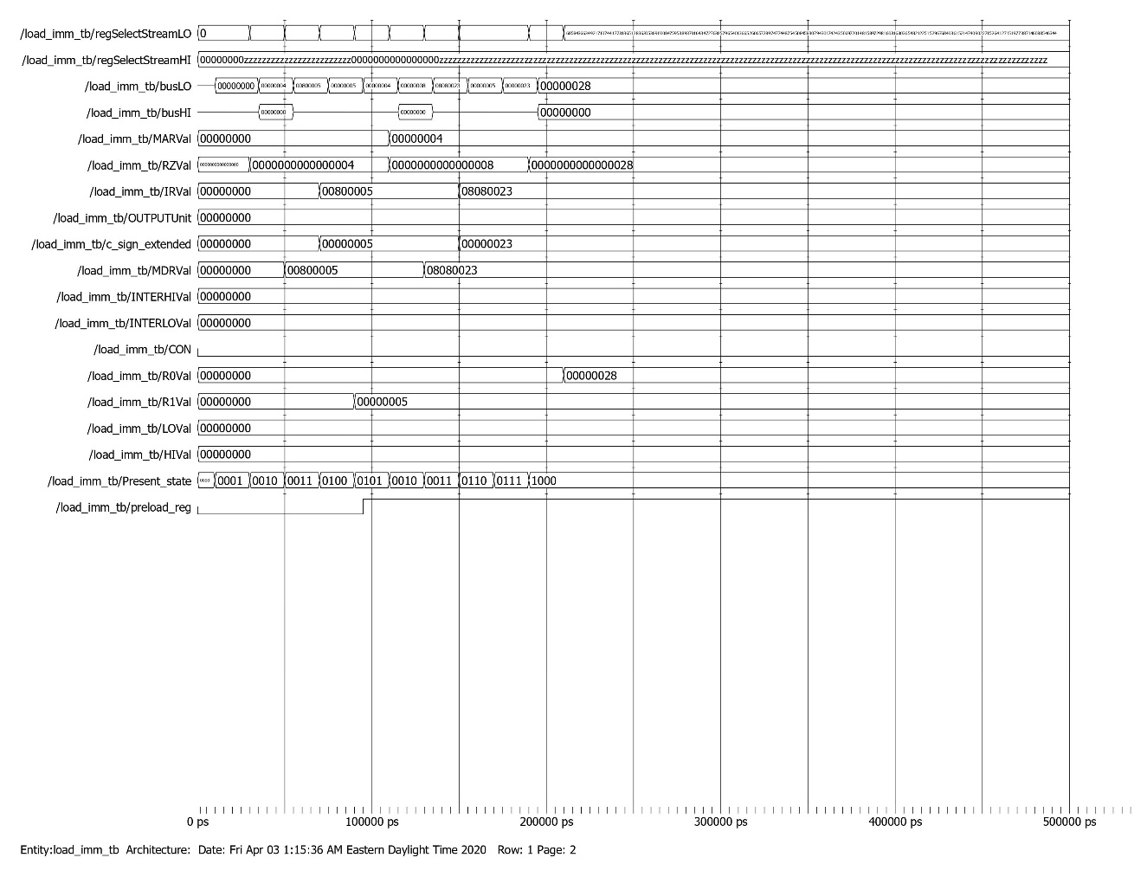

*Memory dump before LD Case 2*

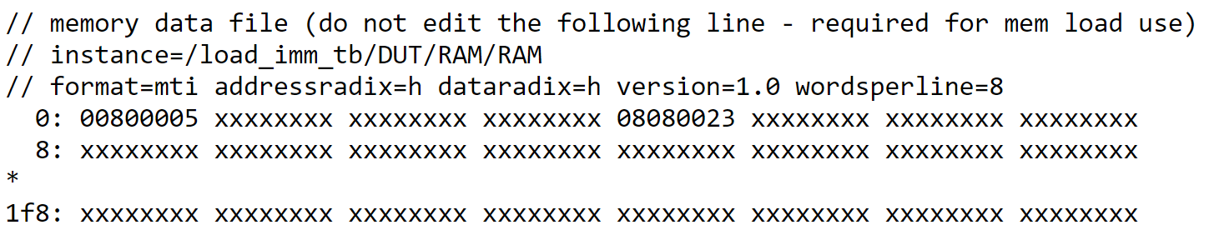

ST Testbench

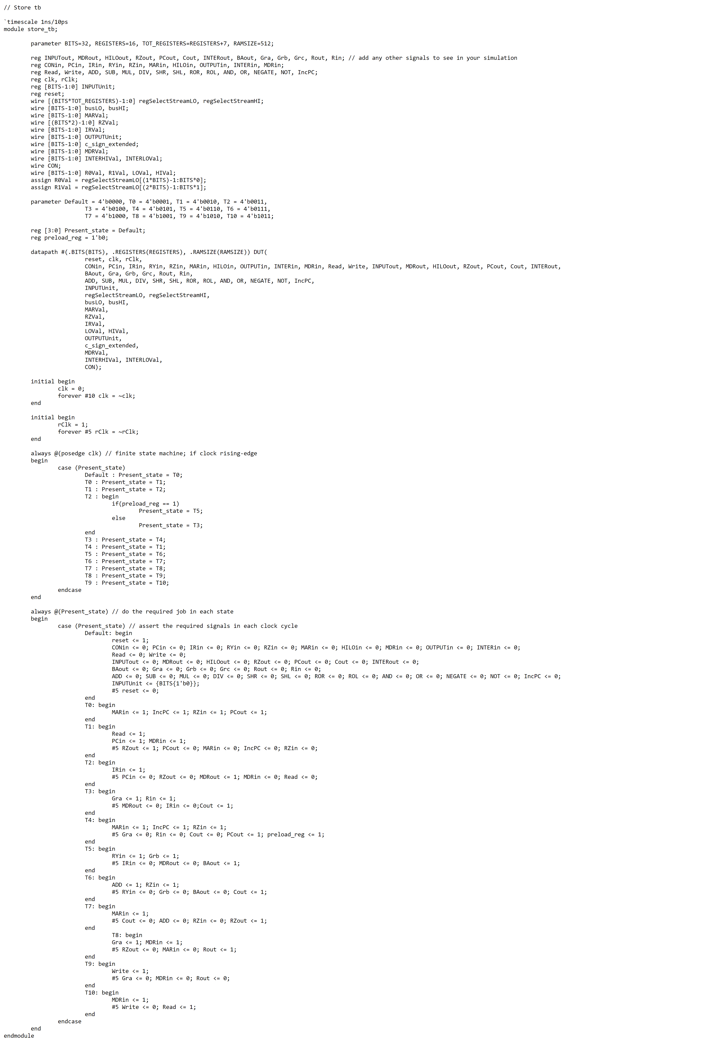

ST Waveform

ST Case 1

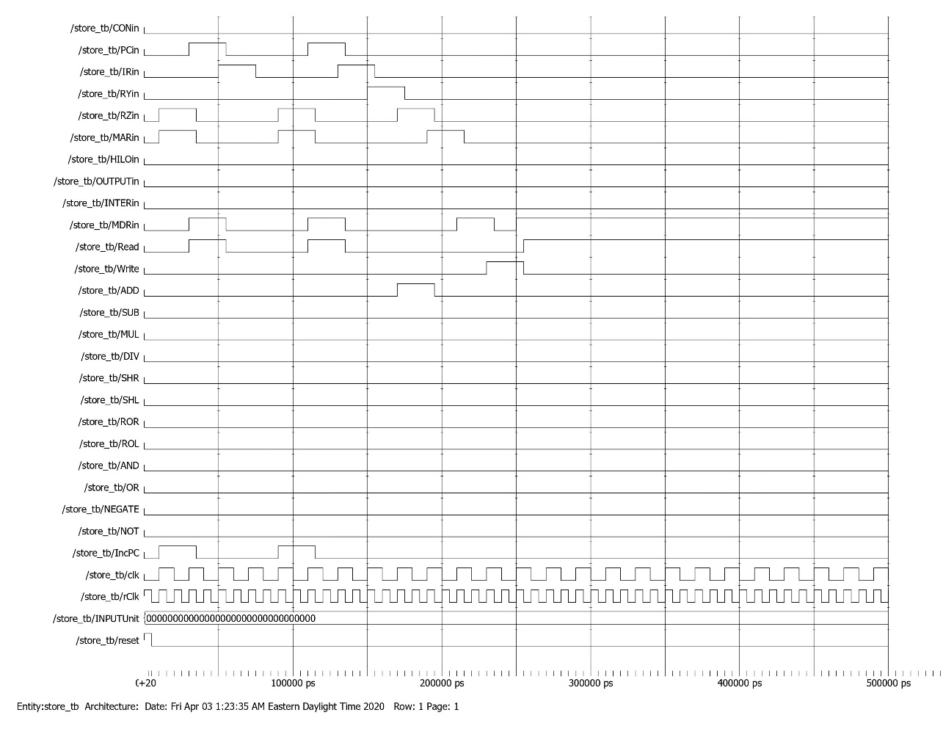

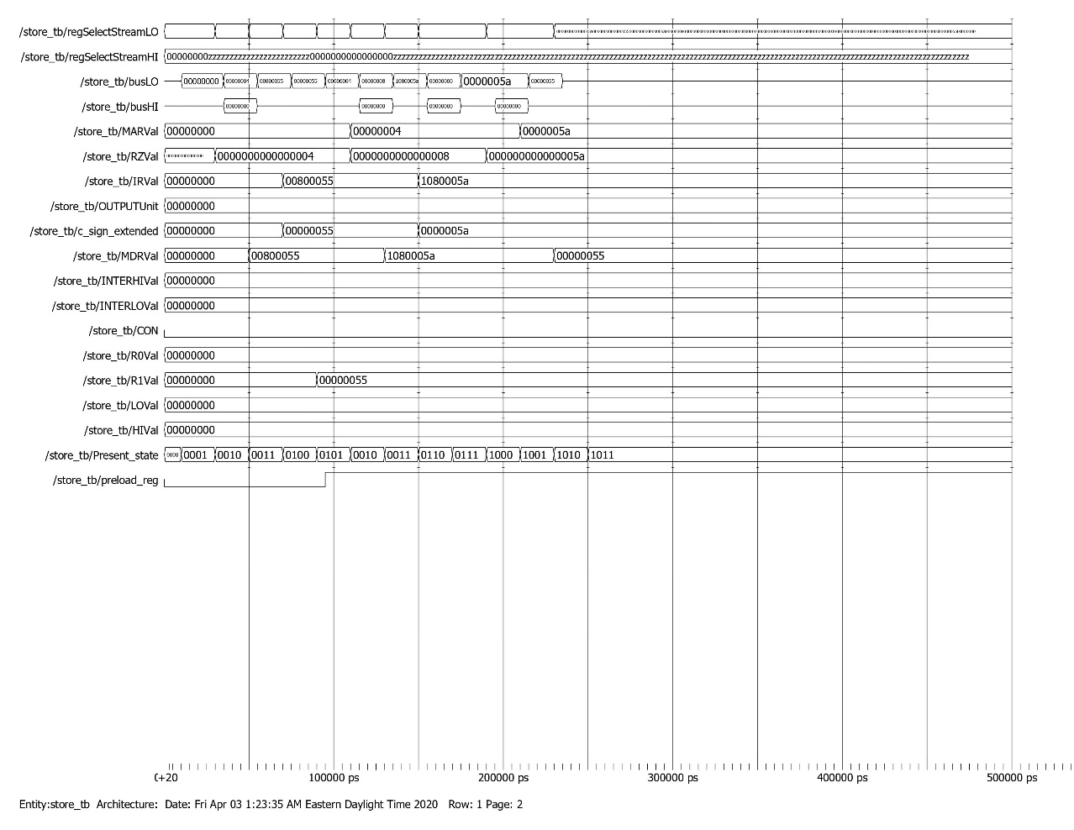

*Memory dump before ST Case 1*

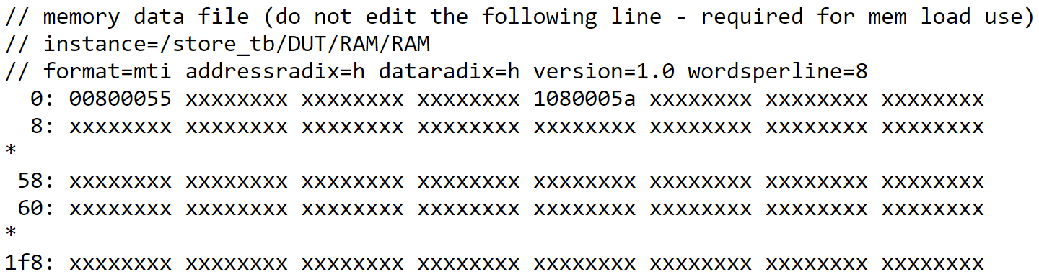

*Memory dump after ST Case 1*

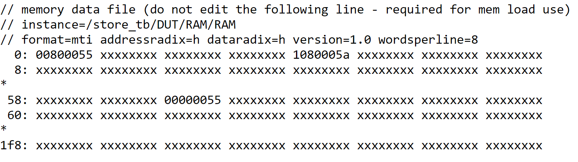

ST Case 2

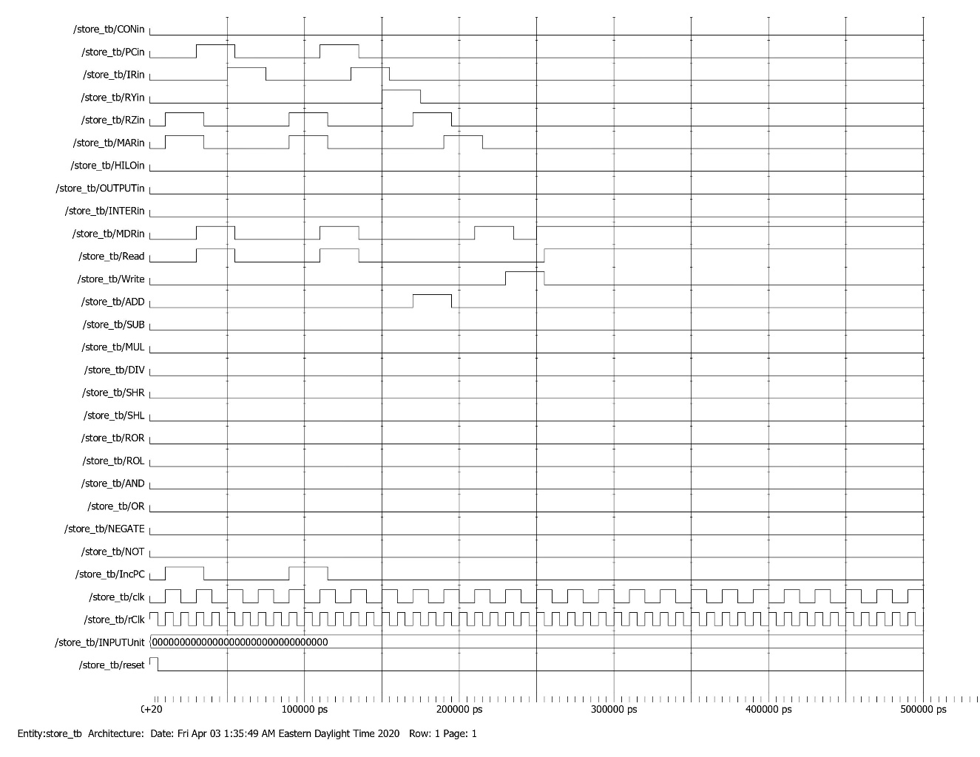

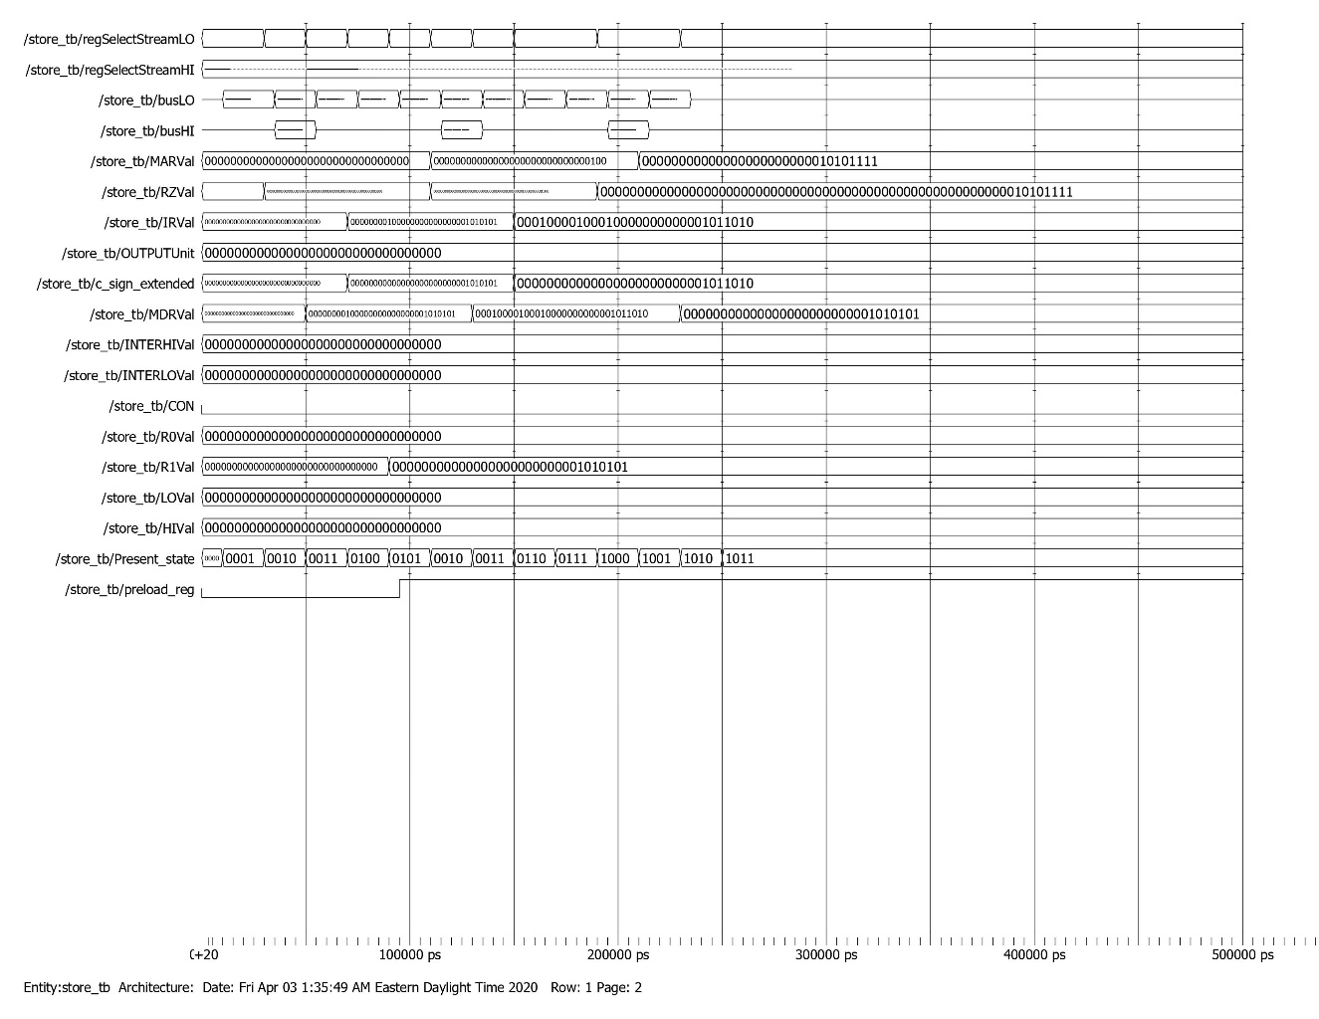

*Memory dump before ST Case 2*



*Memory dump after ST Case 2*

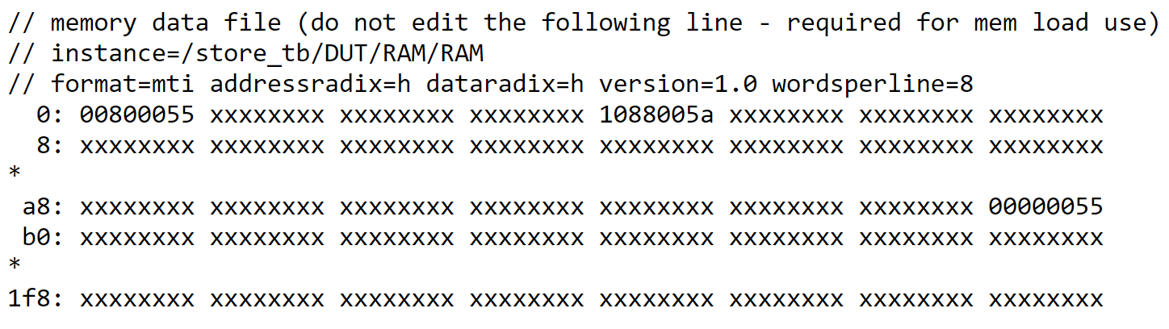

ADDI Testbench

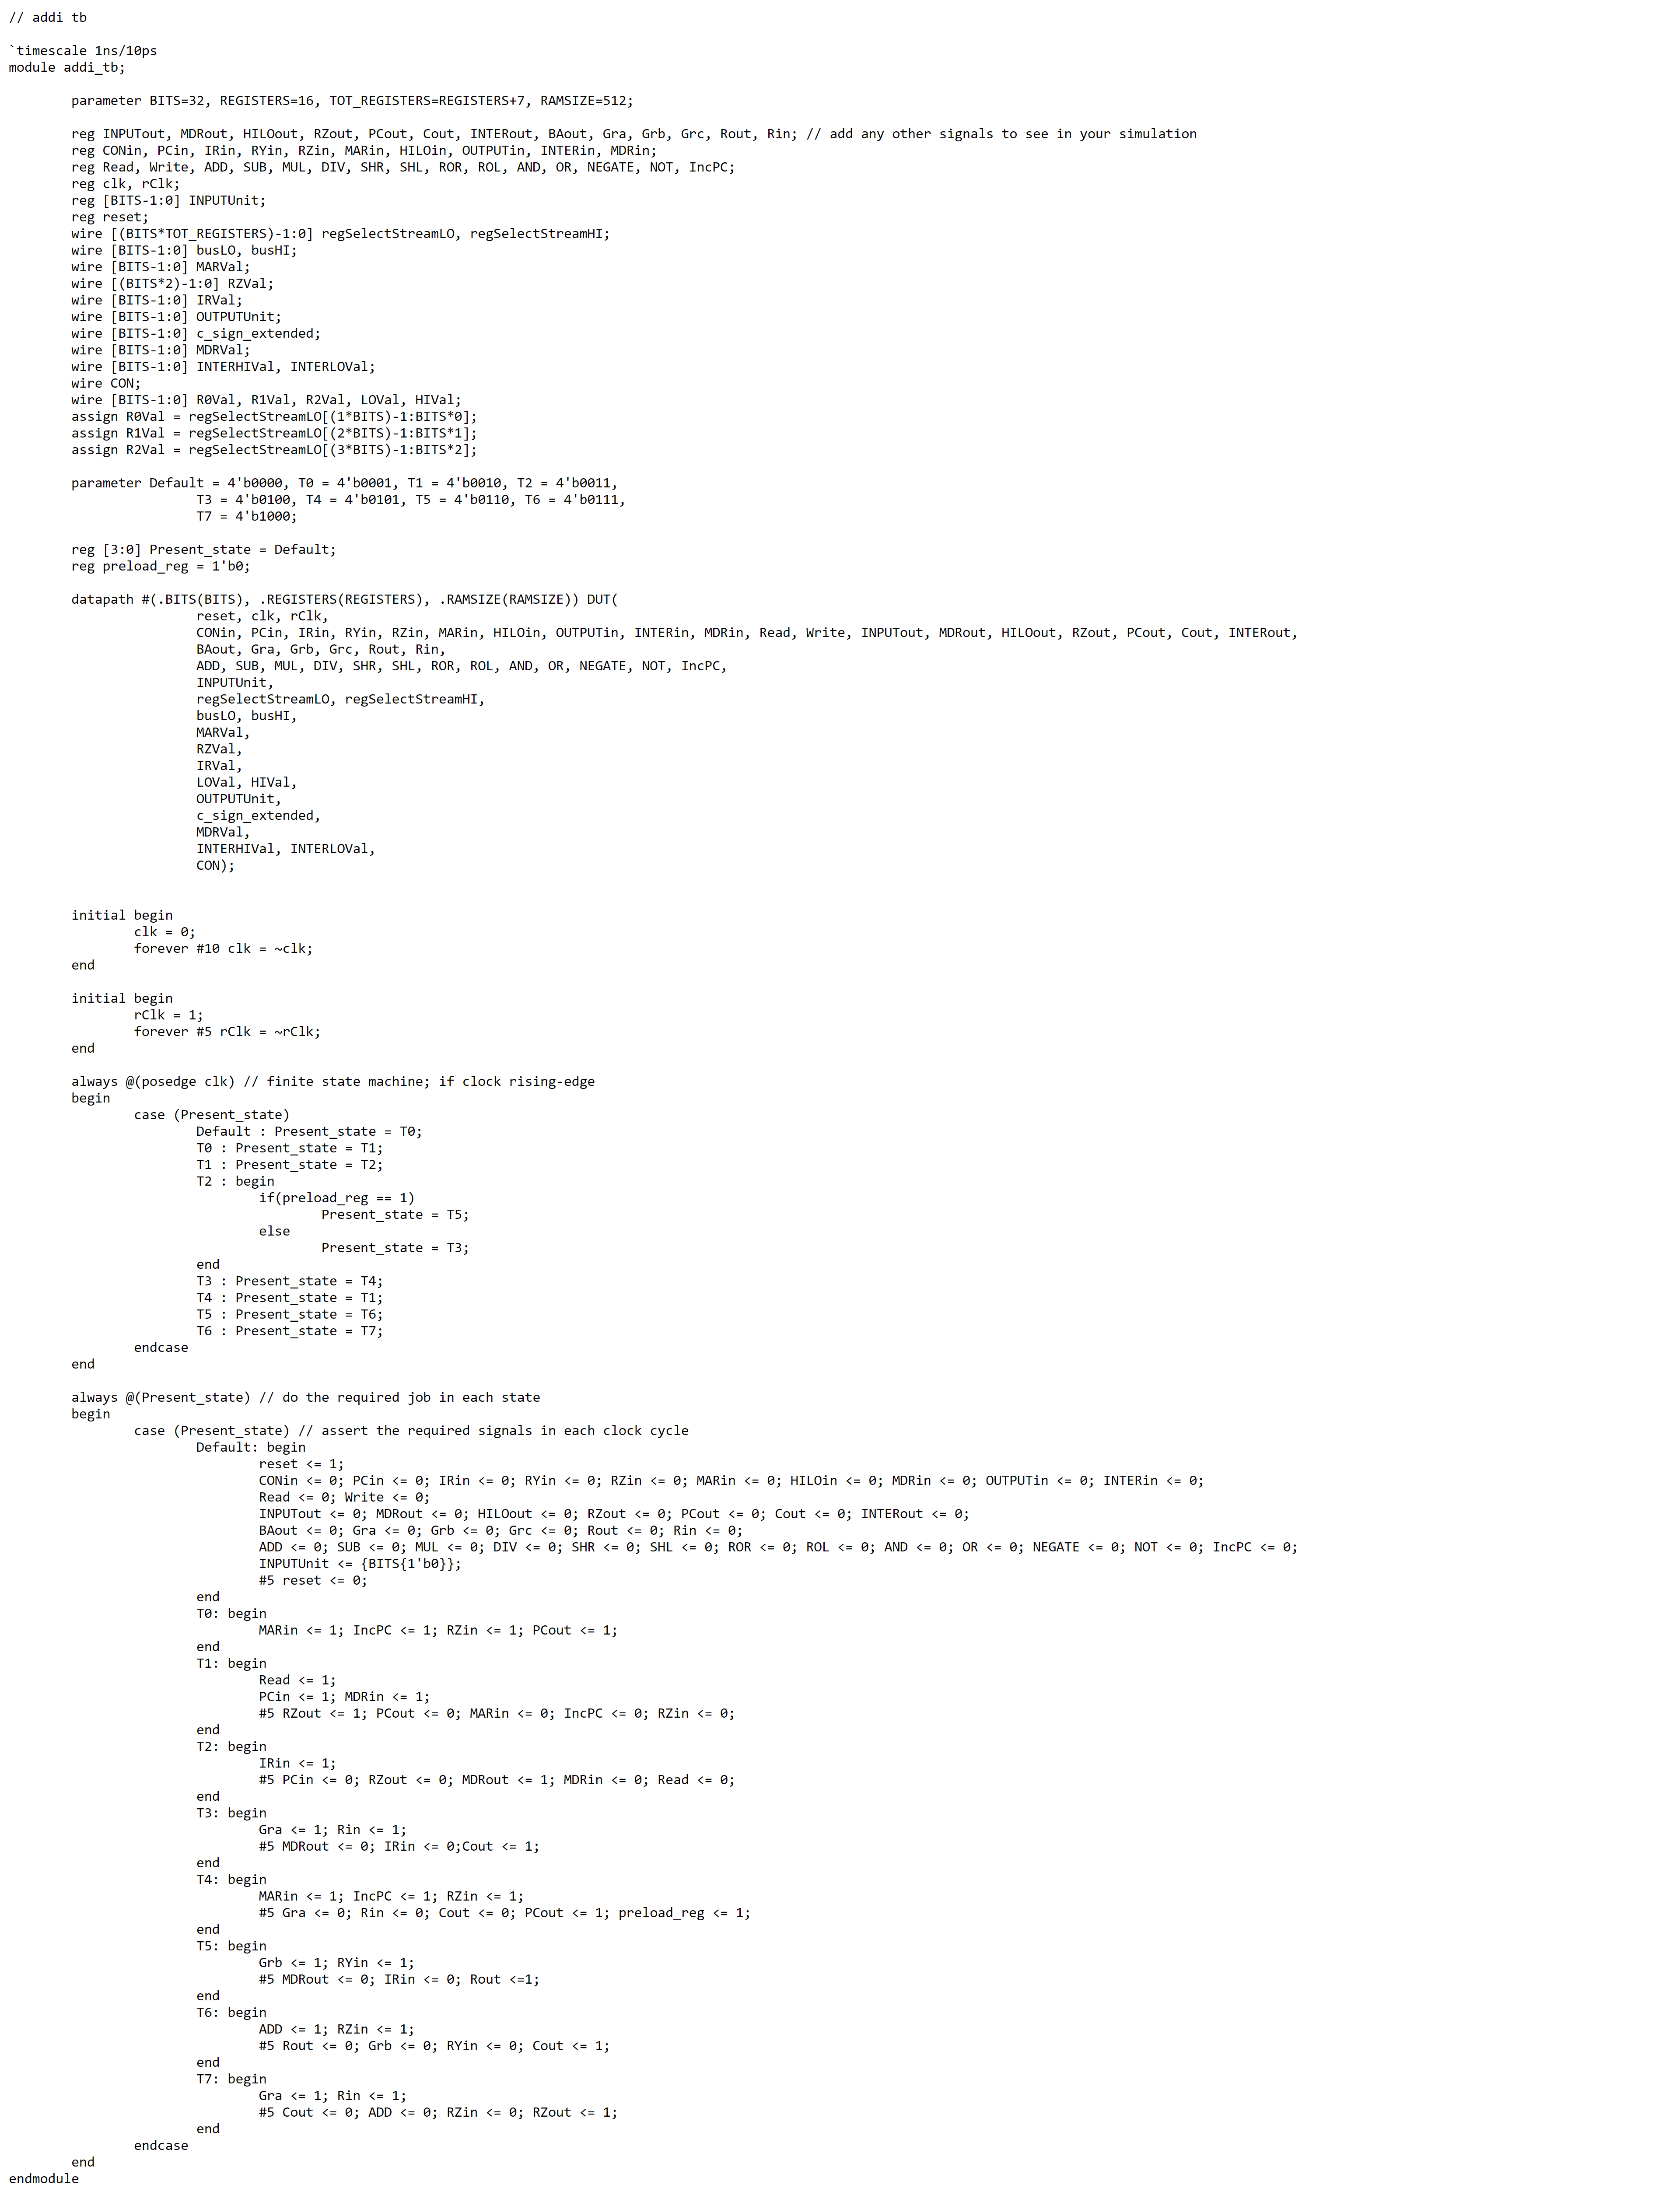

ADDI Waveform

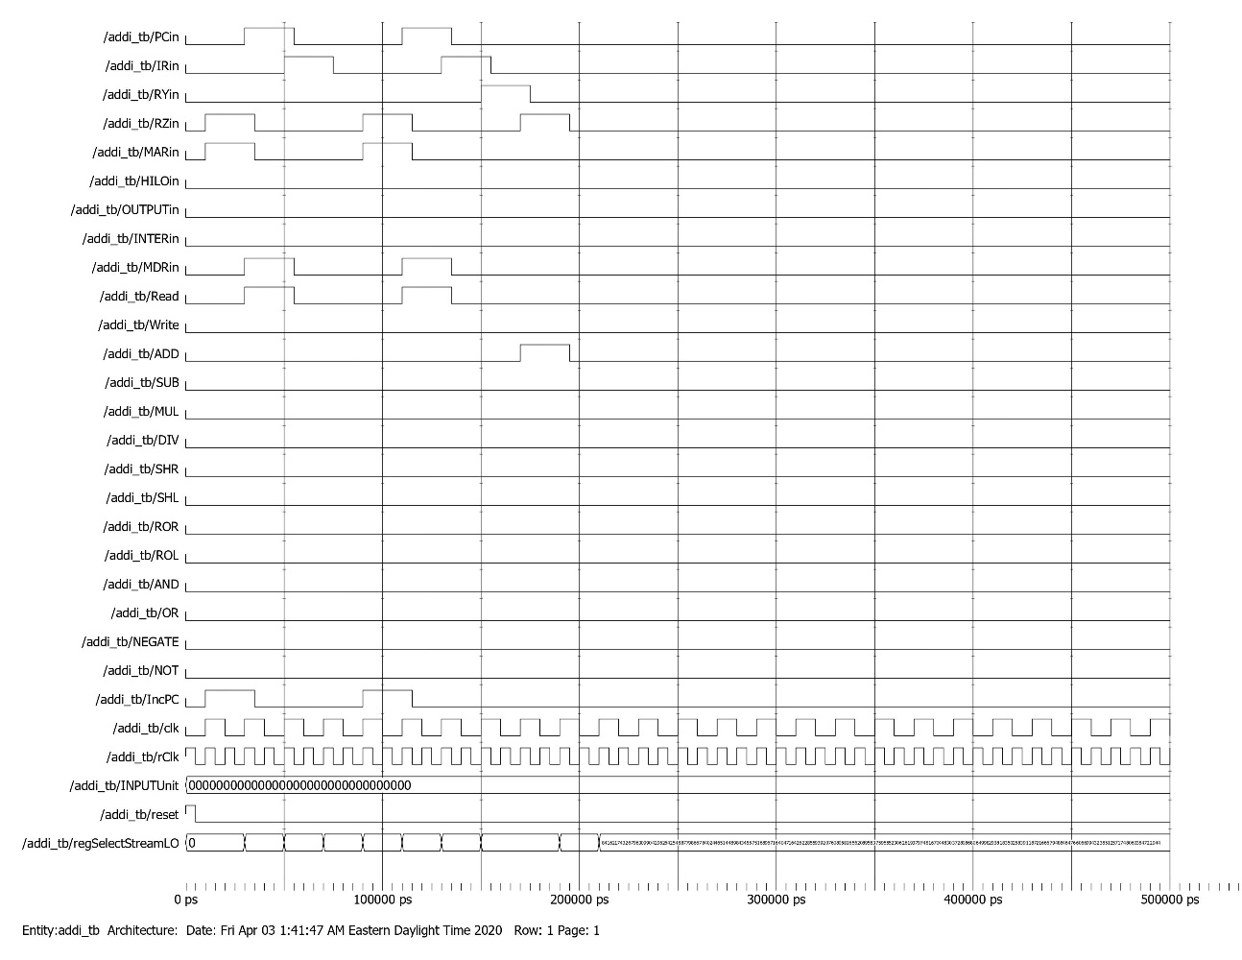

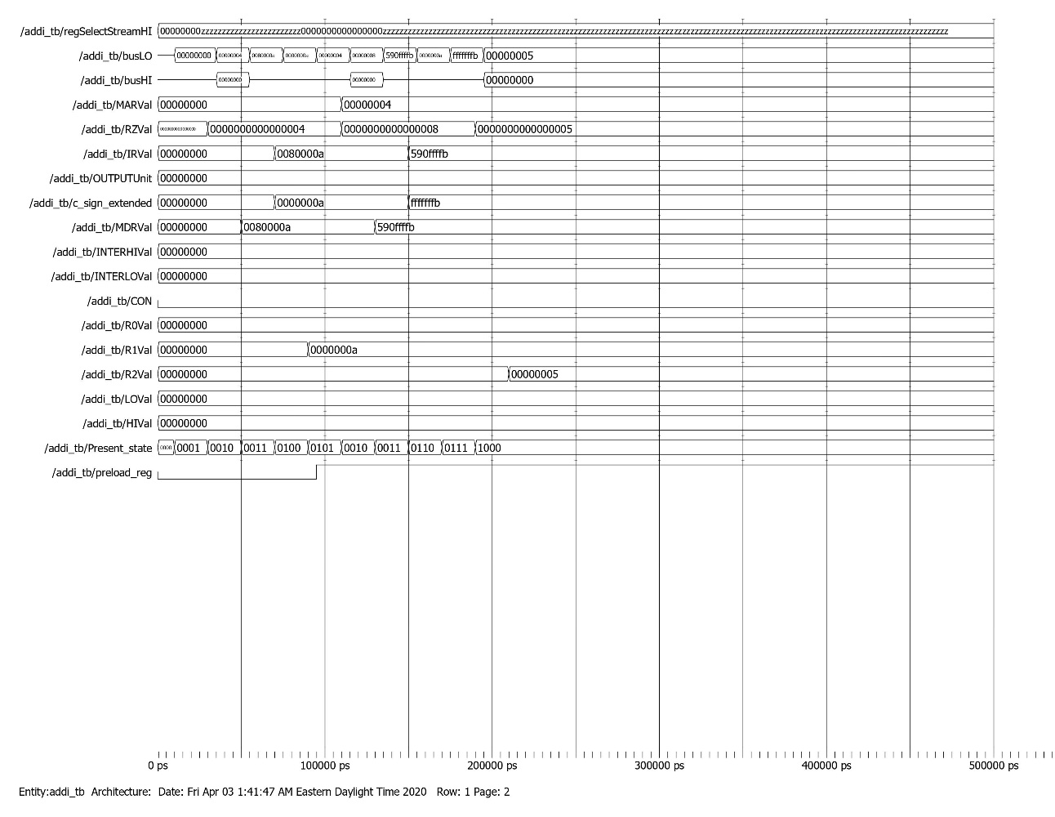

ANDI Testbench

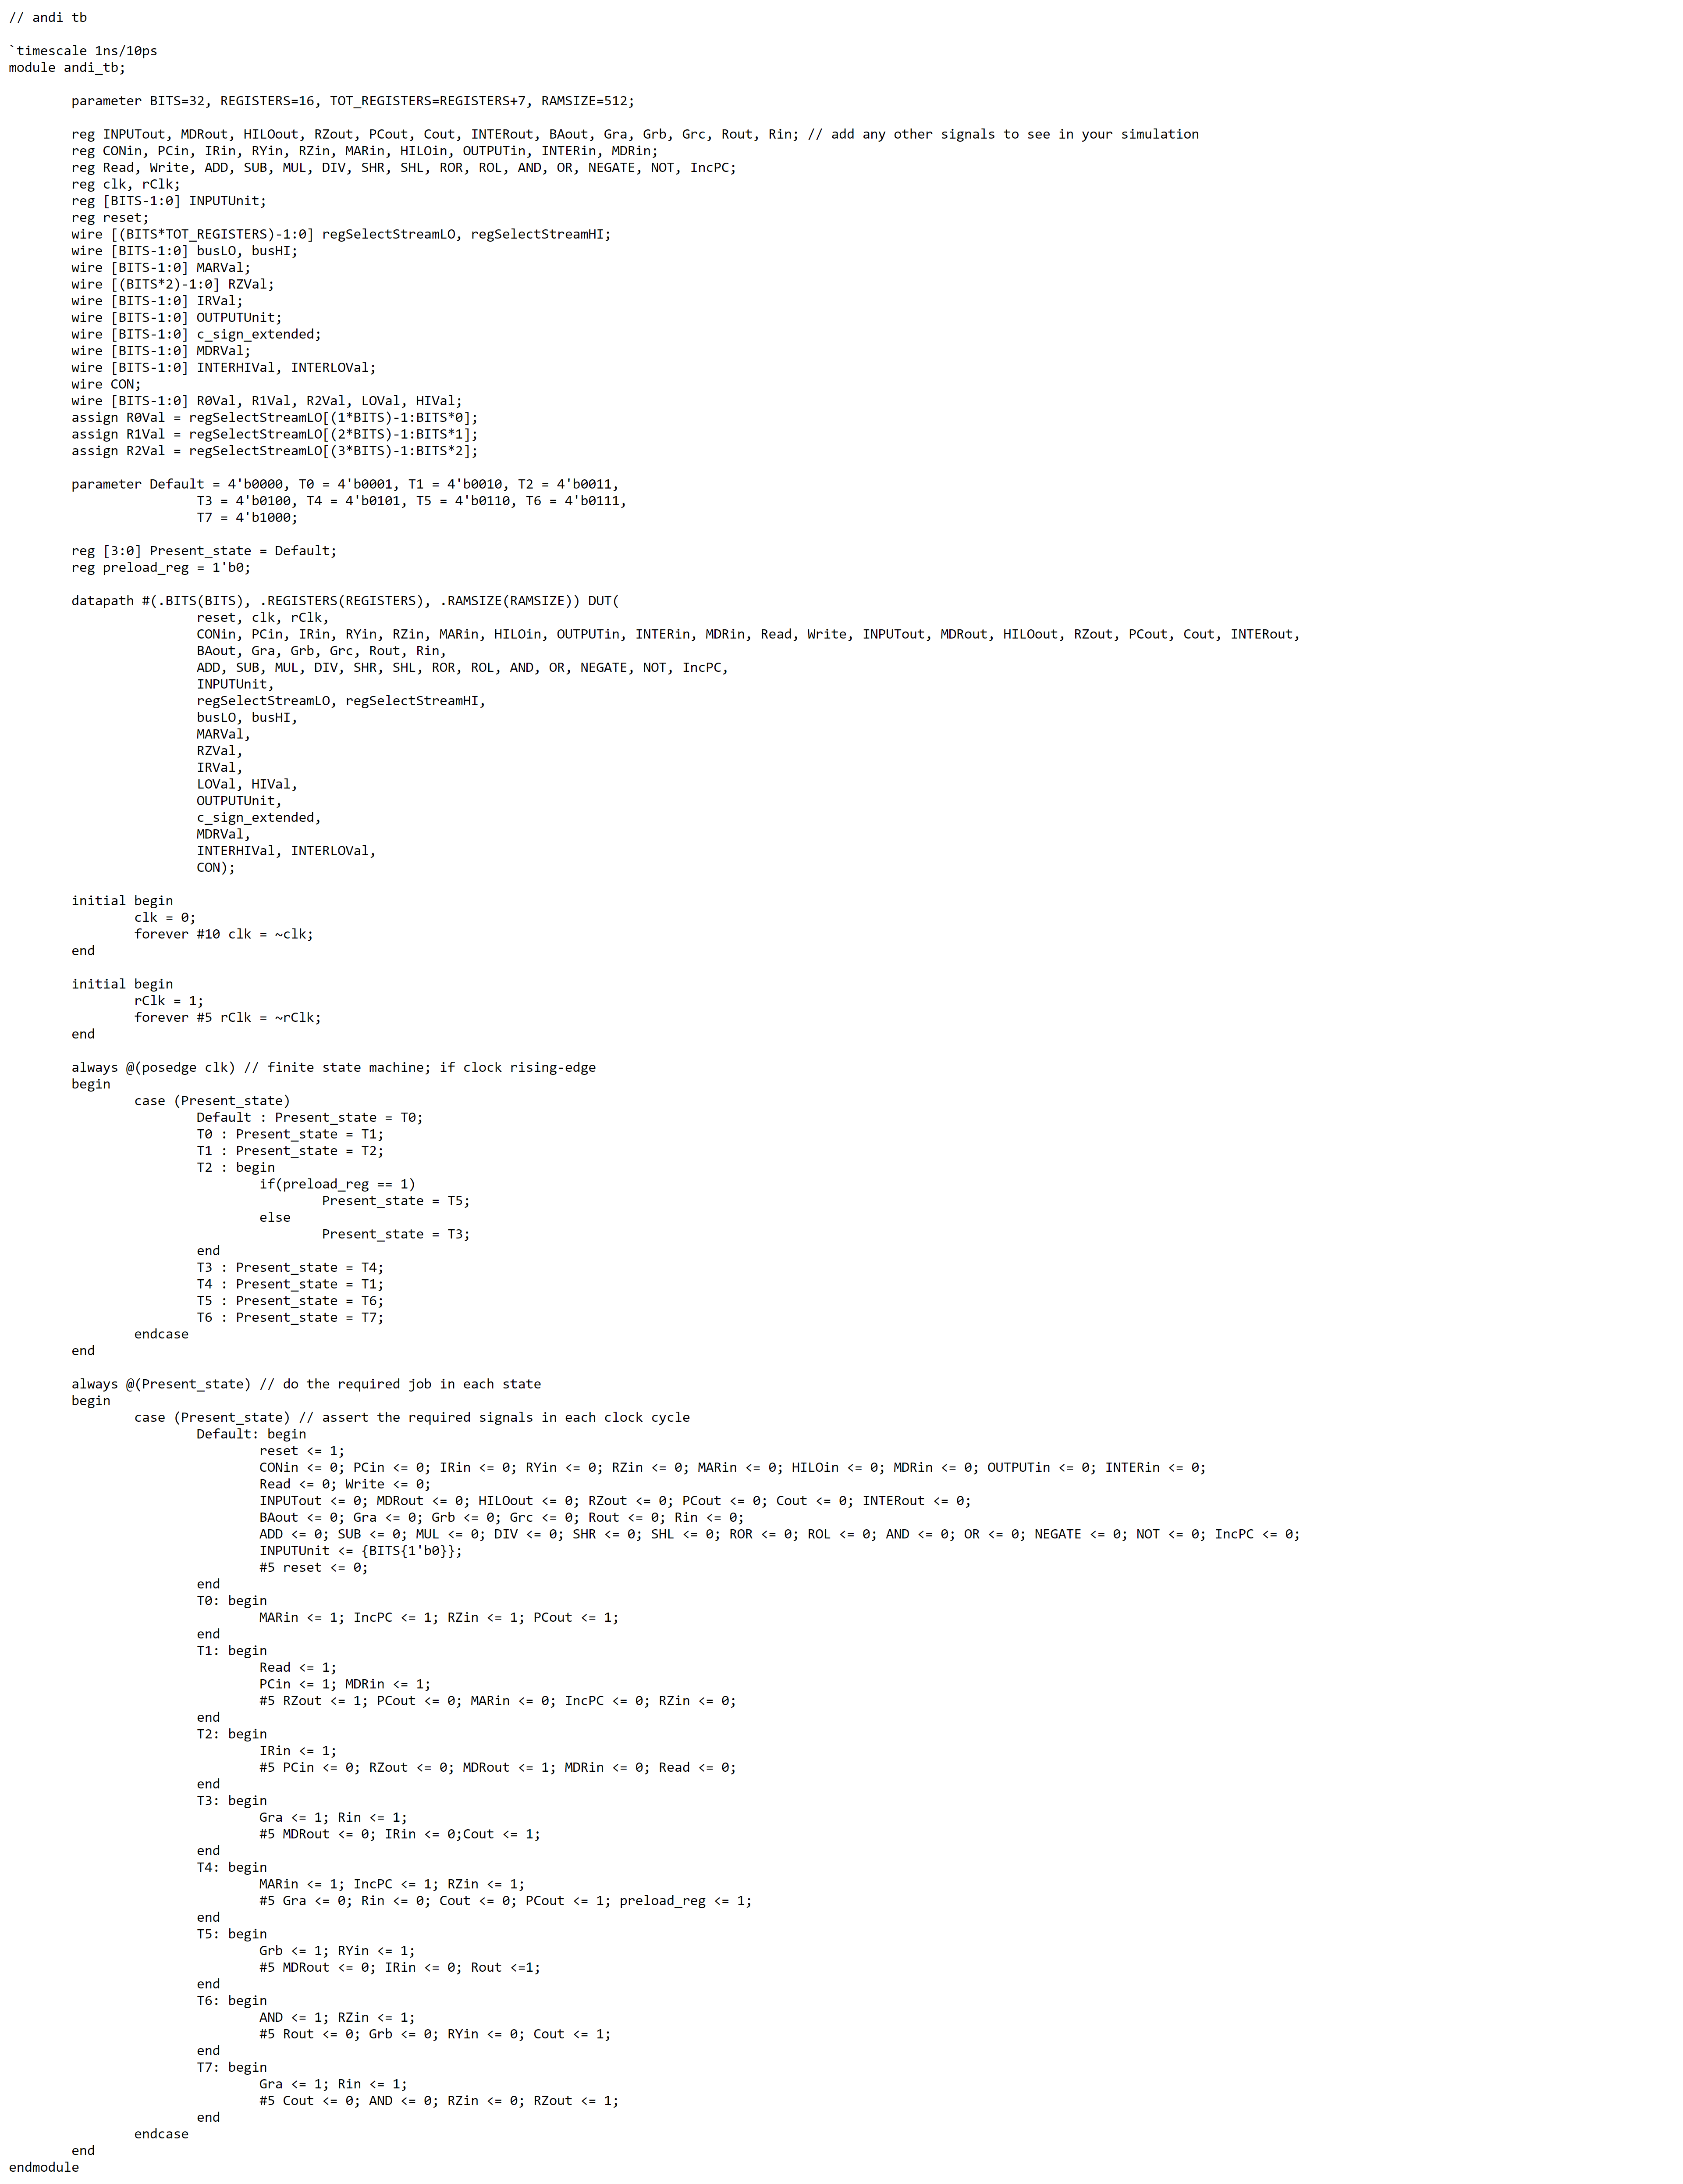

ANDI Waveform

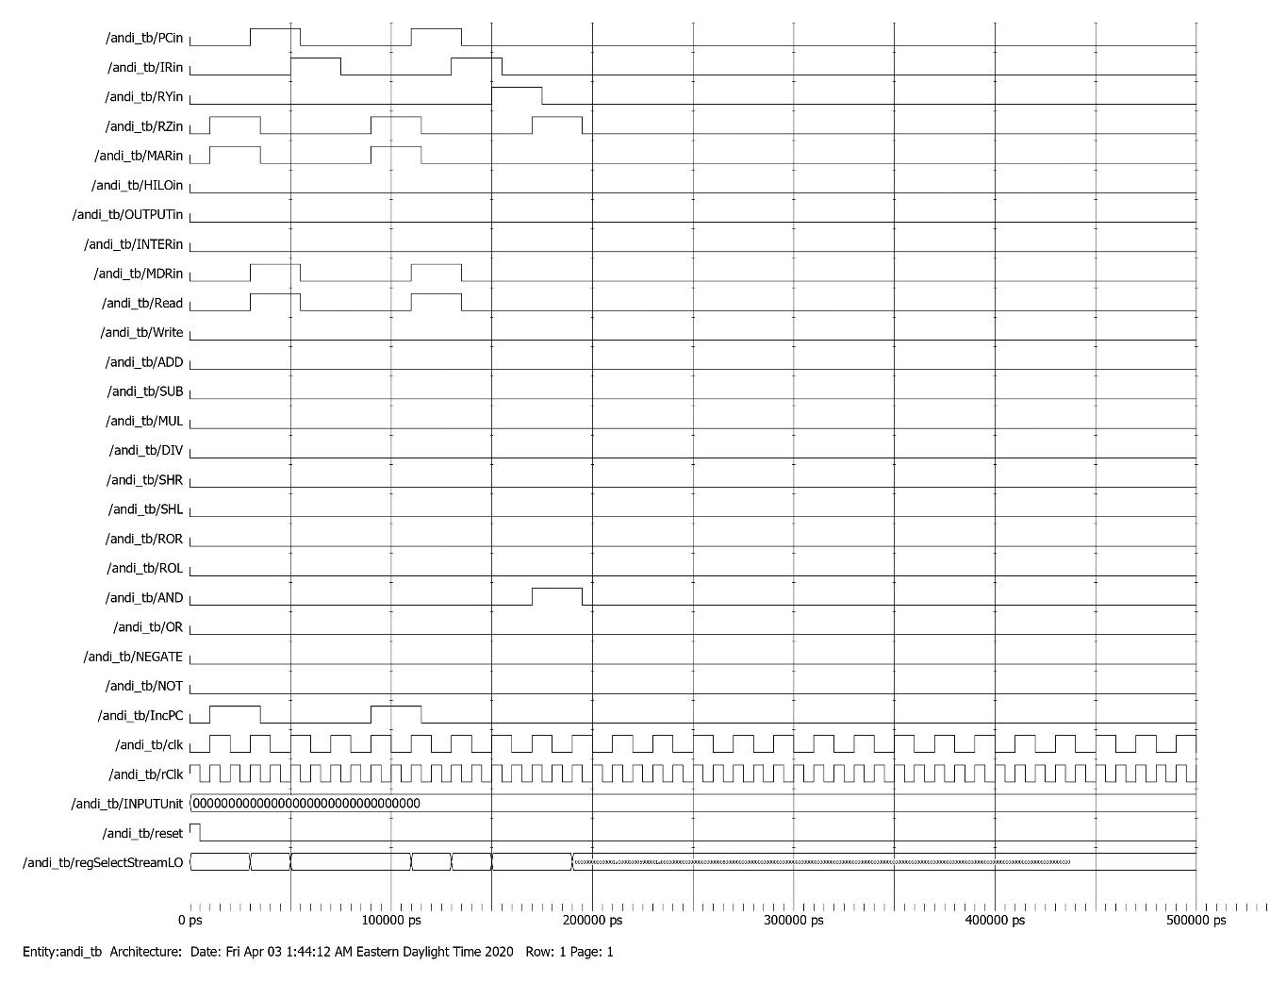

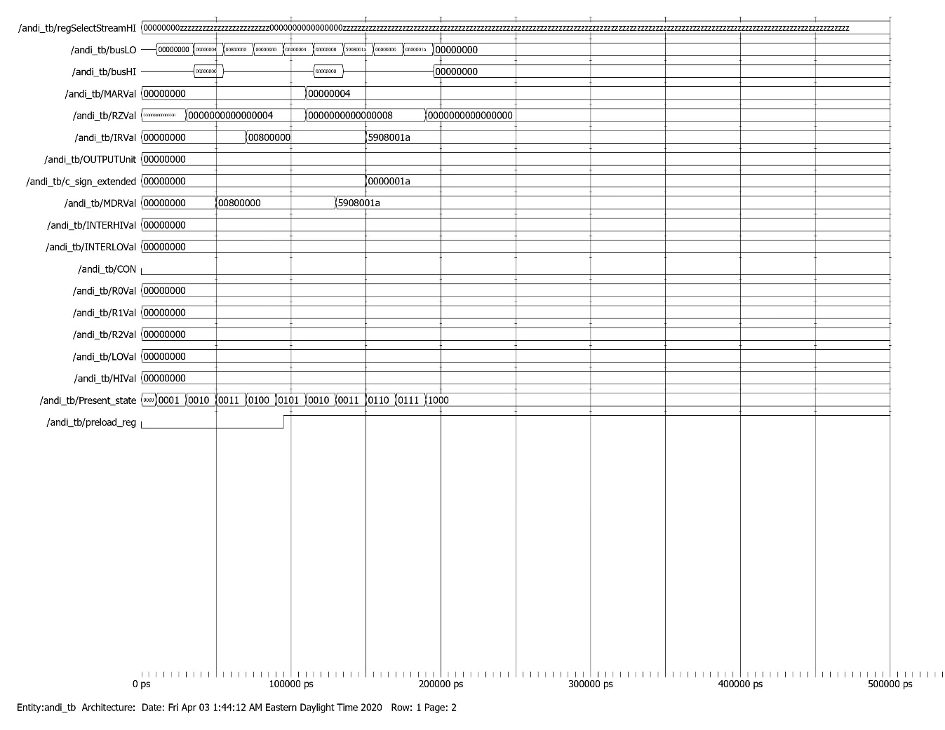

ORI Testbench

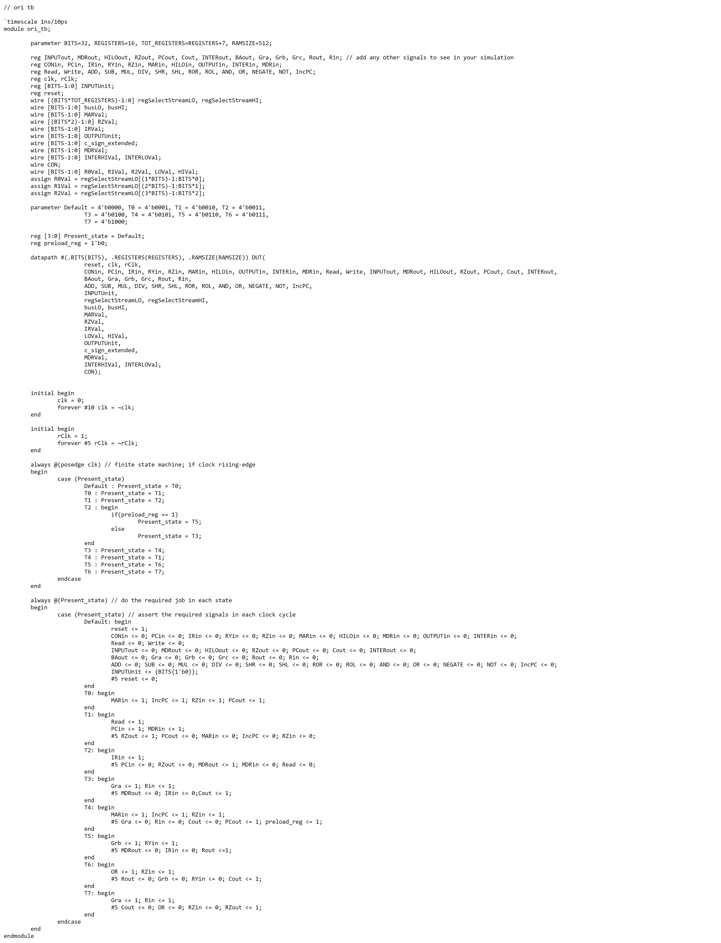

ORI Waveform

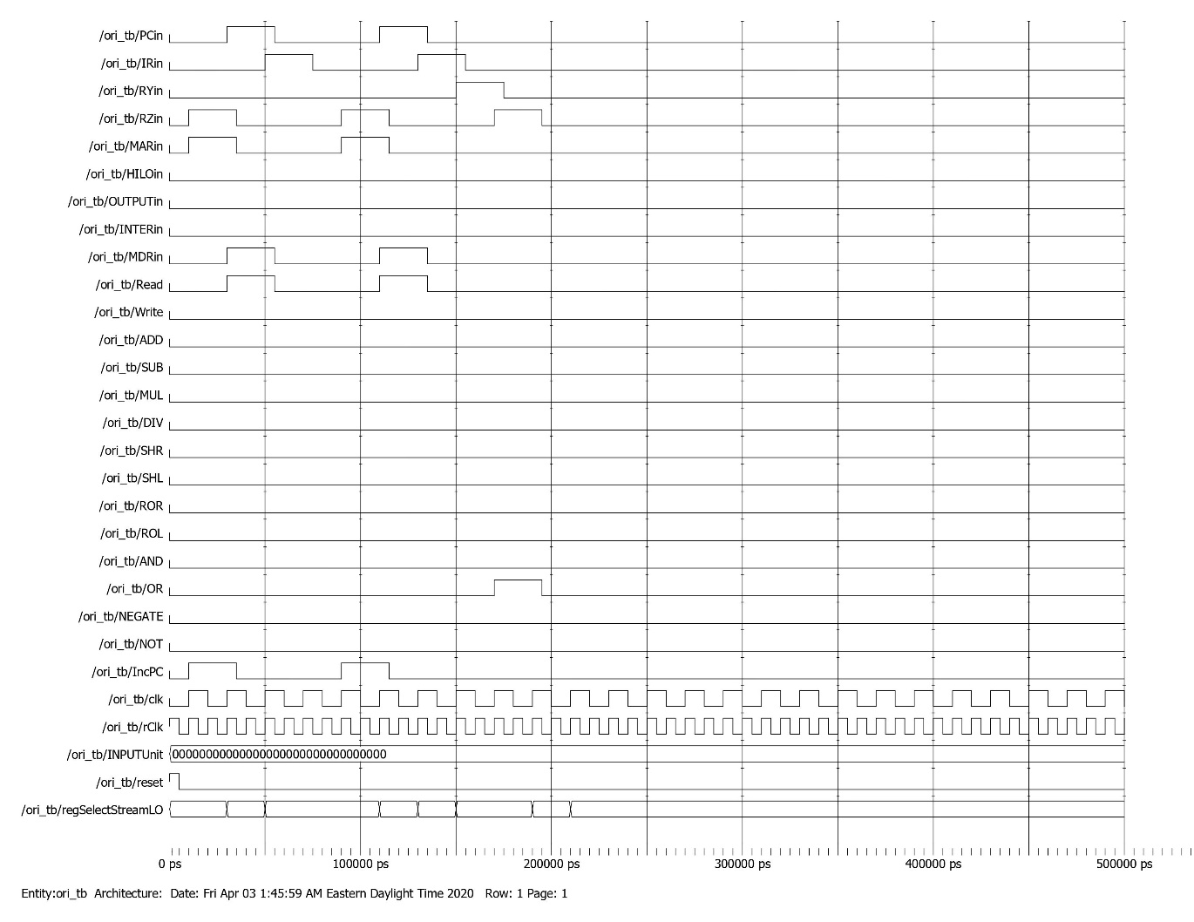

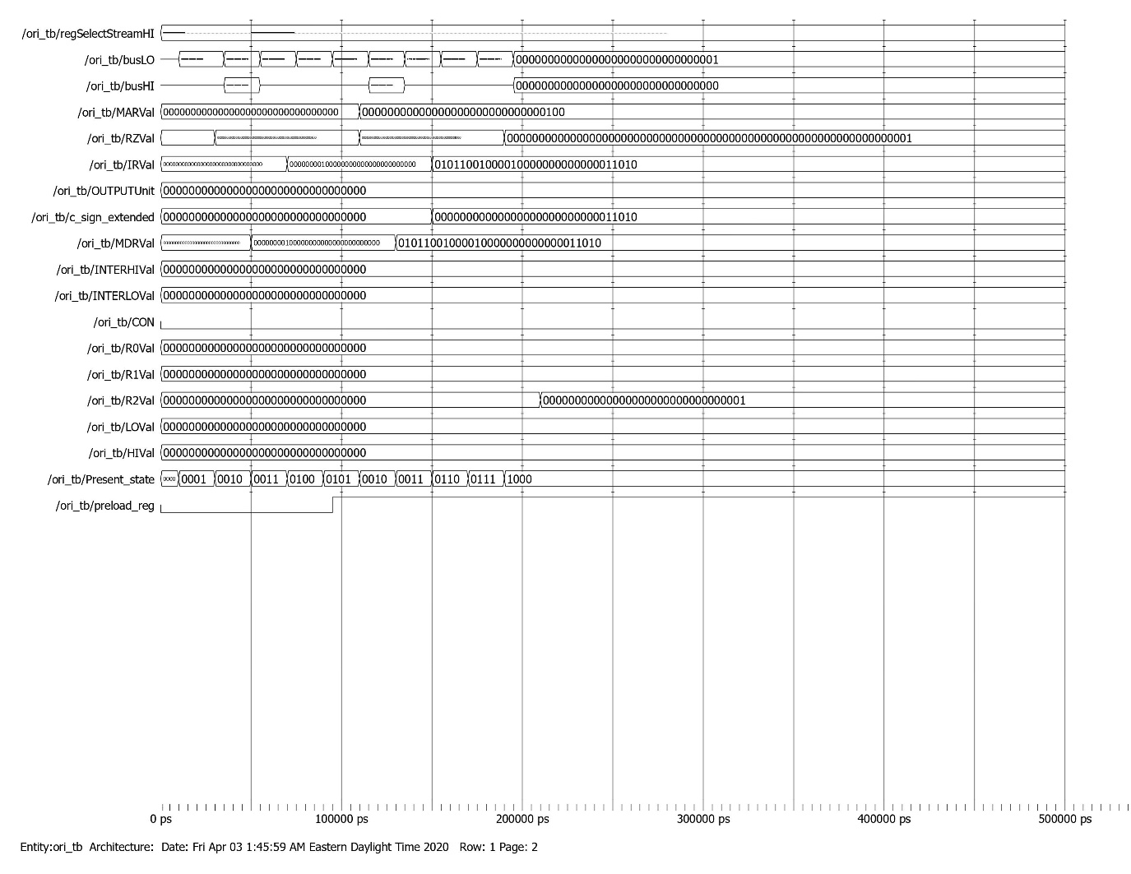

Branch Testbench

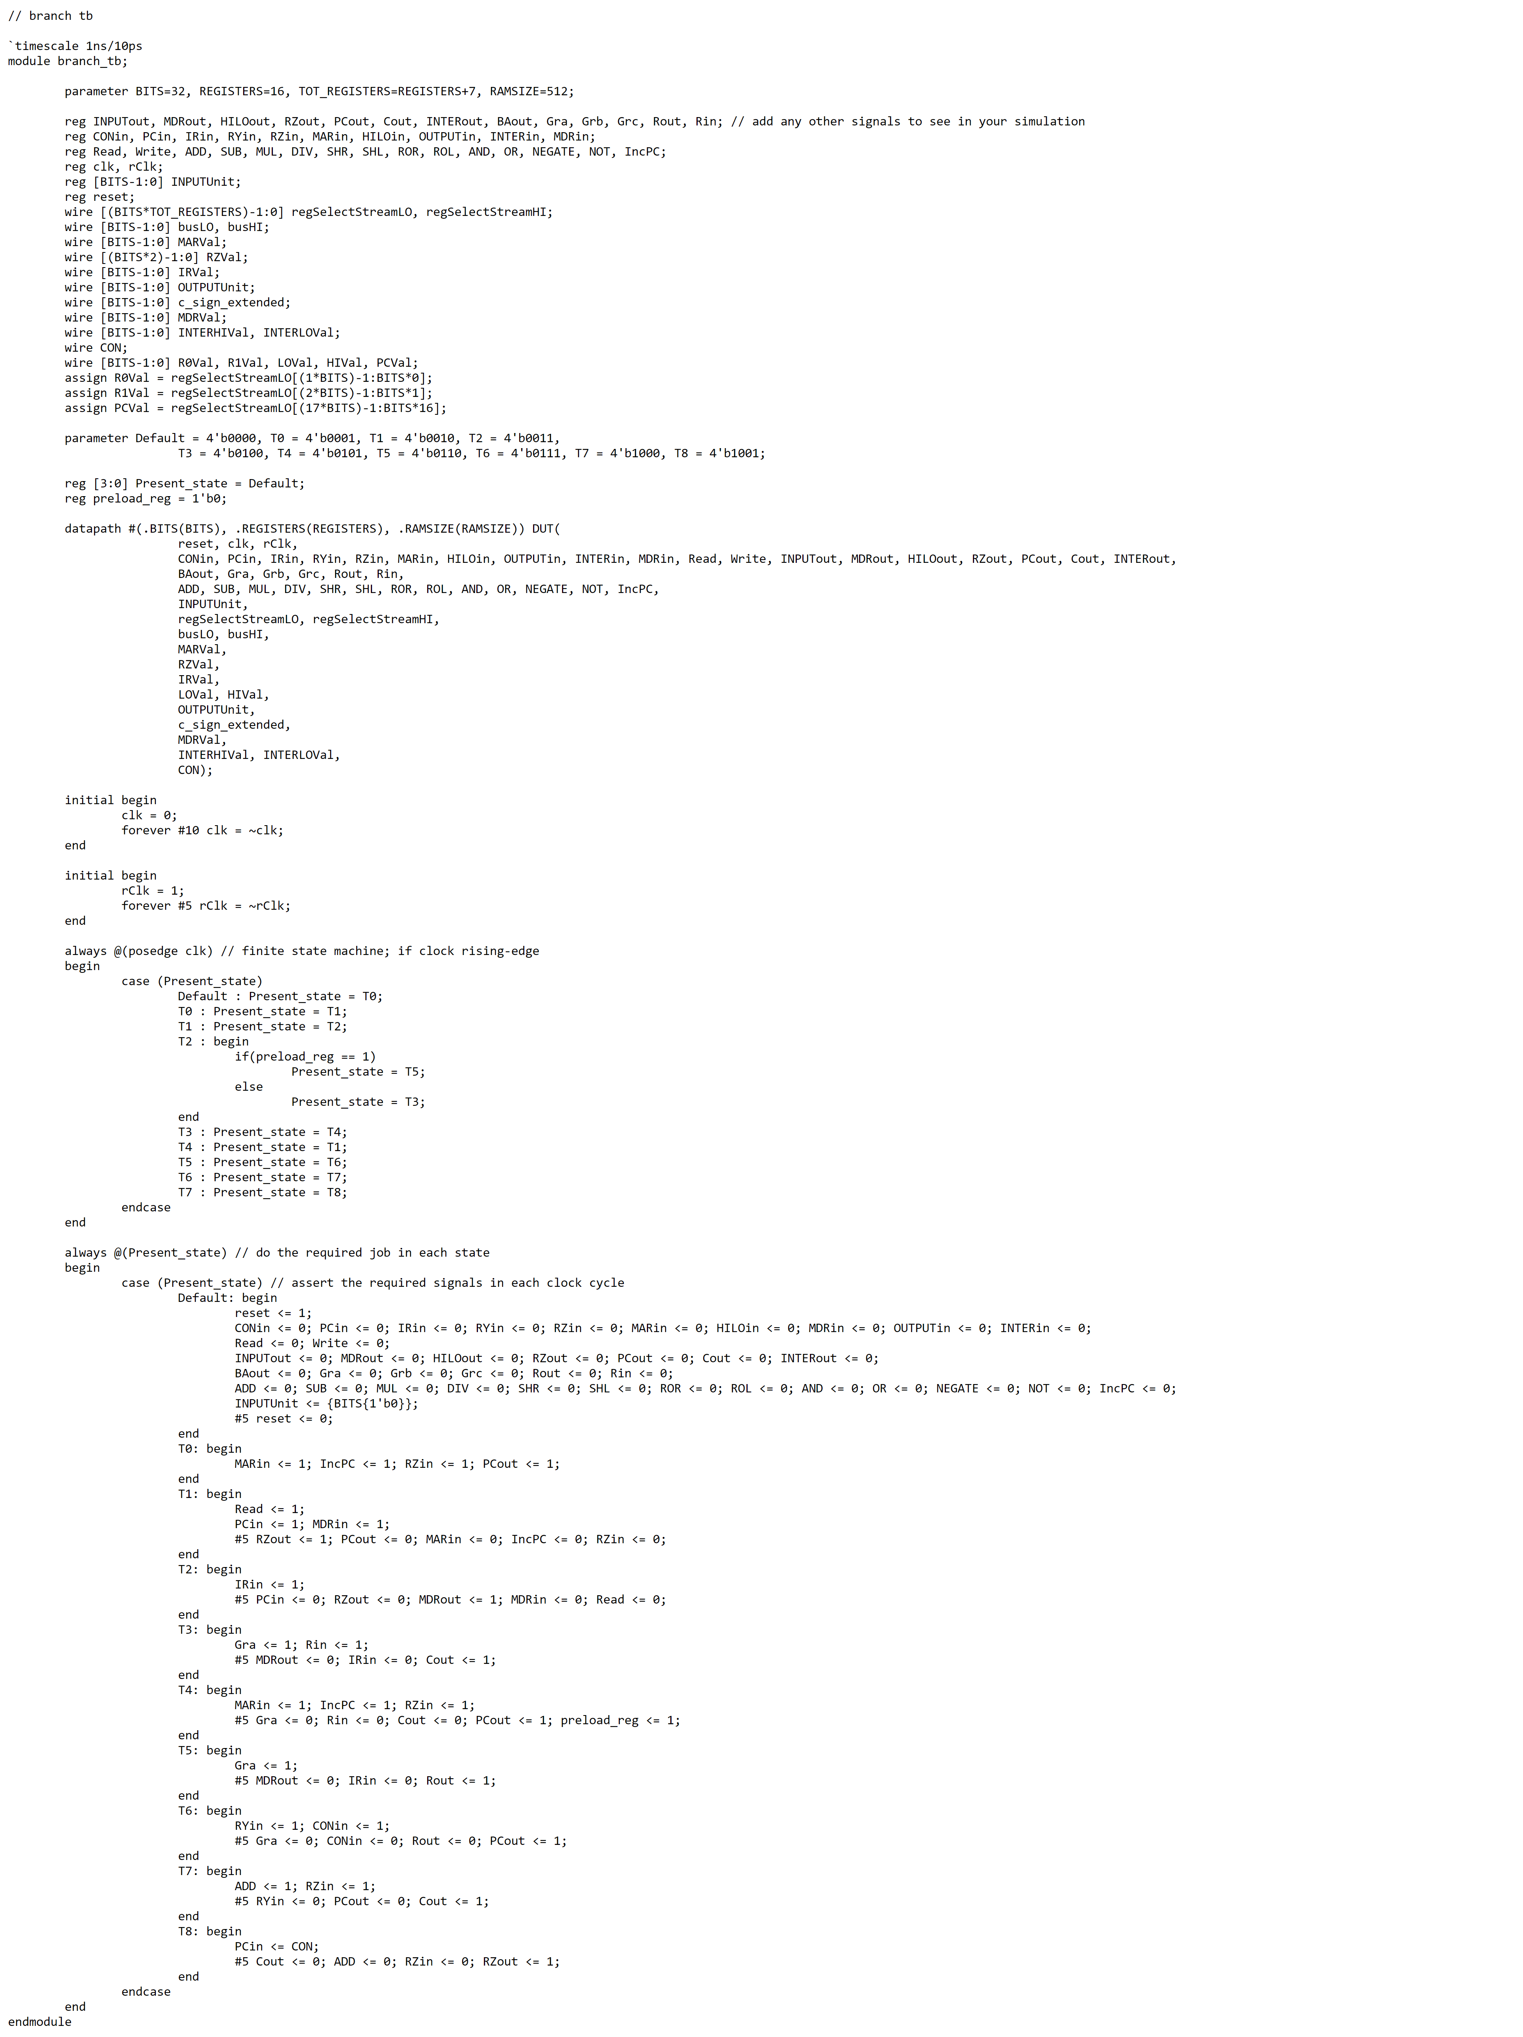

Branch Waveform

Branch Case 1

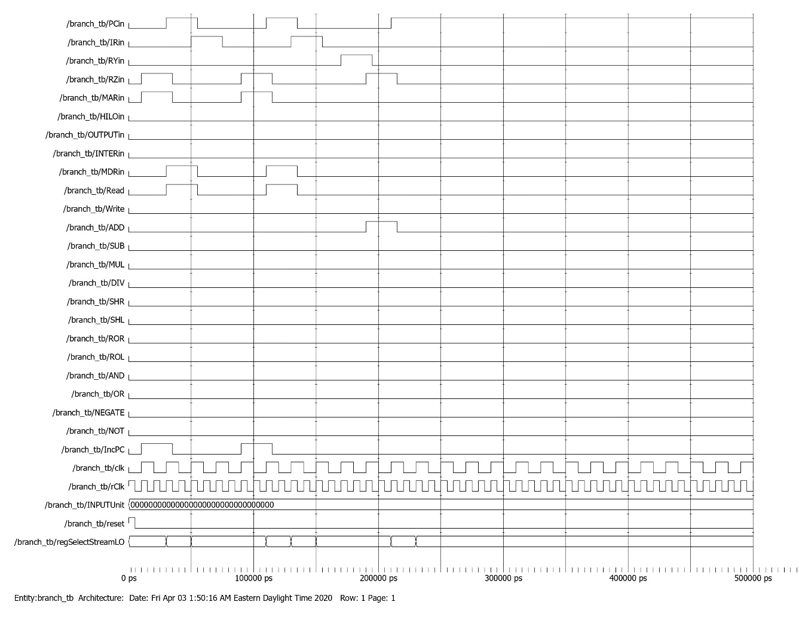

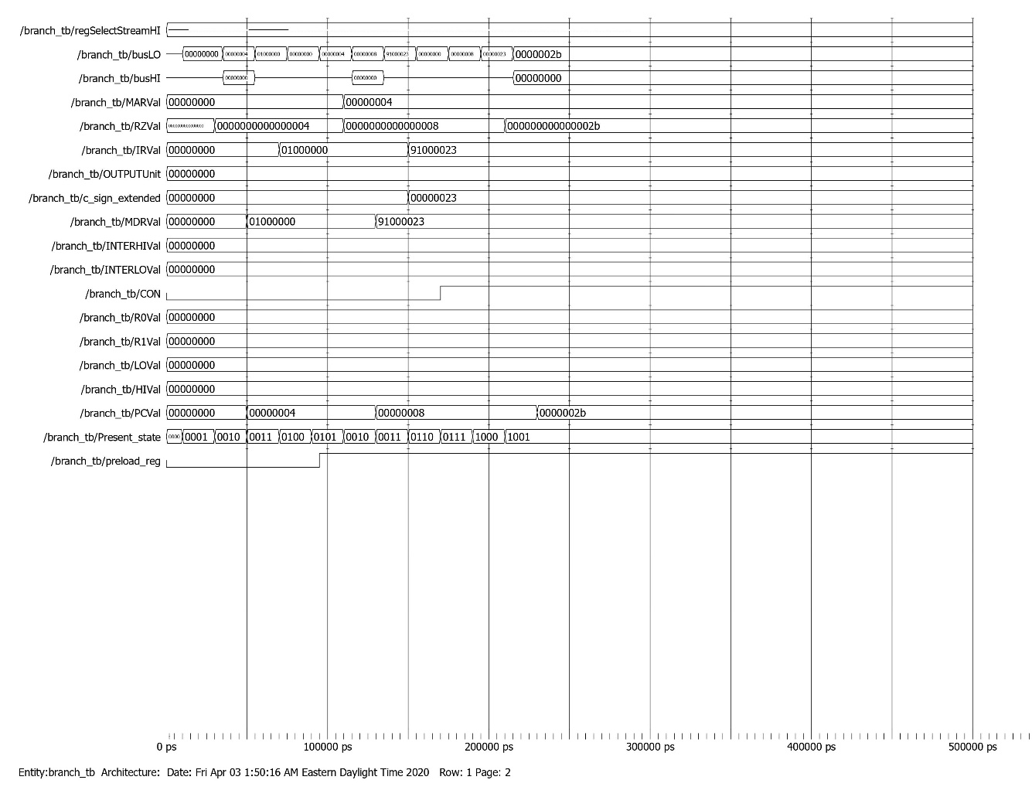

Branch Case 2

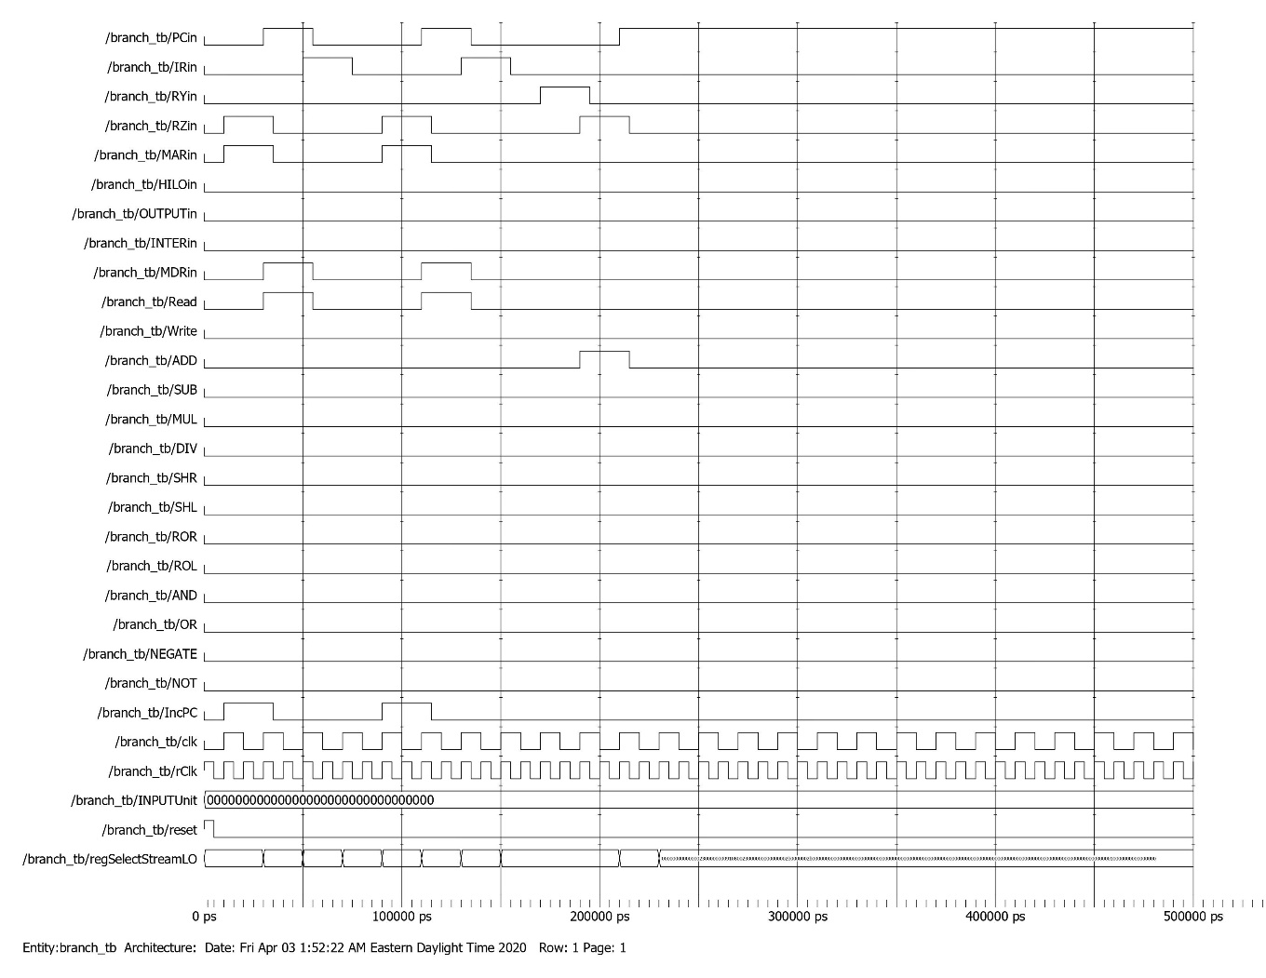

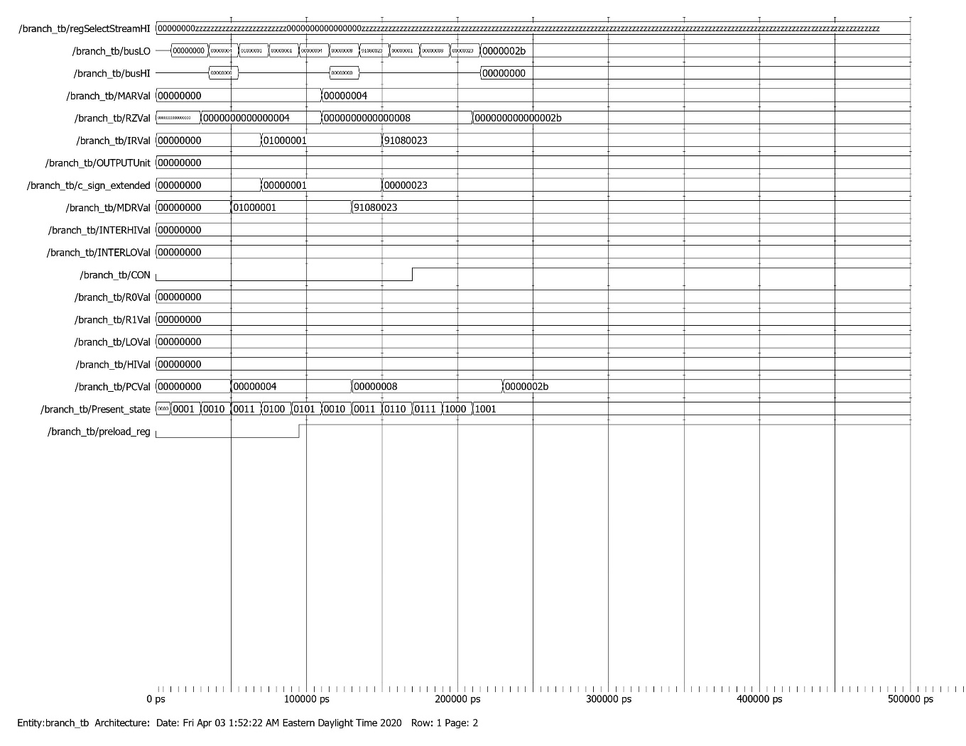

Branch Case 3

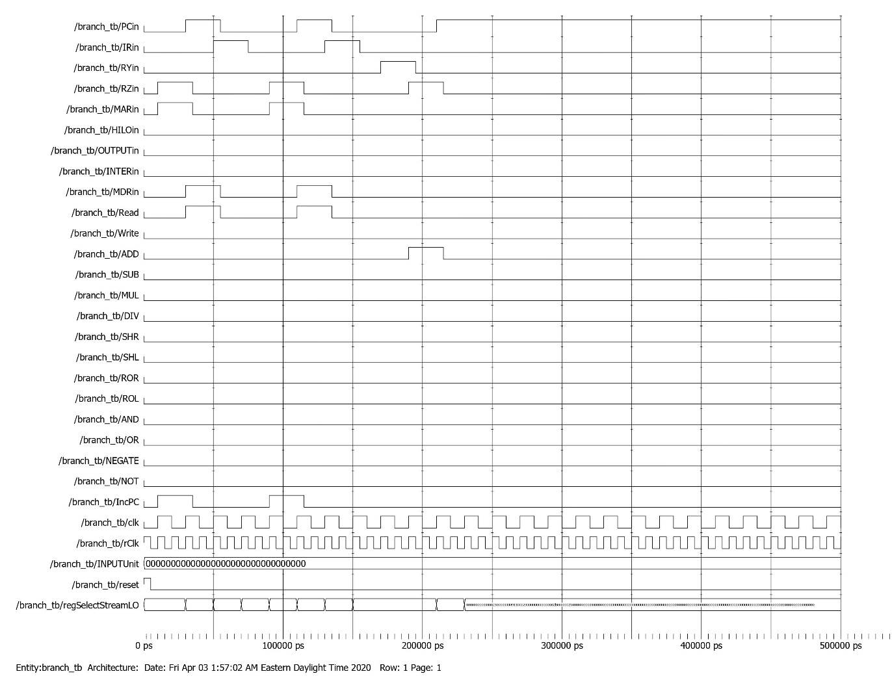

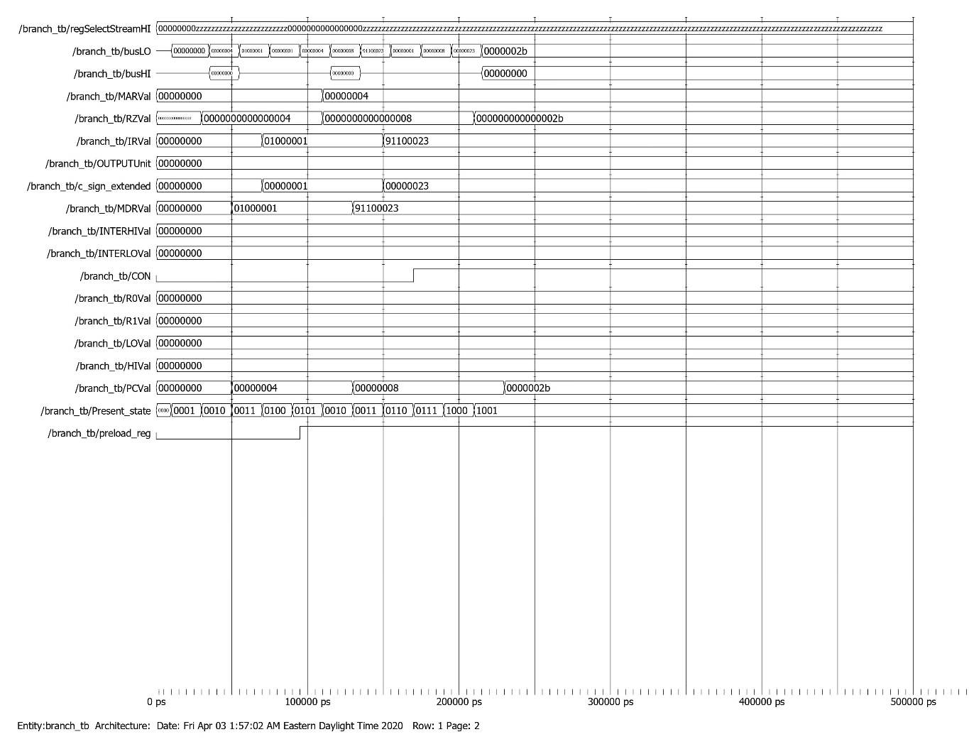

Branch Case 4

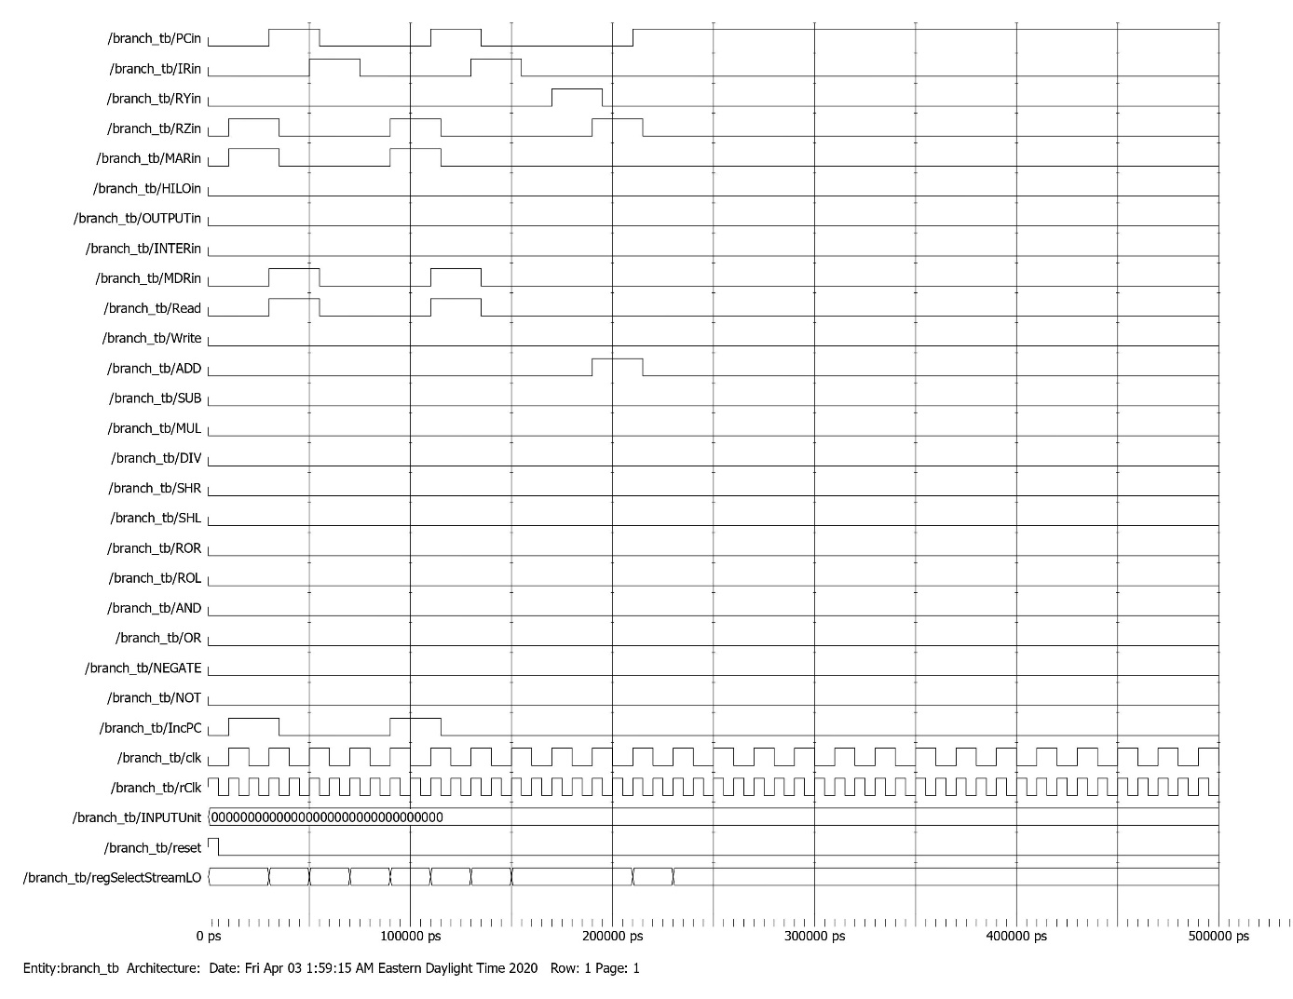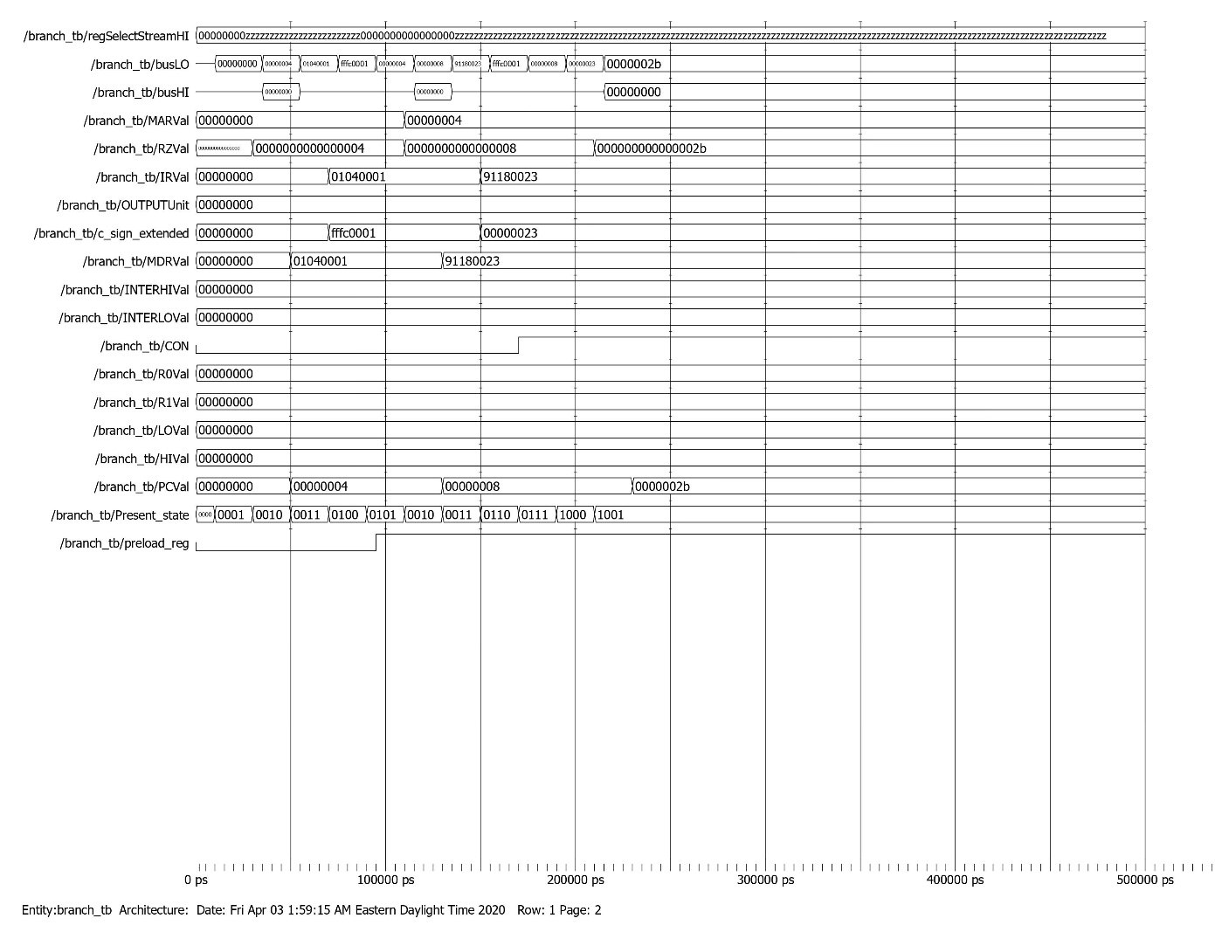

JR Testbench

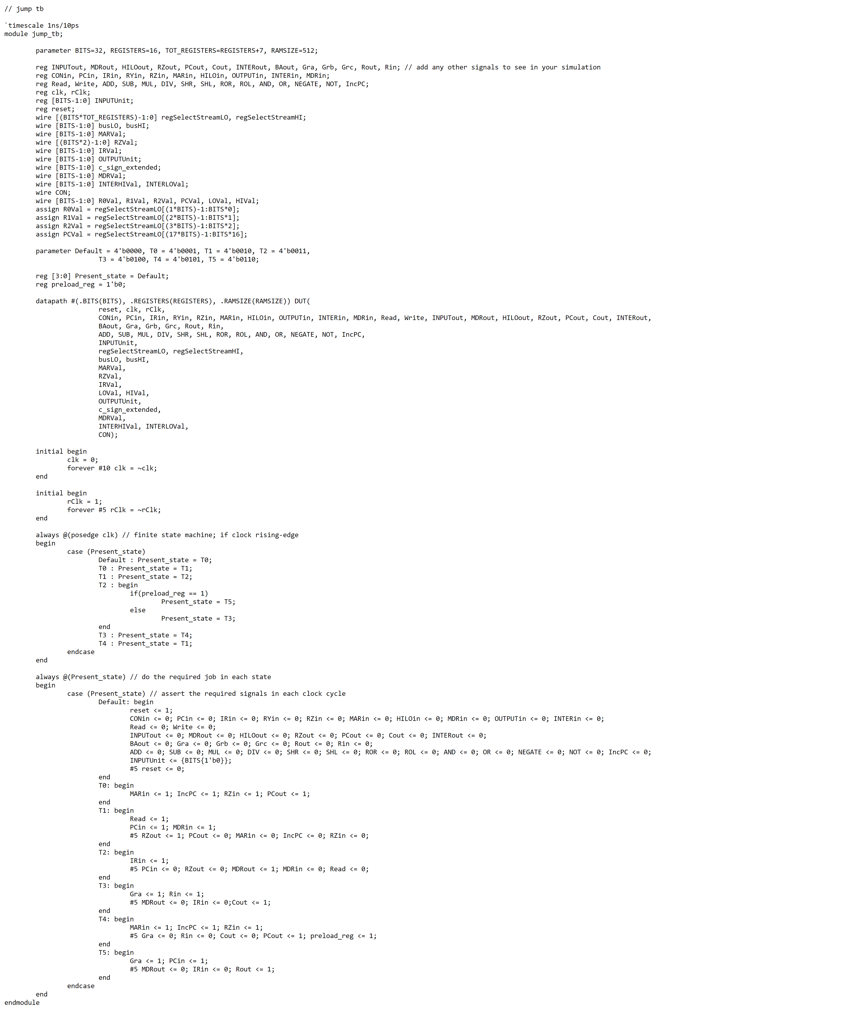

JR Waveform

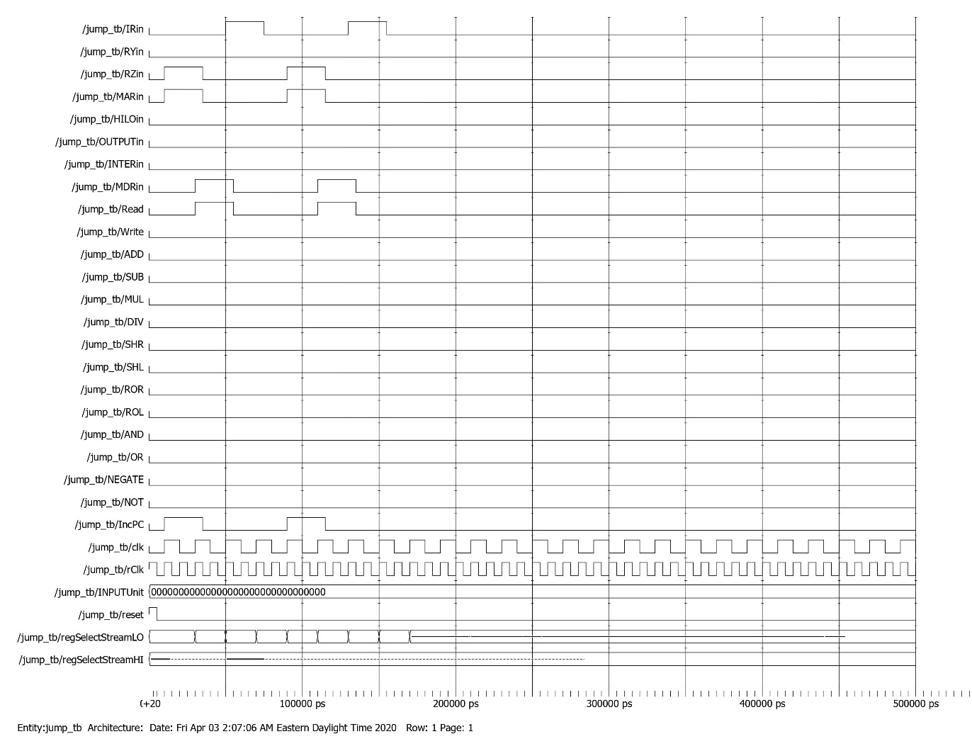

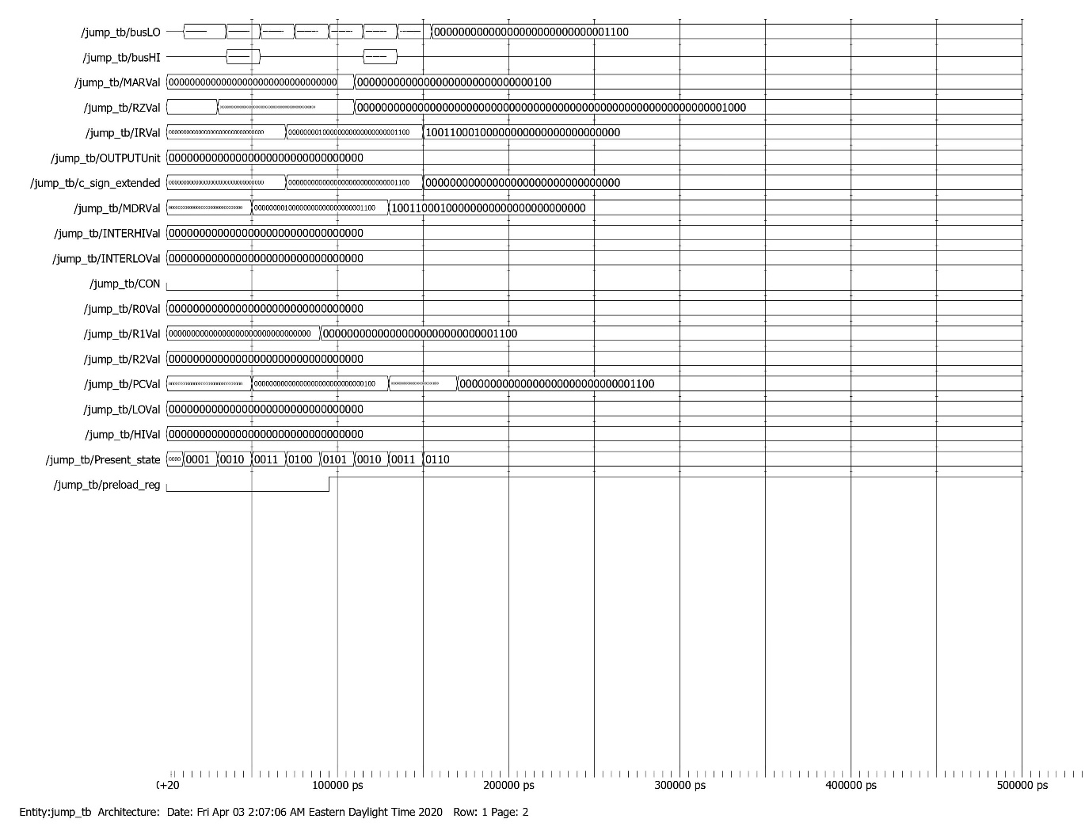

JAL Testbench

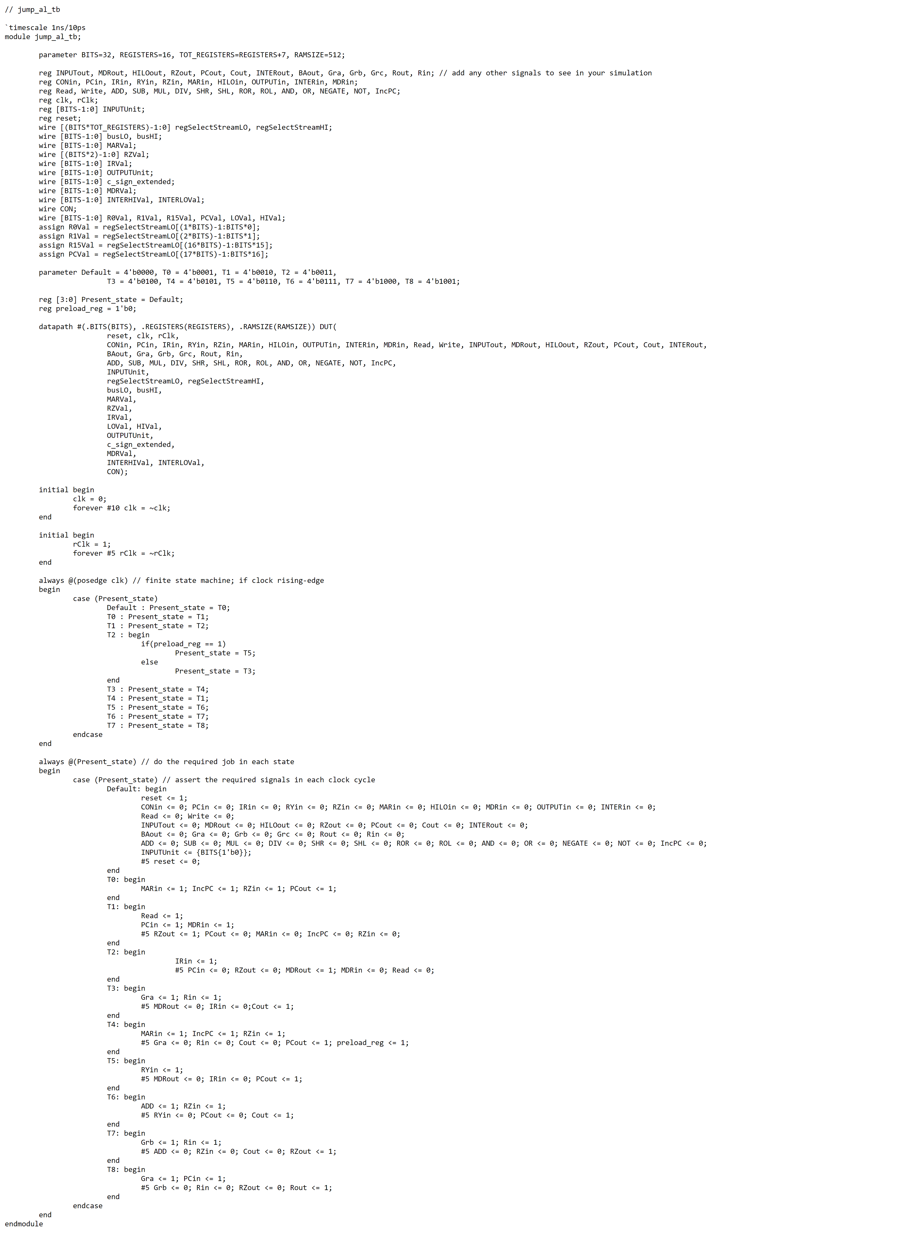

JAL Waveform

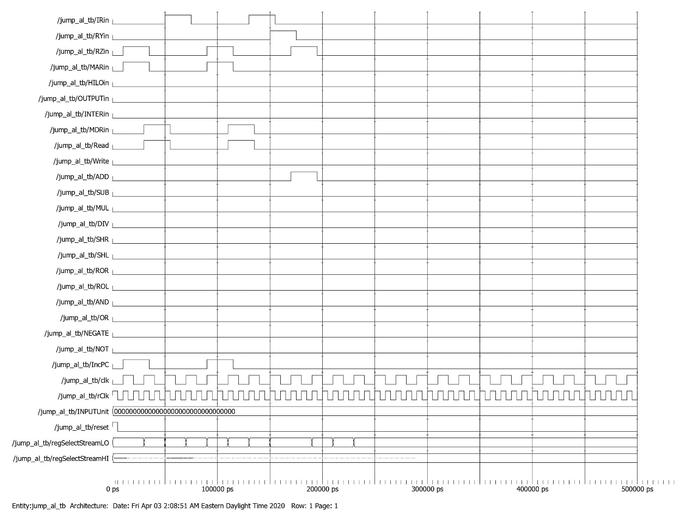

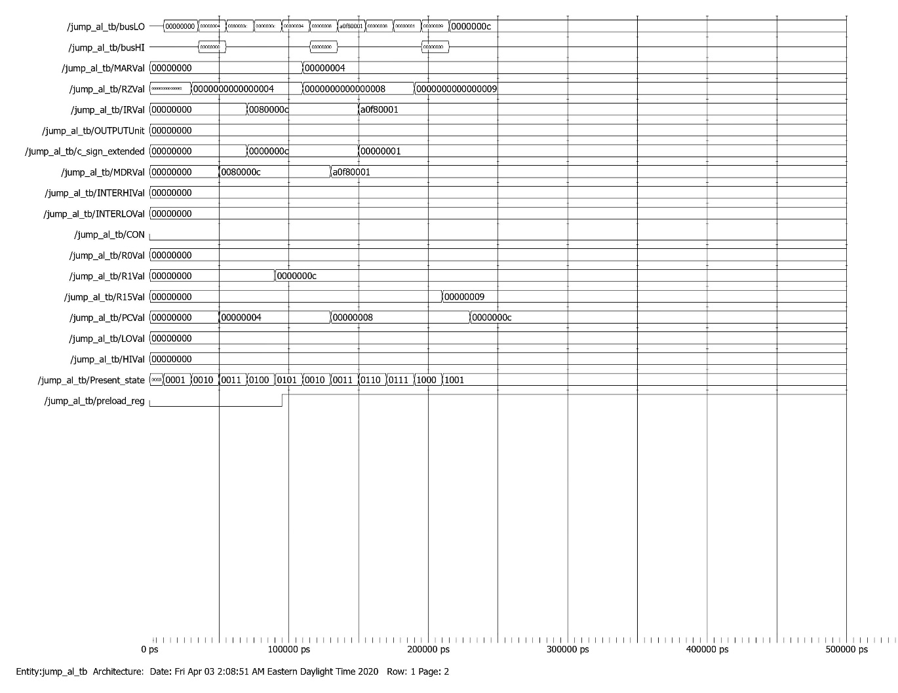

MFHI Testbench

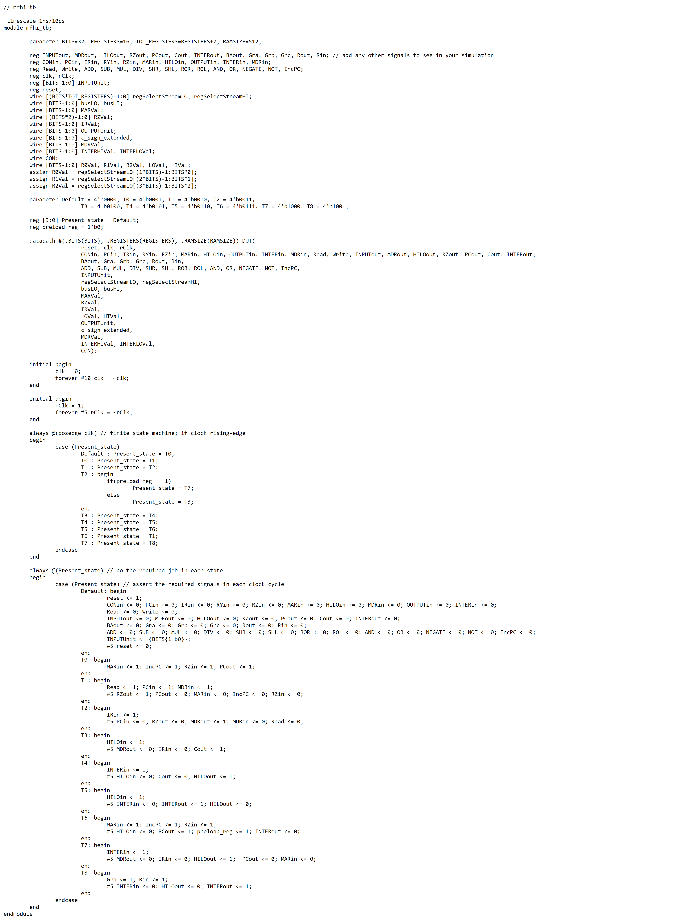

MFHI Waveform

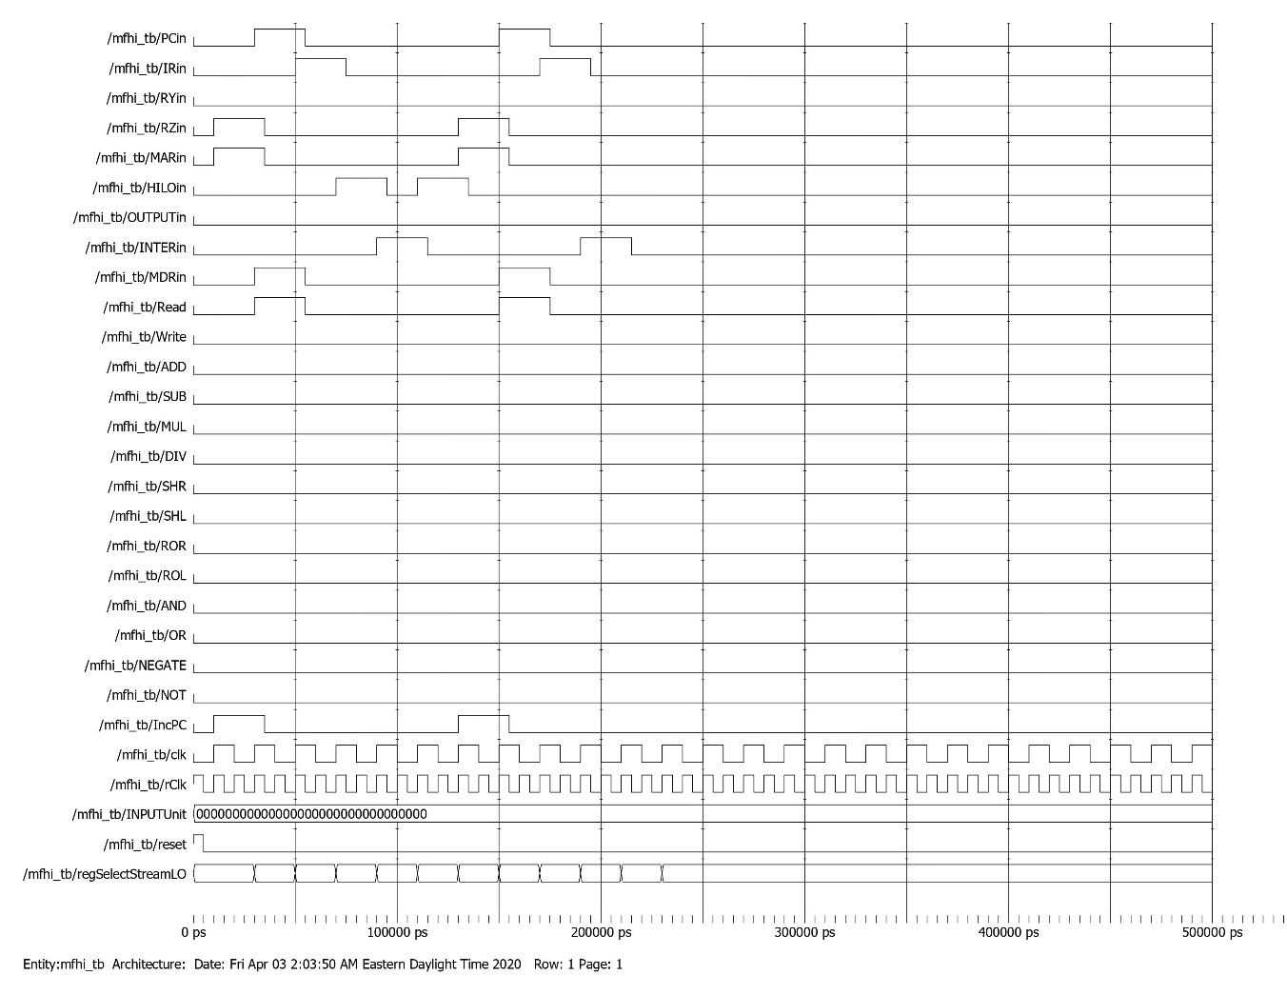

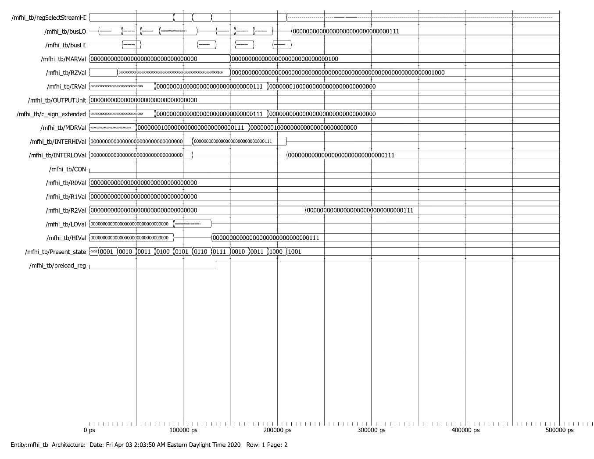

MFLO Testbench

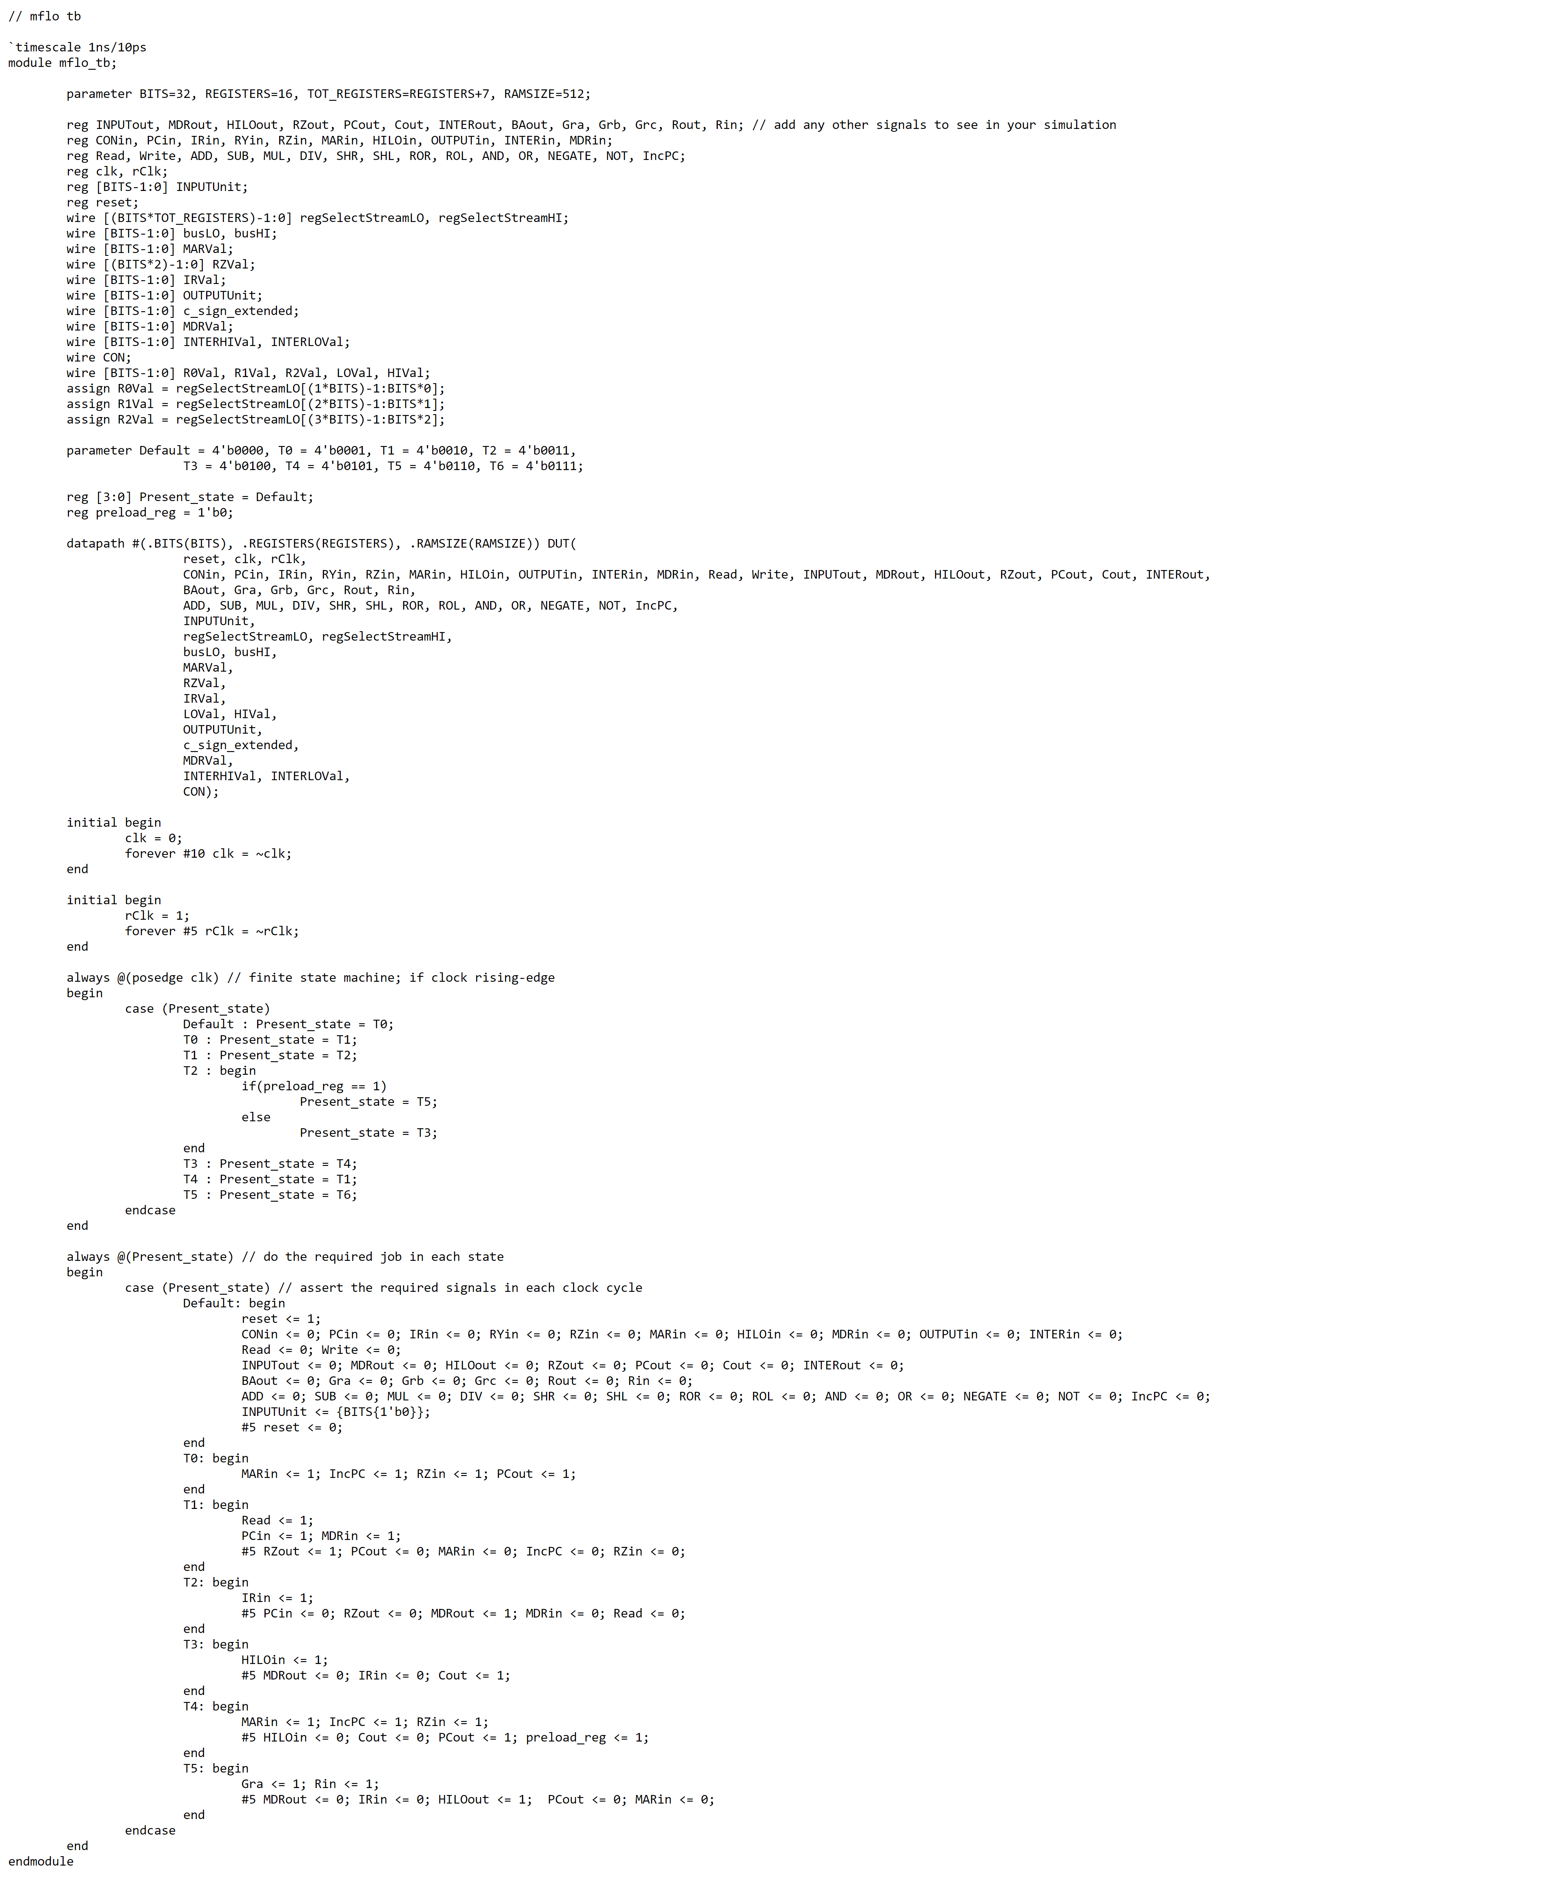

MFLO Waveform

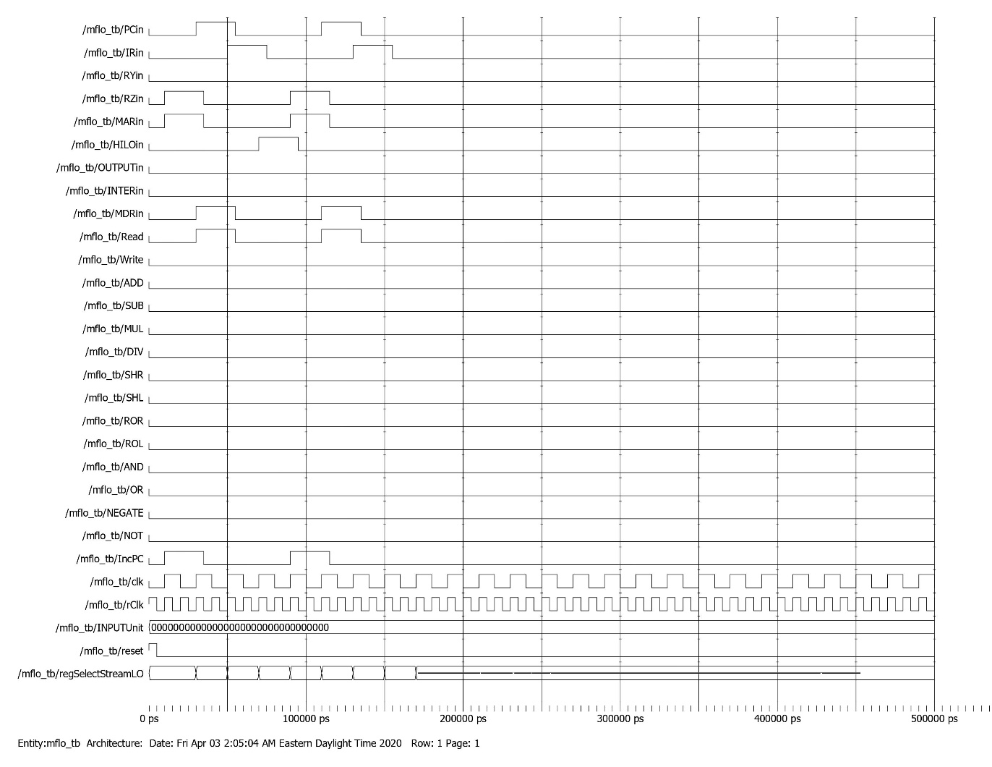

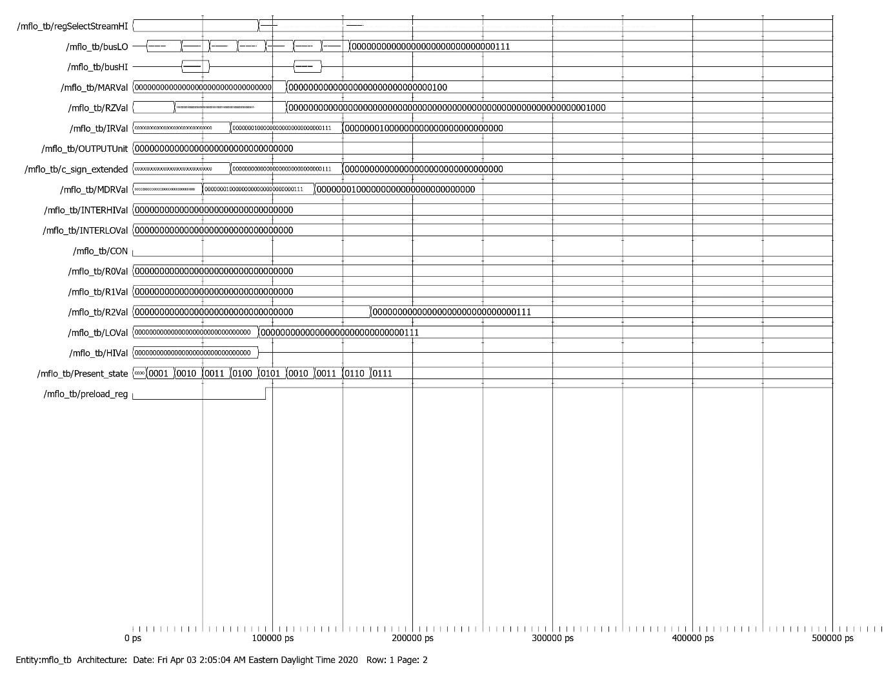

Input Testbench

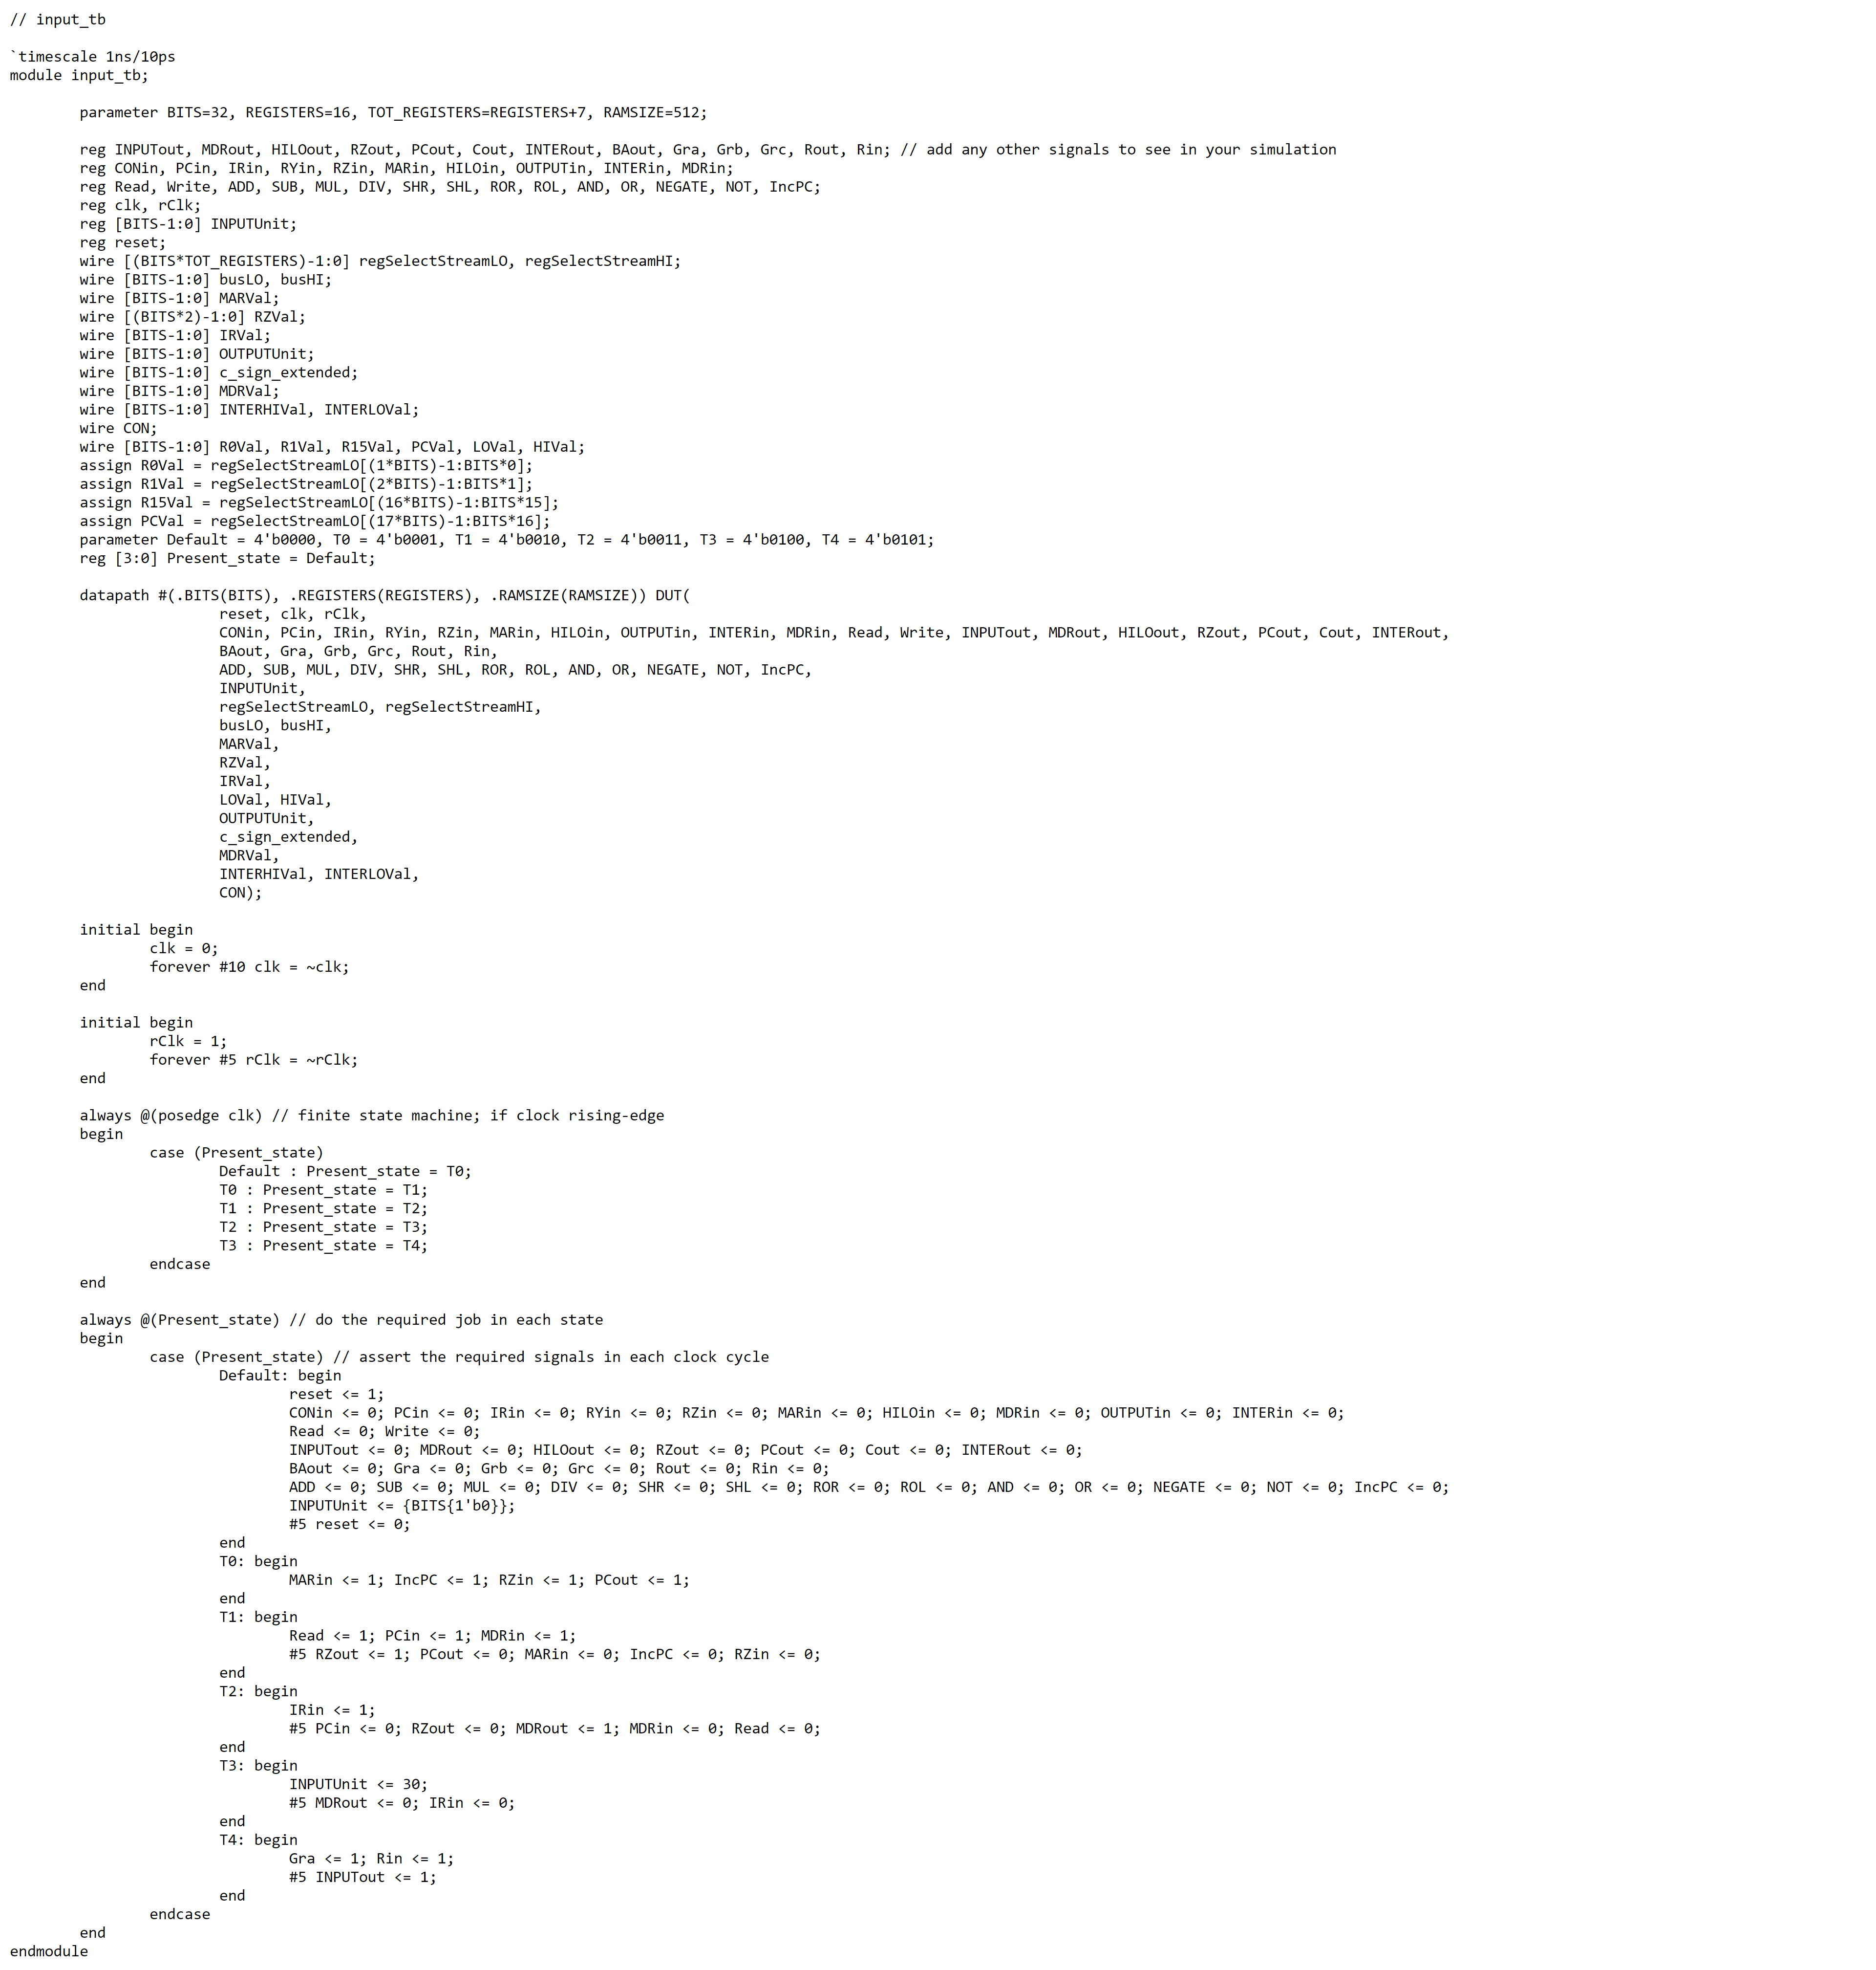

Input Waveform

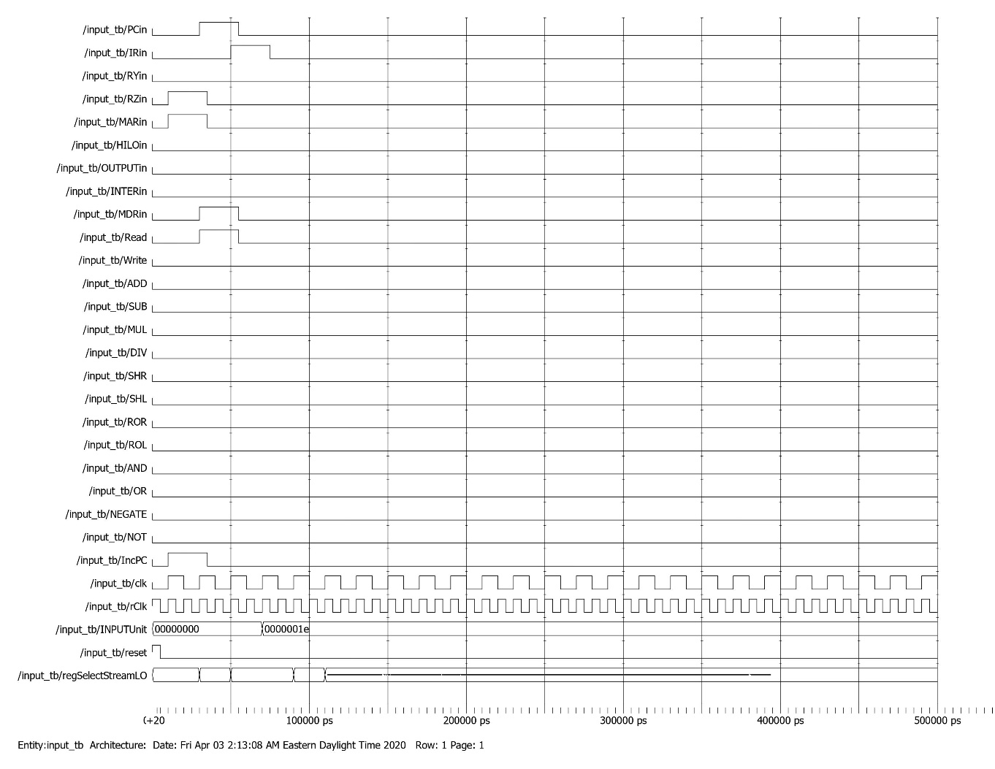

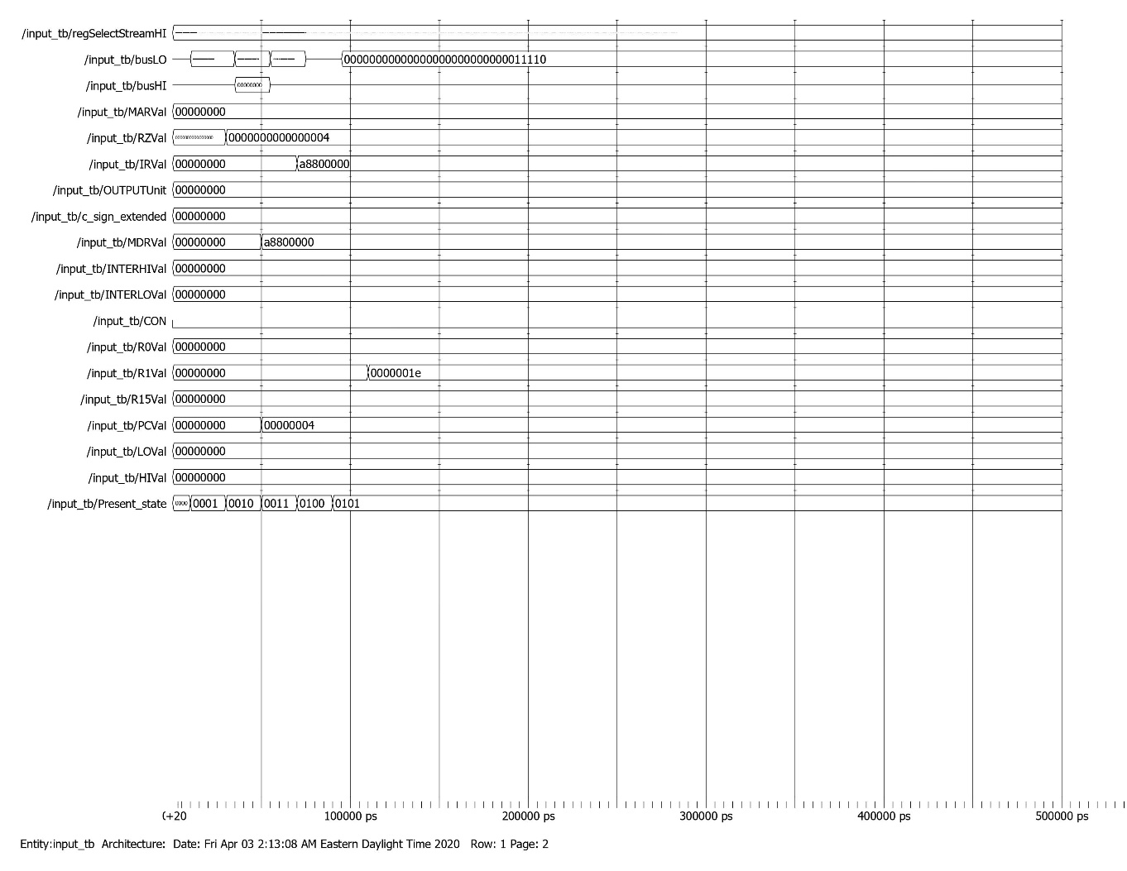

Output Testbench

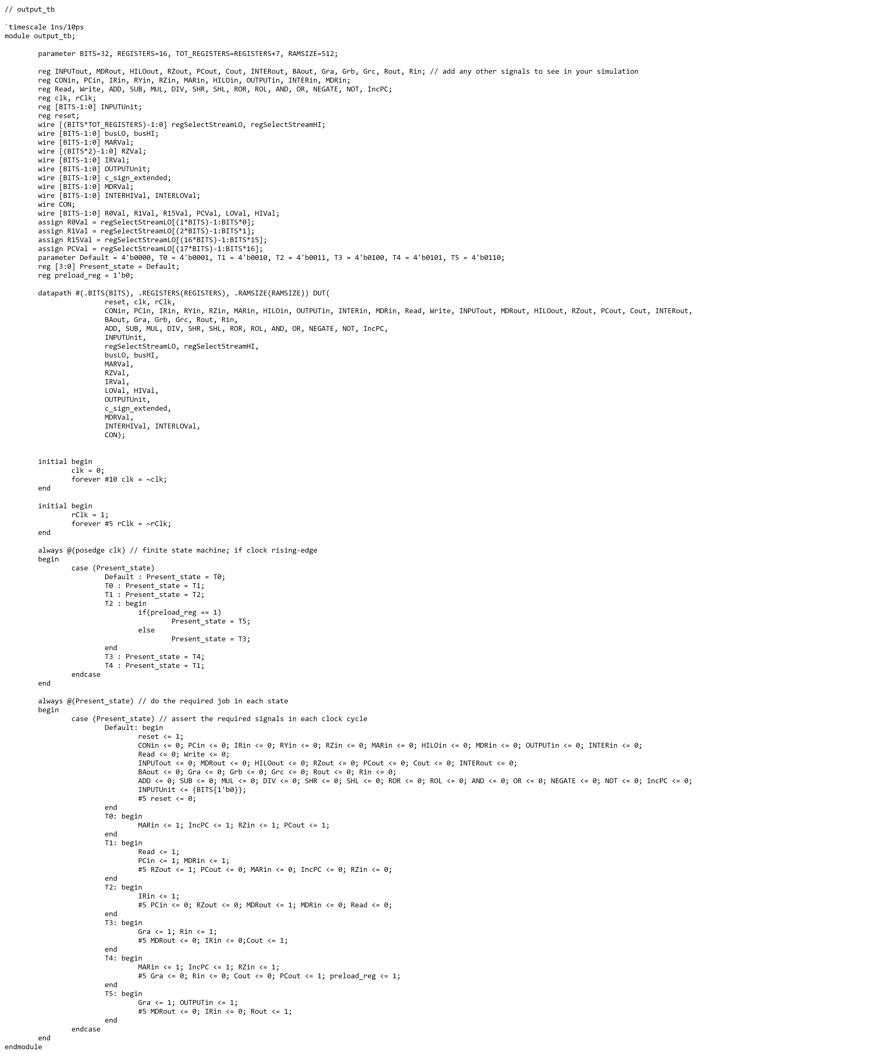

Output Waveform

